Unsupervised Machine Learning to Track Humpback Whale Song Structure

Ariel Raizman

Mentors: Carlos Rueda, John Ryan

Summer 2026

Keywords: Humpback Whale Song, Unsupervised Machine Learning, Bioacoustics

ABSTRACT
Humpback whales (Megaptera novaengelae) are known to exhibit a form of cultural transmission, where population-specific songs are transferred across multiple populations. Tracking these transmissions requires researchers to manually classify and compare components of each song, which is time intensive, and advances in passive acoustic monitoring have made data widely available but impossible to manually parse. Machine learning has become very effective in solving these data bottlenecks. This paper describes efforts to use unsupervised machine learning over acoustic foundation model embeddings to cluster humpback whale song units to understand the transmission of whale song across the ocean.

1 INTRODUCTION
Humpback whales (Megaptera novaengelae) are a keystone species, and their recovery and conservation remain an ecological priority. A key component of complex social behavior is their acoustic communication. Only male humpback whales sing (Winn and Winn, 1978), these songs are consistent within a population (Payne and Payne et al., 1985), and their song evolves over time, sometimes rapidly (Payne et al., 1983). Beyond the intrinsic evolution of song within a population, humpback whales exhibit a form of cultural transmission. Songs and themes have been observed to transfer horizontally between populations across the Pacific Ocean, traversing from one population to another (Garland et al., 2011).
Humpback whale song is highly structural and hierarchical, consisting of individual song units that create phrases, repeated phrases that create themes, a number of themes that create a full song, and repetition of the same song in a song session (Payne and McVay, 1971). Understanding the unit and theme-based vocabulary of humpback whale song is essential to studying song evolution and cultural transfer across ocean-wide studies.
As passive acoustic monitoring (PAM) has advanced, the volume of collected acoustic data has grown exponentially, creating a significant data bottleneck (Gibb et al., 2019). The scale of these datasets makes it very difficult for researchers to manually annotate and track song evolution (Stowell, 2022). Traditional machine learning methods can struggle to solve this bottleneck due to the lack of labelled data, and as the structure of humpback whale song evolves over time, static supervised models will struggle to keep up.
To overcome the annotation limits, this paper evaluates the ability of unsupervised machine learning over acoustic foundation model embeddings. By taking advantage of deep learning architectures trained on large acoustics datasets, we extract high dimensional acoustic embeddings and cluster them without prior human labelling. We evaluate the ability of this pipeline to map the structure of humpback whale song to begin creating a scalable framework for understanding cultural transmission of whale song across the ocean.

2 METHODS

Similar to natural language processing, we focus our pipeline on clustering short sound categories (Sainburg et al., 2020), in this case “song units”, that can then be used for higher level construction, such as phrases and themes. This approach makes mapping structure more feasible as although the number of distinct song units is debated, song units will have less variety than larger coarse-grained features. Furthermore, phrase- or theme-based ground truth labels are not readily available. Therefore, this pipeline was designed to cluster at the unit level.
Our methodology first preprocesses a 4.5 hour raw audio recording of humpback whale song, then runs feature extraction using either Earth Species Project's AVES-Bio (Hagiwara, 2023) or Google's Perch 2.0 (Merriënboer et al., 2024) foundation models to generate embeddings. These embeddings are then reduced using UMAP (McInnes et al., 2020) and clustered using the HDBSCAN algorithm (McInnes et al., 2017), which are then mapped to the manual labels and evaluated using the ARI similarity metric (Hubert and Arabie 1985).

2.1 PREPROCESSING
Clustering and evaluation of this pipeline was done using a manually labelled 4.5 hour continuous humpback whale song session recorded by the hydrophone mounted on the MARS cabled observatory in the Monterey Bay (Ryan et al., 2016) which has been used in previous experiments (Rueda and Ryan, 2020).
Initial audio preprocessing was done using the Sound eXchange (SoX) software (Bagwell et al., 2015). To meet the specific input requirements of the foundation models, the audio was resampled to 32 kHz for Perch 2.0 and 16 kHz for AVES-Bio. The audio was then standardized by applying a high pass filter with a 10 Hz cutoff to remove the DC offset, followed by a 50 dB gain.

2.2 AUDIO SEGMENTATION AND PARAMETER SWEEPING
As humpback whale song units vary significantly in duration, a balanced segmentation of a given song had to be chosen. To determine the best temporal resolution, we performed a hyperparameter sweep on a range of segmentations. The preprocessed audio was divided into equal length windows ranging from 0.25 to 3.0 seconds, with a sliding hop size varying between 25% and 100% of the window duration (representing 75% to 0% overlap respectively).
If the window size was too small, it would cut between individual vocalizations, and struggle to capture the acoustic context of the unit. If the window size was too large, it could capture multiple distinct units, which would dilute the embedding.

2.3 FOUNDATION MODELS
We compared two bioacoustic foundation models that have shown promising few-shot transfer to marine mammal classification tasks without much marine pretraining data. These models were chosen based on their high performance benchmarks and fundamentally different model architectures. AVES-Bio is a self-supervised, transformer-based audio representation model for encoding animal vocalizations (Hagiwara, 2023). Perch 2.0 is a supervised convolutional neural network primarily trained for species classification tasks (Merriënboer et al., 2024), and is known to transfer well to marine bioacoustics (Burns et al., 2025).
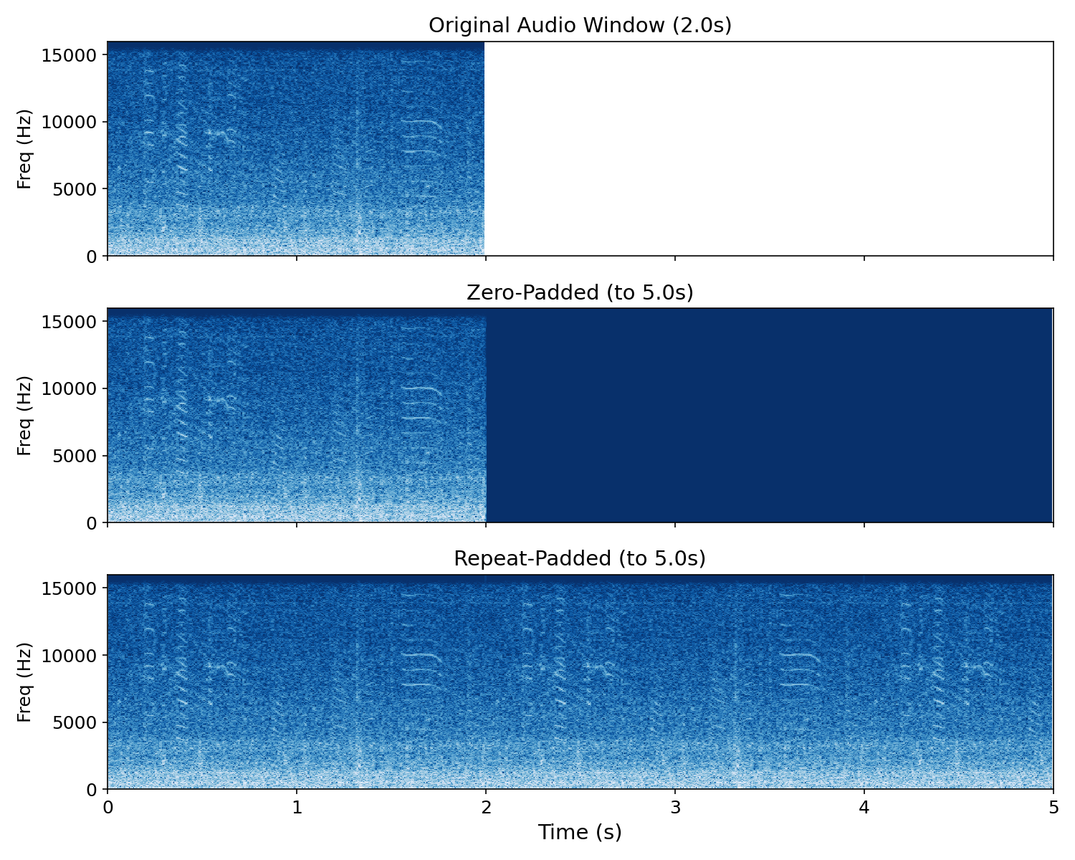
Due to Perch 2.0's strict requirement for 5-second windows, repeat and zero padding were employed and compared to embed our smaller window sizes. Zero padding has shown promise in successfully embedding smaller window sizes using the Perch 2.0 model, but may struggle on very small window sizes, so repeat padding was used as well (Williams et al., 2025).
Figure 1. Example of zero-padding and repeat-padding from 2 second window of humpback whale song into a 5 second window.

2.3 UMAP and HDBSCAN
Both Perch 2.0 and AVES-Bio output embeddings at a high dimensional space. The UMAP dimension reduction algorithm (McInnes et al., 2020) has been shown to effectively reduce the curse of dimensionality to create more meaningful distances for clustering estimations in animal vocalizations (Sainburg et al., 2020), and HDBSCAN is known to not perform well in high dimensional spaces (McInnes et al., 2017). We experimented with UMAP reductions in 5, 10, 15, 20, and 30 dimensions to find a balance between information retention and clusterability.
Due to the highly variable and non-spherical distribution of features in humpback whale song, and the debated number of song units, the density based HDBSCAN clustering algorithm was used (McInnes et al., 2017). Unlike centroid-based models like K-means that assume circular clusters, HDBSCAN clusters points into arbitrary shapes and varying densities, and dynamically determines the number of clusters without the need to state one explicitly.
We experimented with minimum cluster sizes of 50, 100, and 200 clusters, with a sliding minimum sample parameter varying between 25% and 100% of the minimum cluster size. This was done to ensure a robust sweep of clustering parameters to evaluate how strict the algorithm needed to be when drawing boundaries around units.

2.3 EVALUATION
Initial evaluations considered metrics such as ARI (Hubert and Arabie 1985), AMI (Vinh et al., 2010), and Jaccard Similarity (Niwattanakul et al., 2013). All three metrics followed similar trends as a function of window and hop size. We focused on evaluating using ARI in part to facilitate comparison with previous studies (Oppenheimer et al., 2025). Future work will further explore the best use of metrics.
Adjusted Rand Index (ARI) was used to assess model accuracy against a ground truth as two complementary, adjusted-for-chance evaluation metrics (Hubert and Arabie 1985). This Adjusted metric was chosen as standard similarity metrics, such as Rand Index (RI), monotonically increase as the number of clusters increase, creating bias when evaluating cluster-variant algorithms like HDBSCAN (Vinh et al., 2010). Instead, ARI uses a correction for chance where 0 indicates random performance. ARI calculates similarity by taking all pairs of samples, and counting the number of pairs that are aligned similarly between the manual and clustered labels.

3 RESULTS
Preliminary sweep evaluations showed that the Perch 2.0 model outperformed AVES-Bio, achieving a maximum ARI approximately 0.10 higher on the ground-truth dataset. Because of this, all subsequent analysis was done using the Perch 2.0 model.
The intrinsic clustering metric Density-Based Clustering Validation (DBCV) measures clustering quality for density-based and arbitrarily shaped clusters, like those created by HDBSCAN (Moulavi et al., 2014). DBCV was computed for all sweeps as an intrinsic measure of clustering quality. The metric was useful in discarding mathematically poor clusterings, as all configurations with high AMI had a DBCV score of above 0.2. However, beyond this baseline, it showed no meaningful correlation to the biological ground truth. Configurations that had high alignment with the ground truth had variable DBCV scores, ranging from 0.25 to 0.55. Because mathematically dense shapes measured by DBCV did not correlate with distinct biological song units, ARI against manual labels were primarily used to evaluate clustering success.
Sweeps of window and hop size resulted in an ARI range of -0.0002 to 0.6874. The highest ARI was achieved using a window size of 2.0 seconds. Smaller hop percentages generally resulted in better performance, which resulted in the optimal combo of 2.0 seconds with a hop size percentage of 25% of the window (0.5 seconds).

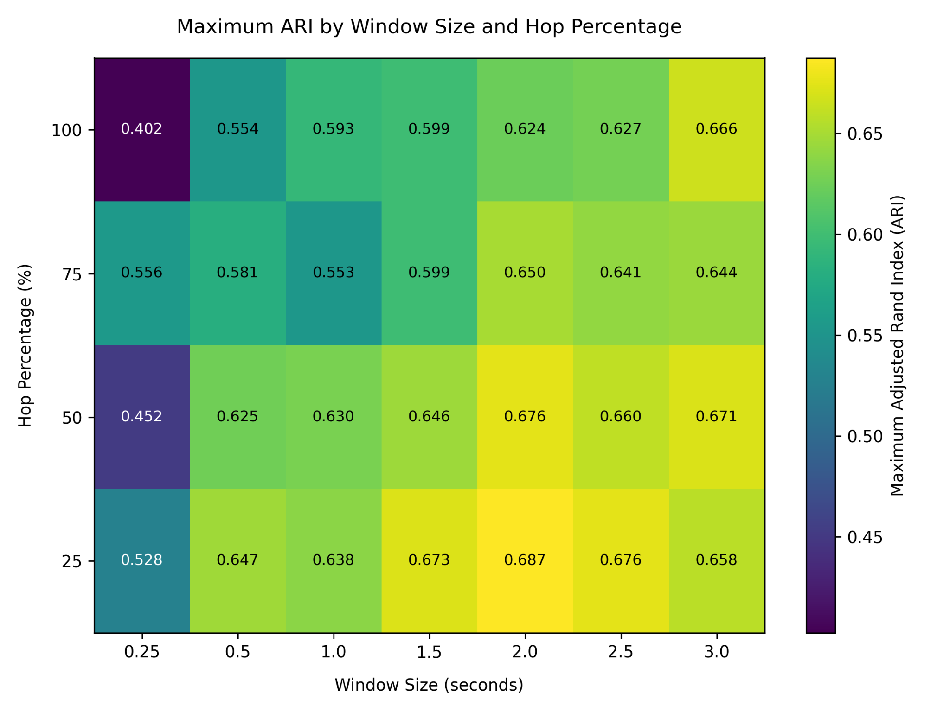
Figure 2. Heatmap of maximum ARI scores by window size and hop percentage.
To augment the window size to fit Perch 2.0’s window parameters, repeat-padding and zero-padding were tested. At smaller windows (<1.0s) repeat-padding achieved significantly higher alignment than zero-padding, improving scores by approximately 0.07, likely due to a significant amount of missing context. At larger window sizes (>2.0s), the variance between padding techniques was significantly smaller. However, highest alignment was achieved using repeat padding, which was used for the final configuration.
Temporal parameters established a clear quality baseline. UMAP dimensions and minimum cluster size sweeps created up to 0.24 variance in combined ARI scores with no clear pattern. Comprehensive sweeping of both parameters was necessary to find the optimal configuration.
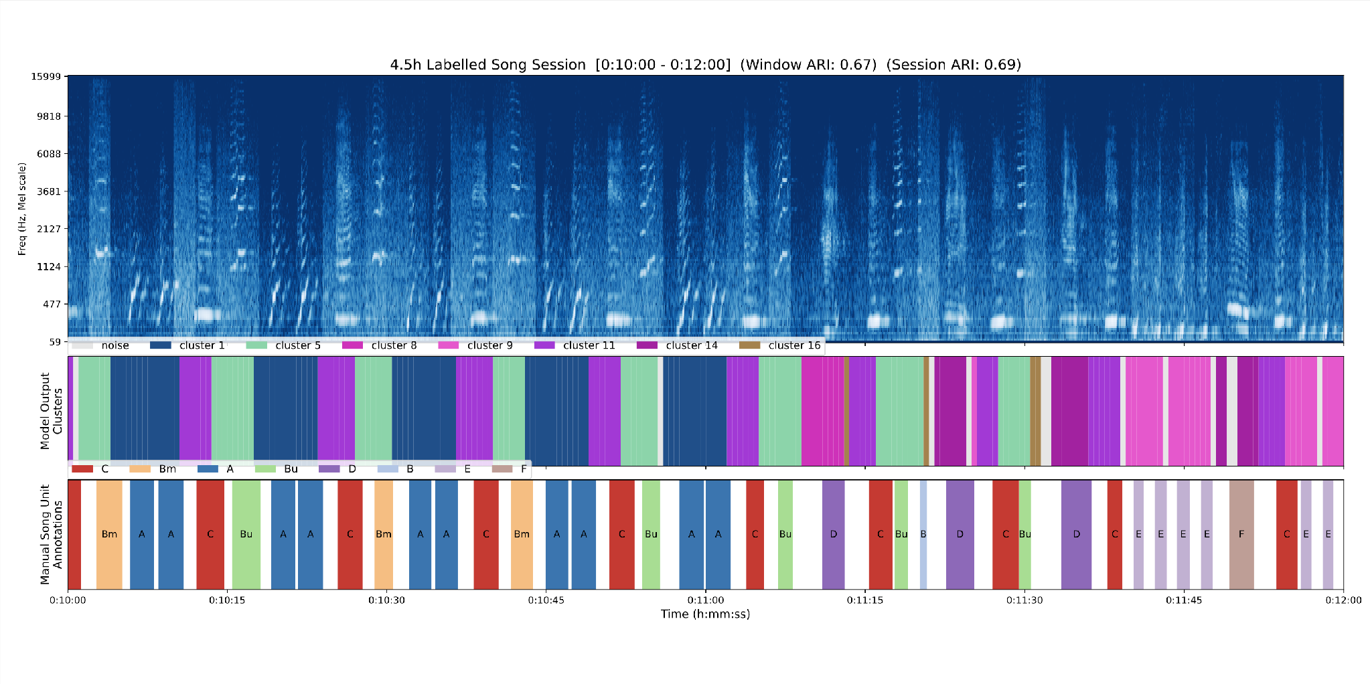
Comprehensive sweeping of the above parameters resulted in an optimal configuration with a maximum ARI score of 0.687 using repeat padding, a window size of 2.0 seconds, 25% hop percentage, compressed to 5 UMAP dimensions, and clustered with a HDBSCAN minimum cluster size of 200.
Figure 3. 2 second window of cluster model output on manually labelled 4.5 hour humpback whale song session. Top: The mel-spectrogram representation of labelled song session with 2 second per-window peak-normalization to 0.25 to match Perch's spectrogram preprocessing parameters. Middle: Displays the model's cluster assignments. Bottom: Manual song unit labels.

4 DISCUSSION
While the best model showed strong unit-level alignment, the cluster mappings struggled to perfectly represent each unit, with some noise and misalignment when strictly compared to the manual labels, which may be partly explained by labelling methodology such as excluding a call’s echo.
A notable limitation is that Perch 2.0 was unable to filter marine background noise, with parts being encoded into a distinct cluster. This is most likely because Perch 2.0 was trained primarily on terrestrial datasets. Further research is required on larger datasets to see if this noise cluster will generalize to a variety of marine background noise or generate multiple clusters that will further muddy the unit classifications.
The algorithm grouped acoustically similar manual labels, e.g. lumping Bu and Bm into a single cluster. These manual labels indicate that the sounds were fundamentally similar (B), but had distinct finer attributes (upward modulation only versus bidirectional modulation over a portion of the sound). It may be important to consider whether some units that do not have sufficient structural variance are important to distinguish between when tracking large scale thematic structure.
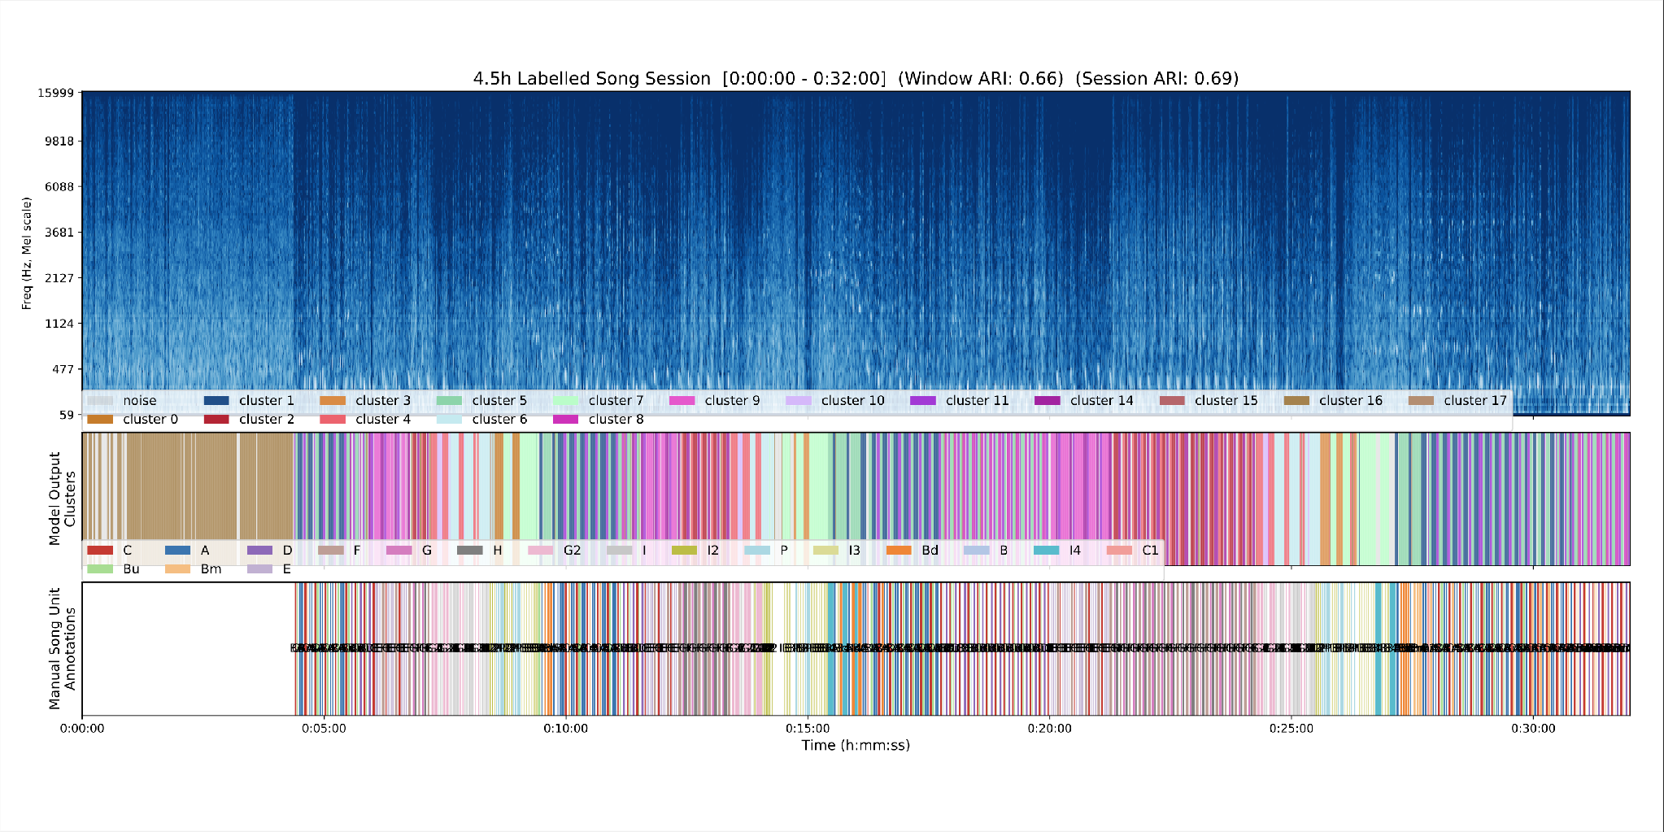
However, when looking at a larger 32 minute window of the song session, the minor misalignments and noise are smoothed out by clear thematic structure in the song represented by this unsupervised approach (Figure 4).
Figure 4. 32-second window of the same song session as Figure 3. Repeated themes created by patterns of clusters can be shown repeating. Large noise cluster (cluster 16) can also be shown before the song begins.
At this scale, the algorithmically assigned clusters are shown to repeat sequentially, which form distinct and structured themes. These themes can then be seen repeated in the same order throughout the song, with themes increasing in duration as the song continues. Because transmission of the elements of humpback whale song across populations occurs at this higher level of structure, themes, these results are promising for the longstanding goal of enabling machine learning to advance the science of cultural transmission in this acoustically exceptional species.

5 FUTURE WORK
While this experiment shows that unsupervised clustering over foundation model embeddings are capable of mapping thematic structure of humpback whale songs, it currently relies on a single continuous 4.5 hour song session for validation. Because the parameters and clusters were optimized for the ground-truth labels of this specific session, there is a risk of overfitting to its acoustic properties. Preliminary testing on separate, distinct song sessions showed that clusters generated by a single song session do not generalize well out of the box.
Future work will focus on data generalization. One possible pathway is to scale the unsupervised pipeline to include many acoustically distinct song sessions, which could converge on an extended vocabulary that is less sensitive to session specific variation and background noise. These clusters could then be validated by training a supervised classifier over those clusters, and evaluating over existing labelled song sessions.
Finally, this pipeline has been exercised on songs with a single singer. Classification and identification of song structure among multiple overlapping singers remains an open challenge.

ACKNOWLEDGEMENTS
I would like to thank Carlos Rueda and John Ryan for their incredible support throughout this program, this project would not have been possible without them. Thank you to the soundscape team, the summer interns, and the MBARI as a whole for creating a creative and welcoming environment. And lastly, thank you to George Matsumoto, Megan Bassett and Jessica Chapman for organizing the program. The MBARI Summer Internship Program is generously supported through a gift from the Dean and Helen Witter Family Fund and the Rentschler Family Fund in memory of former MBARI board member Frank Roberts (1920-2019) and by the David and Lucile Packard Foundation. Additional funding is provided by Dalio Philanthropies and the Maxwell/Hanrahan Foundation.

References:
Bagwell, C., et al. (2015). SoX - Sound eXchange (Version 14.4.2) [Computer software]. http://sox.sourceforge.net/
Burns, A., Harrell, L., van Merriënboer, B., Dumoulin, V., Hamer, J., & Denton, T. (2025). Perch 2.0 transfers' whale'to underwater tasks. arXiv preprint arXiv:2512.03219.
Garland, E. C., Goldizen, A. W., Rekdahl, M. L., Constantine, R., Garrigue, C., Hauser, N. D., ... & Noad, M. J. (2011). Dynamic horizontal cultural transmission of humpback whale song at the ocean basin scale. Current biology, 21(8), 687-691.
Gibb, R., Browning, E., Glover‐Kapfer, P., & Jones, K. E. (2019). Emerging opportunities and challenges for passive acoustics in ecological assessment and monitoring. Methods in Ecology and Evolution, 10(2), 169-185.
Hagiwara, M. (2023, June). Aves: Animal vocalization encoder based on self-supervision. In ICASSP 2023-2023 IEEE International Conference on Acoustics, Speech and Signal Processing (ICASSP) (pp. 1-5). IEEE.
Hubert, L., & Arabie, P. (1985). Comparing partitions. Journal of classification, 2(1), 193-218.
McInnes, L., Healy, J., & Melville, J. (2018). Umap: Uniform manifold approximation and projection for dimension reduction. arXiv preprint arXiv:1802.03426.
McInnes, L., Healy, J., & Astels, S. (2017). hdbscan: Hierarchical density based clustering. J. Open Source Softw., 2(11), 205.
van Merriënboer, B., Dumoulin, V., Hamer, J., Harrell, L., Burns, A., & Denton, T. (2025). Perch 2.0: The bittern lesson for bioacoustics. arXiv preprint arXiv:2508.04665.
Moulavi, D., Jaskowiak, P. A., Campello, R. J., Zimek, A., & Sander, J. (2014, April). Density-based clustering validation. In Proceedings of the 2014 SIAM international conference on data mining (pp. 839-847). Society for Industrial and Applied Mathematics.
Niwattanakul, S., Singthongchai, J., Naenudorn, E., & Wanapu, S. (2013, March). Using of Jaccard coefficient for keywords similarity. In Proceedings of the international multiconference of engineers and computer scientists (Vol. 1, No. 6, pp. 380-384).
Oppenheimer, F., Ryan, J., Cline, D., Edgington, D. (2025). Evaluating the Performance of Topic Modeling for Humpback Whale Song Phrase Segmentation. MBARI
Payne, K., & Payne, R. (1985). Large scale changes over 19 years in songs of humpback whales in Bermuda. Zeitschrift für Tierpsychologie, 68(2), 89-114.
Payne, R., & American Association for the Advancement of Science. (1983). Communication and behavior of whales. (No Title).
Payne, R. S., & McVay, S. (1971). Songs of Humpback Whales: Humpbacks emit sounds in long, predictable patterns ranging over frequencies audible to humans. Science, 173(3997), 585-597.
Rueda, C. A., & Ryan, J. P. (2020). Humpback whale song analysis based on automatic classification performance. The Journal of the Acoustical Society of America, 148(4_Supplement), 2597-2597.
Ryan, J., Cline, D., Dawe, C., McGill, P., Zhang, Y., Joseph, J., ... & Southall, B. (2016, September). New passive acoustic monitoring in Monterey bay national marine sanctuary. In OCEANS 2016 MTS/IEEE Monterey (pp. 1-8). IEEE.
Sainburg, T., Thielk, M., & Gentner, T. Q. (2020). Finding, visualizing, and quantifying latent structure across diverse animal vocal repertoires. PLoS computational biology, 16(10), e1008228.
Stowell, D. (2022). Computational bioacoustics with deep learning: a review and roadmap. PeerJ, 10, e13152.
Vinh, N. X., Epps, J., & Bailey, J. (2009, June). Information theoretic measures for clusterings comparison: is a correction for chance necessary?. In Proceedings of the 26th annual international conference on machine learning (pp. 1073-1080).
Williams, B., Van Merriënboer, B., Dumoulin, V., Hamer, J., Fleishman, A. B., McKown, M., ... & Denton, T. (2025). Using tropical reef, bird and unrelated sounds for superior transfer learning in marine bioacoustics. Philosophical Transactions of the Royal Society B: Biological Sciences, 380(1928), 20240280.
Winn, H. E., & Winn, L. K. (1978). The song of the humpback whale Megaptera novaeangliae in the West Indies. Marine Biology, 47(2), 97-114.

