Characterization of Lithium Cells for Energy Harvesting Applications

Landon Noyes, San Diego State University

Mentors: Andy Hamilton, Scott Jensen

Summer 2026

Keywords: MATLAB, Optimization, Sinusoidal waves, Impedance.

ABSTRACT
The use of lithium batteries in the ocean is a traditional choice due to performance, energy efficiency, lightweight, and durability. However, these batteries are affected by irregular current conditions in ocean deployments that can lead to unpredictable battery behavior, such as charging efficiency and degradation. This project focuses on the characterization of lithium cells, specifically Lithium Nickel Manganese Oxide, in relation to the battery in MBARI’s wave energy converter to get a concrete understanding of the reactance of these batteries in terms of battery health. As well as developing a program to allow MBARI engineers to easily calculate battery health and degradation trends using real recorded data.

INTRODUCTION
MBARI’s wave energy converter absorbs mechanical energy from the waves in the ocean and converts that energy into electrical energy that can then be used to power underwater vehicles. Acting as a charging station in the ocean that accepts waves as alternating currents and converts them to DC to power instruments. However, wave energy harvesting has remained a complex and challenging concept. In the last few centuries, the world has slowly understood and mastered the use of alternating currents and direct currents to power a range of extremely different devices, machines, etc. However, the waves in the ocean don’t move in a perfect sinusoidal wave. They are inconsistent, short, come in bursts, and, in general, extremely different from traditional power sources like generators that use rotating shafts to produce consistent, predictable current.
This irregular waveform is represented directly in recordings from MBARI’s wave energy harvester out at sea. The charge current will remain idle for extended periods of time, and inconsistent large bursts of current will flow through. Comparing this across multiple different recordings further demonstrates the differences in idle periods, gradual charge, and sudden demands. The figure below demonstrates the behavior and charging of electrical current in MBARI’s wave energy converter, reproduced through our design system.
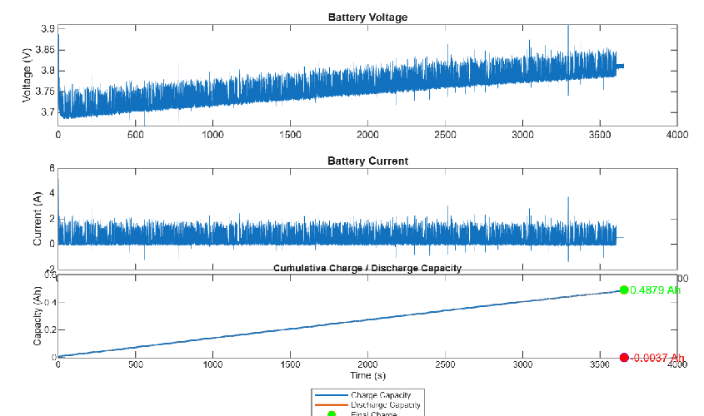
Figure 1: An hour long recording of current/voltage behavior from MBARI’ wave energy harvester commanded to a single cell lithium battery setup.

This difference in power sourcing has remained a challenge for battery efficiency, degradation, and, in general, complete understanding of the reactance and characteristics of lithium batteries in ocean conditions. While the lithium battery in this device operates under electrical current conditions that fall well outside standard battery testing assumptions, my project aims to investigate the nature of this battery through simulation in a laboratory setup.

MATERIALS AND METHODS
Design Setup

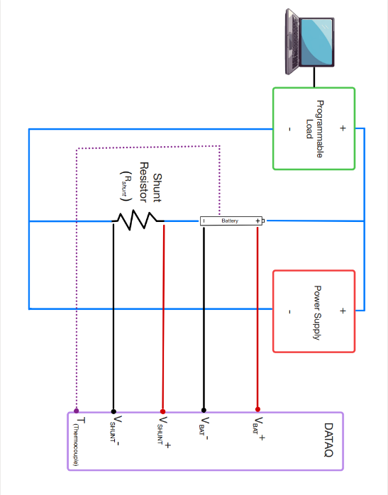
Figure 2: Physical hardware setup, using programmable load and power supply to both charge and discharge the battery, while the Data Acquisition System measures voltage, current, and temperature.

To simulate the active events of a lithium battery in MBARI’s wave energy converter, the lab design setup used a programmable load (BK Precision 8500) in parallel with a power supply and a lithium battery in series with a shunt resistor. The programmable load is useful for drawing out current from a power source in a programmable manner. This circuit emphasizes Kirchhoff’s current law in which all current going into one node (a point) is equal to zero. A shunt resistor is used to measure current through a circuit by creating a very low voltage drop across the resistor and calculating I=V/R. A data acquisition system (DATAQ) is then used to record the voltage across the battery, the voltage across the shunt to calculate current going through the battery, and a thermocouple module to measure the temperature of the battery. This setup allows the battery to be charged or discharged depending on how much electrical current the power supply is supplying and how much electrical current the programmable load demands. For example, if the power supply is 2 A and the load demands 3 A, 1 A must be discharged from the battery. If the power supply is 4 A, the battery will be charged with 1 A.

Beginning Program and Analysis
The next step was to successfully write a program in MATLAB that can send a command through the programmable load to oscillate current in the battery and be recorded as a .CSV file that can be analyzed and plotted in MATLAB later on. The program consists of using a binary packet protocol to send and receive 26-byte structured packets with specific instructions to the load, such as enabling remote control mode(BK_EnableRemote(sp,on)), and setting current (BK_SetCurrent(sp,I). A program sending oscillating current was then written to test the programmable load with alternating current, including offset, amplitude, and frequency. After running this through and recording it into a .CSV file, it is then stored in a MATLAB file that calculates battery characteristics such as impedance, temperature, discharge and charge rates, etc. From this, the I/V characteristics are plotted as well.

Maximum Frequency
To better understand the maximum frequency that the BK precision can send sinusoidal wave patterns to the battery before peaks begin to shrink significantly, a gain test to compare the expected amplitude versus the measured current is required. Gain can be characterized in decibels as 20log10(Imeasured/IExpected). This needs a sine fit regression plot to accurately calculate a consistent measurement of I and find a value that represents the amplitude of the entire length. After calculation, recording, and analysis of the output, it’s conclusive that the max frequency that the system can achieve is 3Hz. At this frequency, the amplitude slightly shrinks at times and gets increasingly distorted after this frequency. An example of this is shown below, where the current at 1Hz closely resembles the expected current while the figure at 5 Hz shows how the actual currents become steplike rather than a true sinusoidal wave. The fitted sine curve also shows that at this frequency, the current fails to reach its expected amplitude.
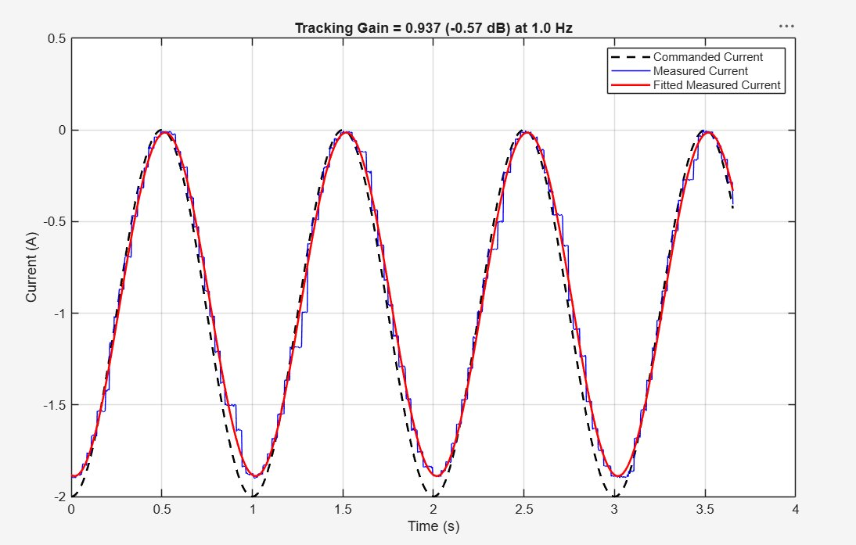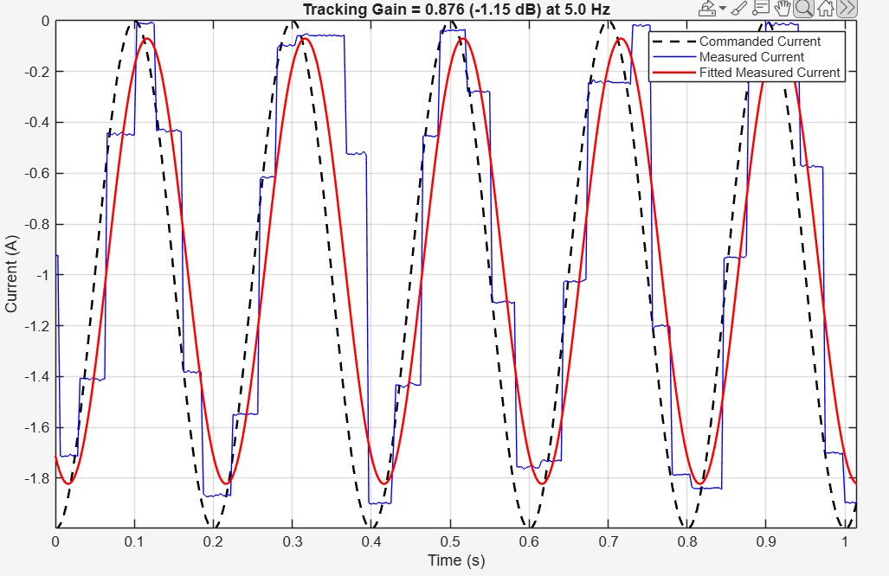
Figure 3: Oscillating electrical current at 1 Hz through the programmable load.
Figure 4: Oscillating electrical current at 5 Hz through the programmable load

After determining the maximum reliable frequency of the system to be approximately 3 Hz, this ceiling was compared against the timescales present in the field data. Ocean waves typically move in cycles spanning several seconds, corresponding to frequencies well below 3 Hz — a relationship further supported by the power spectral density analysis of the field data discussed later in this section, which shows the dominant power distribution concentrated at lower frequencies. This confirms the system can accurately reproduce the current used throughout this study and provides a validated foundation for the frequency and amplitude sweep tests, field-data reproduction, and synthetic sine wave comparisons that follow.

Frequency and Amplitude Sweep
After determining the maximum frequency using the formula for gain, a set of tests was performed to characterize this lithium cell’s impedance behavior at various amplitudes and frequencies. The first set used a constant frequency of 0.5 Hz, and the amplitude varied from [0.5,1,2,4] A with 3 different tests, offsets of -1,0, and 1. While the frequency sweep used the same three offsets, but instead amplitude was a constant 1 A while frequency varied from [0.1,0.5,1,3] Hz. Each segment lasts for 10 minutes and allows for both discharging and charging statistics of the lithium cell.
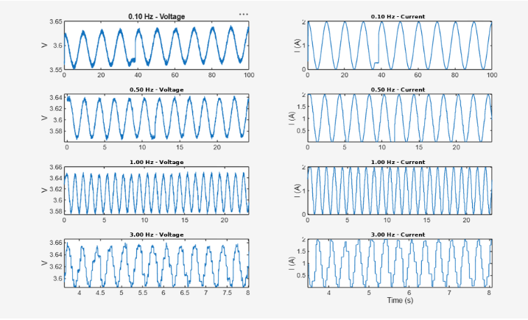
Figure 5: Series of different frequencies under oscillating current, with an amplitude of 1 A.

Simulation of Field Recording
As demonstrated in Figure 1, recorded data from MBARI’s wave energy buoy was used to simulate the charge and discharge patterns of real ocean situations into the lithium cell. Some of these files were input into MATLAB, which scanned the field values from current in a specific “PC_BattCurr” column. This electrical current was then commanded into the programmable load for the battery to be charged or discharged. After this file’s duration is over and the recording is converted into a .CSV, the breakdown of the results of each file begins. Classic battery health indicator values like capacity, energy, power, impedance, etc., are all computed, and voltage and current are plotted to visualize the behavior of the field ocean characteristics and their effect on a single lithium cell.

Generated Sine wave
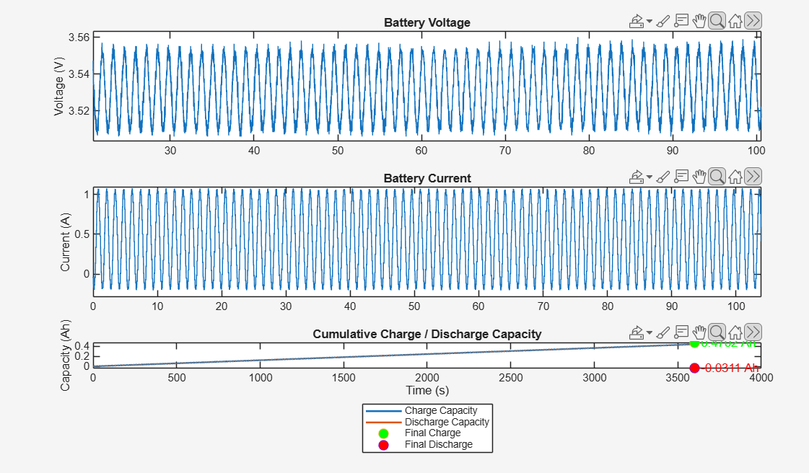
Figure 6: A synthesized sin wave of the recorded data above over a full hour.

For each field data file, a representative sine wave was produced and tested. This sine wave consists of the same RMS and mean values of electrical current as the field data, giving nearly identical values for capacity and total energy. The key parameters used to construct this synthetic wave from the field data were amplitude, offset, and frequency. The offset was set to the mean of the field data current, and the amplitude was calculated using the formula amplitude = sqrt(2*(rms_real^2 - offset^2)). Finding the frequency required computing the power spectral density of the field current and identifying its dominant peak — the frequency carrying the most power in that recording. This process was repeated across multiple field recordings, allowing the dominant frequencies identified in each to be compared against one another to check for consistency and identify a representative frequency range across different real ocean conditions, rather than relying on a single file alone. Comparing spiky, inconsistent field data against a consistent synthetic sine wave let us examine how high-stress current spikes affect resistance and battery behavior differently than smoother, continuous current. The image below shows a PSD plot and the frequencies of waves that are most active in a recording.
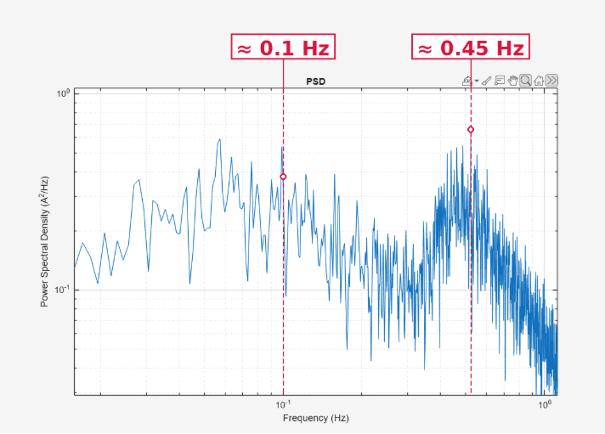

Figure 7: Power Spectral Density representation of a real recording, which is then used to find a singular frequency for a synthetic sin wave

Data Analysis
All electrical data was formulated and processed in MATLAB. Rather than the timing of the recording, time structure was defined using the sample rate on WINDAQ. Originally, the sample rate was 480 seconds. After including a thermocouple module, this changed to 320 samples per second for each of the three channels. Impedance of the field data was calculated by direct current internal resistance (DCIR). DCIR measures that if the current reaches a certain threshold, it is generalized as a spike and computes the ratio of voltage change over current change. Then computing the median of all these surges in current, giving one internal resistance value to represent the entire recording. This method for measuring resistance was chosen for the field data loaded into our lithium cell because it doesn’t require a fitted sine regression line, which is generally used to calculate impedance in a sinusoidal wave. Because this data is inconsistent and burst-like, DCIR is a more appropriate approach and still accurately represents the health trends and resistivity of the battery in the real data. The synthesized sine waves discussed earlier, by contrast, follow a periodic pattern and can be used to calculate impedance via a sine fit regression line. All battery health indicators, such as charge efficiency, total energy, and capacity, were all found using general mathematical formulas after converting the recording into a readable file that is then analyzed in MATLAB.

RESULTS

Frequency Sweep

During the frequency sweep test, impedance remained extremely steady while the impedance phase lag decreased as frequency increased. This nature differs from natural battery behavior. Generally, as frequency increases, the phase lag will increase as well. But in this scenario, we see the opposite. Prompting further exploration if this is genuine battery behavior of this lithium cell or an inaccuracy in calculation.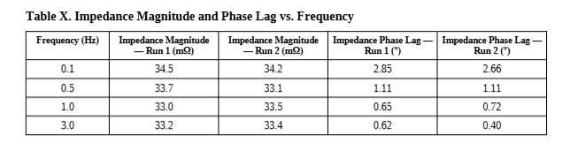
Figure 8: Frequency sweep between two separate runs with different offsets, representing identical changes in impedance phase lag while impedance remains the same

Generated Sine Wave Versus Reproduced Field Data

A comparison between one reproduced field record and a generated sinusoidal wave from 06/28/2025. A major factor this table doesn’t represent is the impedance and DCIR across all these tests, which ranged from 30-33 milliohms. A general overall resistance was found in all our tests. This is one of several comparisons between reproduced field data and a generated sinusoidal wave.

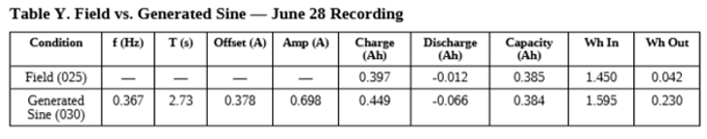
Figure 9: Reproduced field recording from June 28th compared to a generated sinusoidal wave in terms of battery health characteristics.

DISCUSSION

All three factors of the frequency sweep, amplitude sweep, and field versus synthetic comparison led to the emergence of one common feature, namely the fact that internal resistance remained stable in the range of 30-33 milliohms irrespective of the current form used to drive the cell. Whether it was a controlled sine wave at different frequencies, various amplitudes, or actual, uncontrolled current taken from the recordings done by MBARI, all resulted in resistance staying stable. The significance of this finding is that wave energy harvesting implies the production of current that changes depending on the fluctuations in the ocean itself, which is significantly different from the regular operation of a generator with constant speed, and all available information on the performance of a lithium cell typically refers to the cases when the current was steady and under control. Thus, finding out that the resistance remained stable for a wide range of current demonstrates that the characteristics of the cell are not highly sensitive to the type and speed of current that the cell receives.
Moreover, this touches on the project's aim of discovering the best operating conditions for the cell. Since the resistance didn’t change significantly with different frequencies or between the real and controlled currents, we can conclude that no current pattern is automatically easier on the cell. Instead, it seems that the cell's performance might be influenced more by factors like its charge level or how many cycles it has gone through. This project only began to explore that question, and further testing could provide clearer answers.

CONCLUSIONS/RECOMMENDATIONS
This project sets out to understand how a lithium-ion cell relevant to MBARI's wave energy converter actually responds to real ocean-driven current, and along the way, it produced a tool for continuing that work. Internal resistance stayed stable across conditions. Phase lag was harder to pin down — we couldn't confidently confirm whether it followed the trend expected from standard battery behavior and would want more data before drawing that conclusion. Comparing real deployment current against energy-matched synthetic sine waves directly using our system showed the same pattern every time: similar resistance, capacitance, and voltage behavior.
Probably the most lasting outcome of this project, though, is the MATLAB pipeline built to produce these results. It takes a recorded current file — whether from a real deployment or a bench test — and turns it directly into standard battery health numbers, without anyone needing to redo the math by hand each time. The goal is for MBARI engineers to have a consistent way to test future battery candidates under real-world conditions.
Looking ahead, the most valuable next step would be running the field and generated conditions repeatedly to see whether the efficiency differences found here actually translate into faster degradation over time — everything reported here comes from single measurements, not long-term trends.

ACKNOWLEDGEMENTS
The MBARI internship is made possible through the Dean and Helen Witter Family Fund, the Rentschler Family Fund, the David and Lucile Packard Foundation, and the Maxwell/Hanrahan Foundation. I want to thank Monterey Bay Aquarium Research Institute for making this internship an amazing experience where I could learn and grow substantially. I want to especially thank George Matsumoto and Megan Basset for the opportunity to explore other facilities, enjoy the Monterey area, and, in general, for leading the internship program. Finally, I want to thank my mentors Andy Hamilton and Scott Jensen, whose expertise, guidance, and support made this project possible.
REFERENCES
Monterey Bay Aquarium Research Institute. 2025. Wave energy converter deployment recordings. Internal dataset, unpublished.

