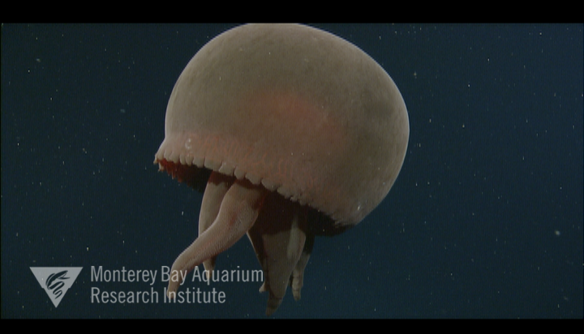
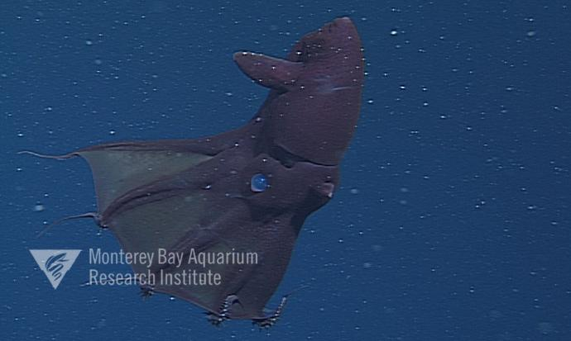
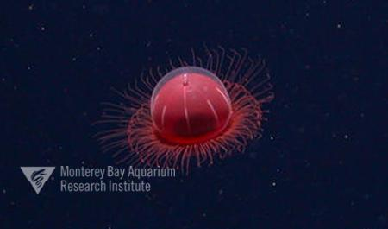
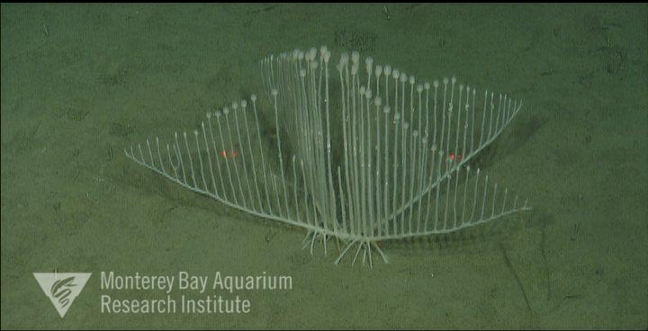
Vampire Squid Big Red

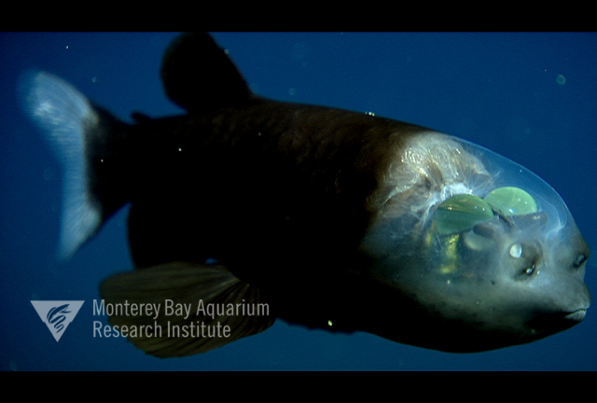
Little Red Jelly Carnivorous Sponge
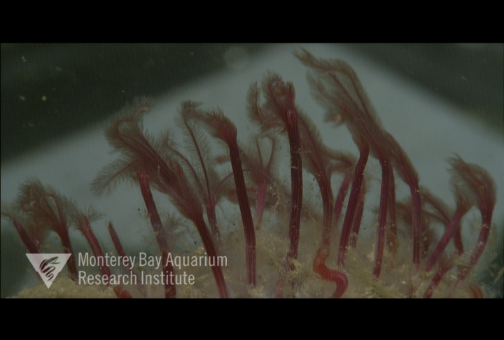
Spookfish Bone Eating Worm

Teacher Reference Page
Common Name | Scientific Name | Depth | Weblink | Data link (data products)
Vampire Squid | Vampyroteuthis infernalis | 600-800m | http://dsg.mbari.org/dsg/view/concept/Vampyroteuthis%20infernalis | http://dsg.mbari.org/dsg/plots/concept/Vampyroteuthis%20infernalis/Global
Spookfish | Macropinna microstoma | 700-900m | http://dsg.mbari.org/dsg/view/concept/Opisthoproctidae | http://dsg.mbari.org/dsg/plots/concept/Opisthoproctidae/Greater%20Monterey%20Bay
Big Red Jelly | Tiburnia granrojo | 900-1000m | http://dsg.mbari.org/dsg/view/concept/Tiburonia%20granrojo | http://dsg.mbari.org/dsg/plots/concept/Tiburonia%20granrojo/Greater%20Monterey%20Bay
bone eating worm | Osedax rubiplumus | 1800-2000m | http://dsg.mbari.org/dsg/view/concept/Osedax%20rubiplumus | http://dsg.mbari.org/dsg/plots/concept/Osedax%20rubiplumus/Greater%20Monterey%20Bay
little red jellies | Benthocodon hiatus | 2500-3000m | http://dsg.mbari.org/dsg/view/concept/Benthocodon | http://dsg.mbari.org/dsg/plots/concept/Benthocodon/Greater%20Monterey%20Bay
carnivorous sponge | Chondrocladia lyra | 3300-4000m | http://dsg.mbari.org/dsg/view/concept/Chondrocladia%20lyra | http://dsg.mbari.org/dsg/plots/concept/Chondrocladia%20lyra/Greater%20Monterey%20Bay

Jacobsen Stout, N., L. Kuhnz, L. Lundsten, B. Schlining, K. Schlining, and S. von Thun (eds.). The Deep-Sea Guide (DSG). Monterey Bay Aquarium Research Institute (MBARI). Consulted on: 2018-06-28.

