Blue Mud Shrimp Mystery Update
Jim Johnson
Summary
This lesson plan is an extension of the Blue Mud Shrimp Mystery adding information and activities on the Chronic Wasting Disease (CWD) threatening the white tail deer and elk population in Pennsylvania and other places. It will align with the Pennsylvania Academic Standards, NGSS, and the PA Game Commission environmental education public outreach program. It will be an extension of the Blue Mud Shrimp Mystery: Zombie Shrimp but will expand the aquatic version of the lesson plan to include terrestrial animals.
Students will be introduced to the Blue Mud Shrimp lesson and will then explore the CWD as it relates to the Pennsylvania deer and elk herd. Students will be exposed to the background of the disease, its risk of causing extinction of the whitetail deer and elk in Pennsylvania, and will be encouraged to conduct independent research on various aspects of the CWD program and will suggest possible actions to correct or reduce the risk of transmission.
This will incorporate STEAM concepts to the classroom and beyond using Science, Technology, Engineering, and Math. Students will study the science of the disease centering in the biology of proteins, the chemistry of isomers, the technology of measuring the deer and elk herd, the art of using English to write brochures or web site language, and the math of calculating and displaying the Disease Monitoring Areas.
An attempt will be made to update the Blue Mud Shrimp Mystery lesson by including data sets from John Chapman’s work because the BMS lesson is one of the older lessons and has not been updated in a while. Dr. Chapman was contacted to see what data sets and other information can be added.
The approach will reinforce the use of the Scientific Method talking about an observation resulting in a n hypothesis, collecting data, conducting an experiment, deriving a conclusion and then communicating the results to others.

Tags: Invasive Species; Chronic Wasting Disease; Parasites.
Standards – NGSS https://www.nextgenscience.org/search-standards?keys=invasive+species&tid_4%5B%5D=All&tid_1%5B%5D=All&tid_2%5B%5D=All&tid%5B%5D=All&=Search
For example: HS-LS2-7 Ecosystems: Interactions, Energy, and Dynamics
Students who demonstrate understanding can: Design, evaluate, and refine a solution for reducing the impacts of human activities on the environment and biodiversity.
[Clarification Statement: Examples of human activities can include urbanization, building dams, and dissemination of invasive species.]

Science and Engineering Practices

Constructing Explanations and Designing Solutions
Constructing explanations and designing solutions in 9–12 builds on K–8 experiences and progresses to explanations and designs that are supported by multiple and independent student-generated sources of evidence consistent with scientific ideas, principles, and theories.
- Design, evaluate, and refine a solution to a complex real-world problem, based on scientific knowledge, student-generated sources of evidence, prioritized criteria, and tradeoff considerations.

Disciplinary Core Ideas

LS2.C: Ecosystem Dynamics, Functioning, and Resilience
- Moreover, anthropogenic changes (induced by human activity) in the environment—including habitat destruction, pollution, introduction of invasive species, overexploitation, and climate change—can disrupt an ecosystem and threaten the survival of some species.

LS4.D: Biodiversity and Humans
- Biodiversity is increased by the formation of new species (speciation) and decreased by the loss of species (extinction). (secondary)
- Humans depend on the living world for the resources and other benefits provided by biodiversity. But human activity is also having adverse impacts on biodiversity through overpopulation, overexploitation, habitat destruction, pollution, introduction of invasive species, and climate change. Thus sustaining biodiversity so that ecosystem functioning and productivity are maintained is essential to supporting and enhancing life on Earth. Sustaining biodiversity also aids humanity by preserving landscapes of recreational or inspirational value. (secondary) (Note: This Disciplinary Core Idea is also addressed by HS-LS4-6.)

ETS1.B: Developing Possible Solutions
- When evaluating solutions it is important to take into account a range of constraints including cost, safety, reliability and aesthetics and to consider social, cultural and environmental impacts. (secondary)

Page Shot
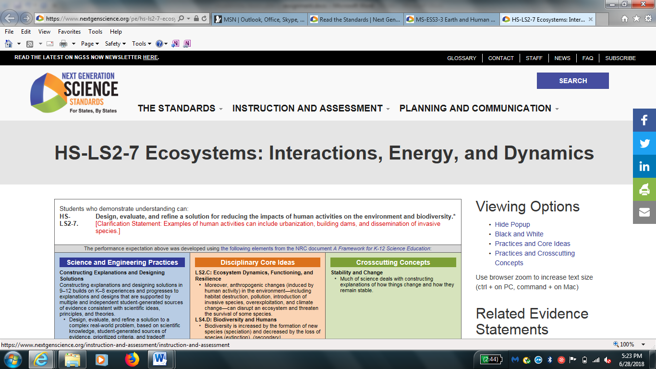
Standards – State
Teachers should verify if their state utilizes NGSS or has independent state or core academic standards.
Key Concepts
- An invasive species is a species that does not naturally occur in a specific area and whose introduction causes or is likely to cause economic or environmental harm or harm to human health
- Invasive species affect interactions within a food web and therefore have a negative effect on an ecosystem
- Invasive species impact ecosystems in a variety of ways, including ecological, genetic, economic and health
Objectives
Students will be able to:
- Hypothesize and discuss causes of shrimp population decline
- Demonstrate an understanding of food webs, and how invasive species impact them
- Communicate results by making a brochure, wanted poster or commercial
- Apply the Scientific Method to suggest possible cause and effect relationships
- Ask questions and construct explanations
- Define problems and design solutions
- Develop and use models
- Plan and carry out investigations
- Analyze and interpret data
- Use mathematics and computational thinking
- Engage in argument from evidence
- Obtain, evaluate, and communicate information
Materials
- Powerpoint from teacher (and PDF) for students on overview.
- Letter from Fisherman
- Blue Mud Shrimp PowerPoint presentation
- Blue Mud Shrimp Mystery Notebook Entry Worksheet or science notebooks
- Blue Mud Shrimp Mystery Mini Project with Rubric
- Poster Blank
- Data Sets on Blue Mud Shrimp from Dr. John Chapman Mud Shrimp data set
- Student Instruction Sheet for measuring and importing data to spreadsheets Mud Shrimp Lab data sheets
- Student Worksheets for manually entering data for spreadsheets.
Procedure
- Have students read letter from fisherman.
- Have individual students hypothesize in science notebook what they think could have caused the shrimp population to decline.
- Have students meet with a partner to discuss their hypotheses.
- Have partners share their hypotheses with the class.
- Teacher presentation of Blue Mud Shrimp PowerPoint.
- Hands on activity showing measurement of shrimp (or crayfish).
- Have students complete Notebook Entry Worksheet and enter into spreadsheet. Show results in graphic form, either individually or in pairs.
- Students will then work in small groups to research an additional invasive species or and complete mini project: brochure, “Wanted” poster, or commercial. (Suggestion: Chronic Wasting Disease as a condition potentially caused by an invasive species affecting protein structure.)
- Include the step-by-step procedure for completing the lesson

Assessment
- Product— Students create a Brochure, Wanted Poster, or a Commercial
- Performance—Did student participate in class discussion? Did student successfully complete worksheet/notebook entry questions? Did student successfully complete mini project?
- Formative assessments—Did student actively participate in all activities? Note some or all areas in which addition reinforcement or reteaching may be necessary.

- Summative assessments—Did student groups successfully create a product and/or contribute to the group activities. Teacher checklist will be used to document individual effort. Did data represent a realistic set of observation?

- Assessment Rubrics aligned with your school practices or classroom expectations.
Additional Resources
Please list any websites, books, publications, or other resources that would be helpful for teachers or students preparing for this lesson.
- https://www.mbari.org/blue-mud-shrimp-mystery/
- John Chapman: Saving the native shrimp Upogebia pugettensis from the introduced parasite Orthione griffenis
- Native Shrimp Once Killed With Pesticides Now At Risk From Invasive Parasite
- Mud Shrimp data set
- Mud Shrimp Lab data sheets
- PA Game Commission
www.pgc.pa.gov/Wildlife-RelatedDiseases/Pages/ChronicWastingDisease
- Chronic Wasting Disease Alliance www.cwd-info.org
Extensions or adaptations
List any adaptations to the lesson that will make it more accessible to a wider audience, or any extensions that will move the lesson beyond initial understanding or experience.
Pillbugs/Sowbugs https://leafpacknetwork.org/

Dichotomous Key http://www.fishandboat.com/LearningCenter/Documents/pondstream.pdf

BBC Cordyceps Zombie Ants
https://www.youtube.com/watch?v=XuKjBIBBAL8
Chronic Wasting Disease
http://www.pgc.pa.gov/Wildlife/Wildlife-RelatedDiseases/Pages/ChronicWastingDisease.aspx

