EXPLORE…Ocean Acidification, Changes in Seaside…
8th Grade Science
Ms. Forman
Name:____________________________ P:______ Date:____________
Objective: Students will be able to plan and carry out an investigation regarding the chemistry of our local ocean.
Instructions:
- Watch the background video, complete the notes
- Collect our first data set (we will collect in the fall, winter, spring and summer)
- Analyze and Interpret Pacific Coast Data that we already have access to
- Use mathematics and graphs to interpret data
- Make some observations, construct some explanations based on the data.
- FINALLY, create a question and hypothesis for our own investigation.

Background:
- Watch the video “Demystifying Ocean Acidification and Biodiversity Impacts”, and complete the video notes below…
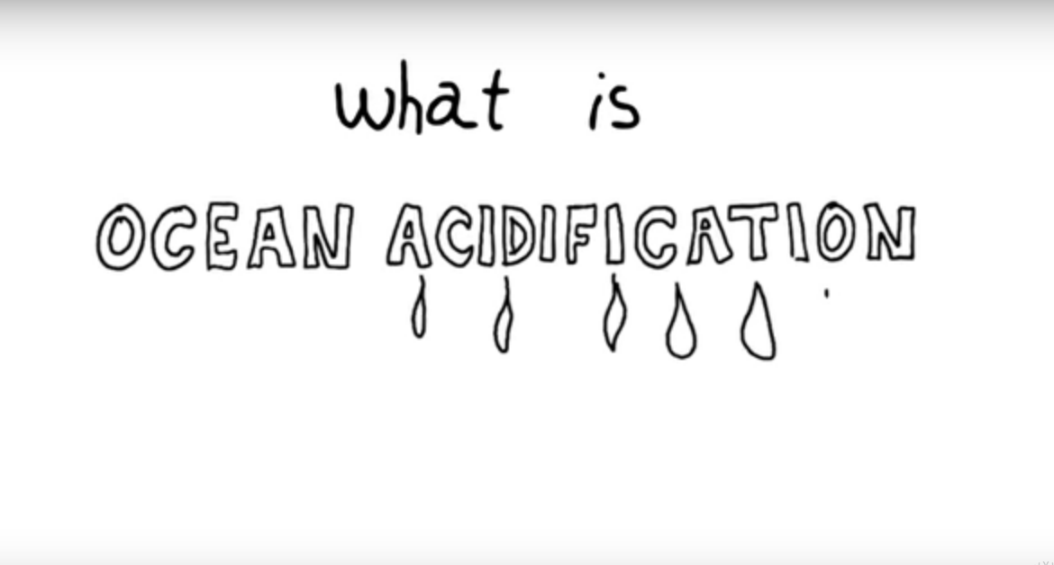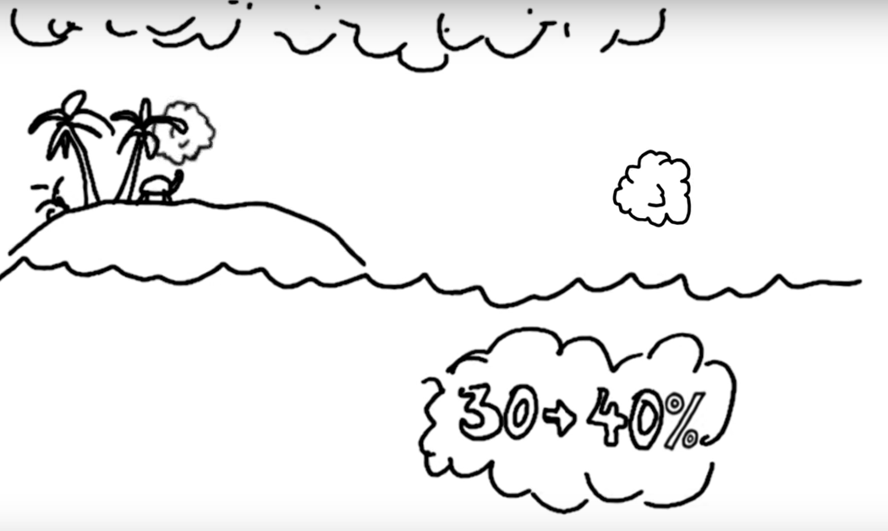
https://www.calacademy.org/explore-science/demystifying-ocean-acidification
Notes from Video:
Basics of CO2 Emissions and Effects: | pH Scale:
1. Of the CO2 created by humans, ____-_____% (almost half), dissolves in the ________.  2. The rest stays in the ___________________, OR it’s incorporated into other living things.  3. The added CO2 causes an increase in ________________________.  4. We measure acidity by using ______. | 1. The pH scale goes from ____ to ____.  2. 0=highly _______________  3. 14= highly _______________ (also known as highly _____________)  4. A pH of 7 is ______________________.  5. An increase of ACIDITY means the number scale is going _______________.  6. An increase of ALKALINITY means the number scale is going ___________.  7. Logarithmic means that the scale changes by factors of ____.  8. That means, a change in one step on the scale is _____X, a change in two steps on the scale is _______X.  9. The P stands for _________________.  10. The H stands for _________________.
Carbon in Seawater: | pH Levels:
1. Between 1751 and 1990s, ocean acidification increase from 8.25 to 8.14, that’s a ______% hydrogen ion concentration increase in the ocean.  2. CO2 plus H2O leads to _________________ acid.  3. An increase in hydrogen ions leads to an __________________ in ocean acidity. That’s the ________ point! | 1. It’s not that the pH levels are changing, it’s that they’re changing ________________ than ever!  2. According to geologic history, biodiversity can be ________________ by increased ocean acidity.  3. Drops in pH can cause destruction of ______________, by triggering chemical reactions.
Calcium Carbonate: | Foramanifera and Coccolithofor:
1. Many organisms in the ocean use a special building material called ______________ carbonate.  2. Corals, mollusks and _____________ use calcium carbonate.  3. Unfortunately, due to ocean acidification, calcium carbonate is being _____________ (this means it is disappearing).  4. No calcium carbonate means that creatures can’t grow or repair their _____skeletons. | 1. Forams help create _____________, but are deeply affected by ocean _______ levels.  2. Coccolithophores are ___________-celled algae that are important for feeding phytoplankton (and phytoplankton feed many larger ocean organisms!!)  3. Less coccolithophores may mean that global warming gets ____________.
Increased CO2 effects on larger organisms: | Change in Ocean Chemistry:
1. Increased CO2 above a tank can lead to dissolving of the exoskeletons of ____________, crabs, or _______ stars.  2. Increase CO2 can also lead to something called hypercapnia, that messes with the ____________ systems of fish and squids. | 1. Organisms that use echolocation may be impacted because increased CO2 means more ocean ______________.  2. Acidic environments can interfere with the construction of ear _________ and balance _____________.
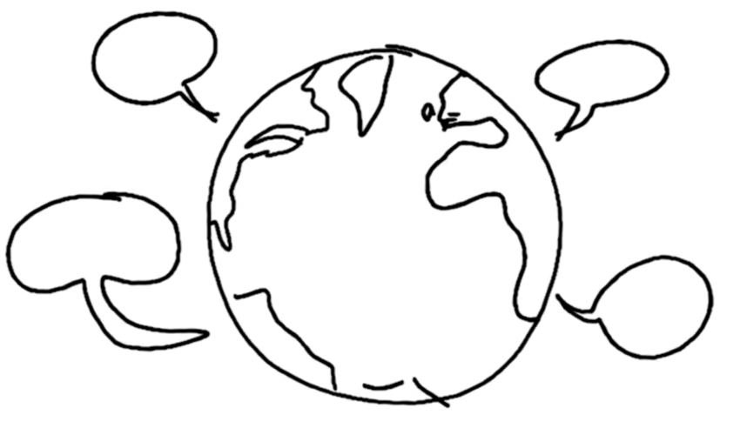
Ocean acidification is a global problem, which needs global solutions.
Some solutions to lower YOUR OWN contribution of CO2 include:
1. Eat less meat (meat production releases carbon)
2. Drive less (this is the number one driver!)
3. Reduce or stop using plastics (creating plastics releases carbon)
4. Buy less STUFF!! No more dollar store! (Production of anything means CO2 release)

2. So, WE LIVE ON THE OCEAN!!!

Does this make you a little bit curious about what the levels might be on OUR COAST!?
How are __________ impacted?
How are __________ impacted?

3. Let’s collect some data. Ms. Forman will describe how to use the Vernier probes. Please listen carefully
#3
#2
#1
Site #1, Seaside Beach
Date:  (04-21-1988) | Time:  (0930) | Temperature of Water: (°C) | pH of Water:  (# to the nearest tenth) | Salinity:  (ppt) | General Observations:

Site #2, Necanicum River
Date:  (04-21-1988) | Time:  (0930) | Temperature of Water: (°C) | pH of Water:  (# to the nearest tenth) | Salinity:  (ppt) | General Observations:

Site #3, Neawanna Creek
Date:  (04-21-1988) | Time:  (0930) | Temperature of Water: (°C) | pH of Water:  (# to the nearest tenth) | Salinity:  (ppt) | General Observations:

4. When you get back to the classroom, choose one person from your group to enter your data into the class data sheet (on G. Classroom)

5. In the meantime, let’s look at some data gathered locally…calculate the mean and find the range.
Date | pHround | Date | pHround
11-Oct-2017 | 8 | 21-Oct-2017 | 7.9
11-Oct-2017 | 7.8 | 21-Oct-2017 | 7.9
12-Oct-2017 | 7.9 | 22-Oct-2017 | 7.9
12-Oct-2017 | 7.7 | 22-Oct-2017 | 7.9
13-Oct-2017 | 8 | 23-Oct-2017 | 8.1
13-Oct-2017 | 7.6 | 23-Oct-2017 | 7.7
14-Oct-2017 | 8.1 | 24-Oct-2017 | 7.9
14-Oct-2017 | 7.6 | 24-Oct-2017 | 7.7
15-Oct-2017 | 8.3 | 25-Oct-2017 | 7.8
15-Oct-2017 | 7.8 | 25-Oct-2017 | 7.8
16-Oct-2017 | 7.6 | 26-Oct-2017 | 7.7
16-Oct-2017 | 7.8 | 26-Oct-2017 | 7.4
Average (mean) |  | Average (mean)
Range |  | Range

6. Graph it…plot your points and connect them with a trend line. USE A RULER.
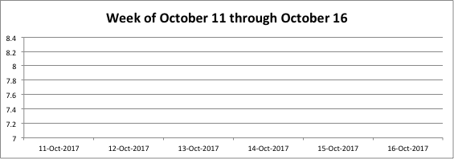
7. Make some observations.
In one complete sentence, describe what happens to the pH levels during the first week? | In one complete sentence, describe what happens to the pH levels during the second week? | In one complete sentence, describe the change in the pattern of pH level changes.

8. Stability and Change…Cause and Effect…
- In the first week there was a stability in the levels… agree disagree

- In the second week there was a change in the pH level pattern… agree disagree

I can tell you right now, that the scientist who presented these data DID NOT KNOW why this happened, but she had a theory…do YOU have a theory?
Potential Cause:

Effect:

9. Question and Hypothesis…
We are located just south of the mouth of the Necanicum and Neawanna rivers. We will be conducting this data collection during October, December, March and June. The LAST thing you will do today is to ask a question, and create a hypothesis for what you think will happen with levels throughout the seasons.
Question: | Hypothesis:

