Name: _____________________________

Draw at least two deep sea organisms the ROV’s captured on video.
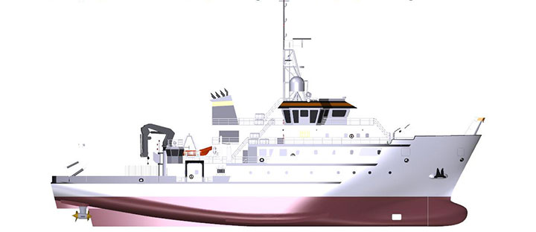
Copyright ©2018
Oregon State University

