CLASSWORK – OCEAN ACIDIFICATION – AP ENVIRONMENTAL SCIENCE

Name: Teacher Version Period: Date:

1. Background Information: Briefly review your notes on climate change and ocean acidification.
What is ocean acidification?
Rising atmospheric CO2 levels are not only increasing global temperatures, but as the ocean absorbs more of this CO2 it is changing the chemistry of the seawater, a process called ocean acidification (OA). International experts define ocean acidification (OA) as a decrease in ocean pH over decades or more that is caused primarily by uptake of CO2 from the atmosphere.
Because modern human activities (especially burning of fossil fuels) release more CO2 into the atmosphere, the ocean is taking up CO2 faster today than it has in the past. Many marine organisms are very sensitive to either direct or indirect effects of the change in acidity (H+ concentration) in the marine environment. Physiological processes such as respiration, calcification (shell/skeleton building), photosynthesis, and reproduction are affected by changes in CO2 concentrations in seawater - along with the resultant changes in pH and carbonate ion concentrations - that are expected over the next century.
As carbon dioxide dissolves into seawater, it creates carbonic acid. Through a series of chemical reactions, carbonic acid releases hydrogen ions - which decreases seawater pH, and decreases the concentration of carbonate ions - which provide chemical building blocks for marine organisms’ shells and skeletons.
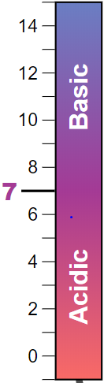
2. Make sure you understand the pH scale. If you do not remember how the pH scale works, use this link to view a simulation.
“Acidity” is the concentration of hydrogen ions (H+) in a liquid, and pH is the scale on which this concentration is generally measured. The amount of hydrogen ions in a liquid determines how acidic the liquid is.
3. Look up ocean pH values using at least 3 worldwide ocean buoys (floating devices that are anchored in the ocean and used for science or navigation). Create a simple table from the data resources below and show the name of the buoy, the general location, date, and pH value.

Name of Buoy | General Location | Date of Reading | pH value
GOM | Gulf of Maine | 3/11/2018 | 7.92
Answers will vary. Advise students to use recent data. If see -999 that is an error code (no reading). Some buoys will not have pH data.
Data Resources:
- NOAA Data Portal: https://www.pmel.noaa.gov/co2/map/index
- Mooring Data Viewer: https://www.nodc.noaa.gov/oads/stewardship/mooring_table.html

4. Analyze pH measurements taken from an oceanic research cruise in the Gulf of Mexico.
- Browse. Take 5 minutes to browse the information on the NOAA (National Oceanic & Atmospheric Administration) ocean science cruise from 2012 (GOMECC-2). This is a good example of scientists (and college students!) doing research. You might choose to watch the video or read a blog.
- Download data. Click CRUISE DATA DISCREET SURFACE SAMPLES. Download the Excel file of measurements directly taken from seawater samples while the ship was underway conducting research.
- Locate and highlight the column on pH readings taken from ocean water samples.
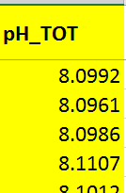
- Calculate the mean, median, and mode for pH readings taken on this cruise from surface water samples. Measures of central tendency—mean, median, and mode—can help you capture, with a single number, what is typical of a data set. Make sure students download the correct data set. Ensure they highlight the correct column (see Excel teacher template attached). Although you can calculate average with the Average Function, you may wish to have students calculate the median manually to reinforce basic math skills. Follow the directions in the reference (lesson plan) to calculate median and note that is helpful to first sort pH column from small to large values first. Also be careful that row numbers are 1=2 and so forth since the 1st row is a header. This is good practice for students to become familiar with the basics of spreadsheets.
- The mean is the average value of all the data in the set.
Average = 8.09

The median is the middle value in a data set that has been arranged in numerical order so that exactly half the data is above the median and half is below it.

Median = 8.09
e) Graph the data set. Highlight the pH values in the column, and then select the INSERT LINE from the graphing function in Excel. Label your graph. How much did the pH change in August Gulf of Mexico readings? pH changed (increased) by 0.18. Remember short term fluctuations are normal as pH in influenced by many factors (chart below will show long-term trends).
5. Analyze the graph below and answer the following questions.
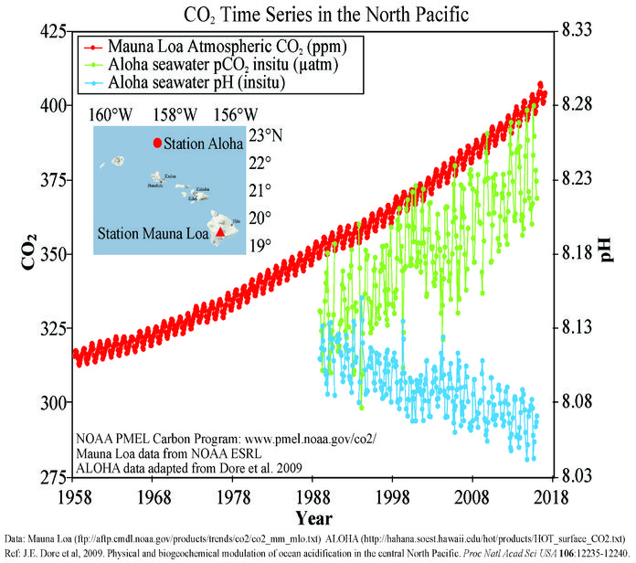
6. Name the 3 variables being measured. Atmospheric CO2, dissolved (ocean) CO2, seawater pH
7. Are CO₂ concentrations fluctuating (changing) each year, or are they the same each year?
Fluctuating over short term (within a year).
8. Regardless of fluctuations each year, this graph clearly shows the overall longer-term trend of each of the 3 variables being measured. What are the overall trends for CO₂ (atmosphere), CO₂ (dissolved in seawater), and pH (of seawater) – are they increasing, decreasing, or staying about the same?
CO₂ (atmospheric) trend | Upward/increasing
CO₂ in situ (dissolved in seawater) trend | Upward/increasing
pH (seawater) trend | Upward/increasing
9. Briefly describe, in your own words, how atmospheric CO₂ and ocean pH levels are related. Be specific.
As atmospheric CO₂ increases from human activities (notably burning of fossil fuels), oceans take up about 25% of that additional anthropogenic atmospheric CO_{2.} (carbon sink). Dissolved CO₂ reacts with H20 to form carbonic acid, increasing the acidity (lowering pH) over time in the oceans. The graph shows this trend with data since about 1988. Technically, the graph does not show cause and effect. However, according to the latest science and evidence, pH decreases gradually over time are the result of increased atmospheric CO_{2.}
10. When taking measurements of CO₂ and pH, natural (not anthropogenic) factors also influence data readings over smaller periods of time such as month-to-month, different seasons, and different geographical locations on the Earth. Why might pH values be different at different times of year in the same area of the Gulf of Mexico?
Photosynthesis, respiration and decomposition – and any process which affects dissolved CO₂ levels - contribute to pH fluctuations in water. In addition, temperature affects pH measurements, but not the actual pH of the water (reference). Additional answers might include upwelling/current fluctuations, freshwater fluctuations including seasonal melting snow/ice, etc.
11. There are both natural and anthropogenic (man-made) sources of CO₂ being added to the atmosphere. The largest source of anthropogenic CO₂ comes from burning fossil fuels. Many states have renewable energy goals to switch energy production away from fossil fuels. Make a claim and predict what will happen to ocean pH if the U.S. produces 50% of its energy from renewable energy (not fossil fuel) sources by 2050. Use evidence and reasoning to support your answer. Use additional sheet of paper if needed.
- CLAIM that ocean pH will . . . decrease over time since there are less fossil fuels releasing CO2 during combustion, which means oceans take up relatively less CO2
- EVIDENCE from data that support my claim are . . . data trends in graph show CO2 levels increasing and ocean pH decreasing. If the former influences the latter, then we expect pH levels to increase over time as the result of less oceanic uptake of atmospheric CO2 (returning to prior historic levels).
- REASONING that my claim is valid is because (“how” this works – use one external source of information to support your reasoning and cite your source).
Answers and sources will vary depending on source. Make sure that sources are reputable and lend direct evidence to claim, and that the relationship between atmospheric CO2, seawater CO2 and ocean pH is clear.
12. Environmental Impacts. Read this NOAA discussion on environmental impacts from ocean acidification and describe, in your own words, one current environmental impact that will likely get worse over time if CO₂ concentrations continue to rise globally. You might choose to discuss impacts on pteropods, shellfish, or coral.

Answers will vary. See website for model explanations.

Adapted from Cooley, S., Mathis, J., Yates, K, and Turley, C. eds. Frequently Asked Questions about Ocean Acidification. U.S. Ocean Carbon and Biogeochemistry Program and the UK Ocean Acidification Research Programme. Version 2. 24 September 2012. www.whoi.edu/OCB-OA/FAQs
PhET Interactive Simulations. University of Colorado, Boulder, 2015. https://phet.colorado.edu/sims/html/ph-scale-basics/latest/ph-scale-basics_en.html.
Image: NOAA, PMEL Carbon Program https://www.pmel.noaa.gov/co2/file/Hawaii+Carbon+Dioxide+Time-Series

