Making and Interpreting Climographs
Max Wei, Andrew Czerny, Mark Tretter; EARTH COES
Summary
This will be a three part lesson.
Initially, we will provide an introduction on climographs and how to make one. Data will be provided. Next, students will be asked to compare graphs from two locations that differ by only one variable (distance from an ocean) In Part 3, we will compare the long term changes (if any) over time in the climate of one location.
[TAGS: Climate Change, Analyzing and Interpreting Graphs, Art, Human Impact.]
Key Concepts
- Constructing a climograph
- Interpreting climographs
- Climate
- Temperature change over time
Objectives
Students will be able to:
- Identify graph types and relate graph type to the data set.
- Demonstrate the ability to create a climograph from a dataset
- Analyze difference in trends between graphs
- Apply knowledge of climate patterns to understand change in climate over time
Procedure
- Introduce students to climographs
- Provide data set for students to make the graphs (Monterey and St. Louis, MO)
- Find a location that differs by only one variable from the initial location
- Have students look over the two climographs and recognize important differences and trends
- Choose one location and look at graph to compare over longer periods of time(ex: 1980-2000, 2010-2017)
- Ask open-ended questions in order to incorporate concepts such as climate change, human effects, global warming

Assessment
- Students will demonstrate the ability to transform data sets into visually appealing climographs
- Students will produce answers or questions as to why there are or are not any differences between graphs.
Additional Resources
- https://www.ncdc.noaa.gov/cag/time-series/us
- https://www.climate.gov/news-features/event-tracker/where-oh-where-has-alaska%E2%80%99s-winter-gone
- https://en.climate-data.org/

Part 1- Introduction to Climographs

Directions: On the blank set of axes provided below, construct a climograph with the data set given.
- Label the x- axis jan, feb, etc.
- Label the left y-axis “temperature in degrees Celsius”.
- Label the right y-axis “rainfall in milliimeters”.
- Plot temperature using a line graph.
- Plot rainfall as a bar graph.

Data for Monterey, CA
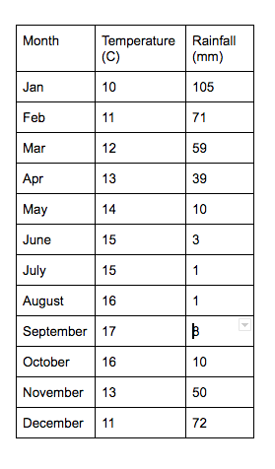

Part 2- Comparison of two different locations

Climograph for St. Louis, MO
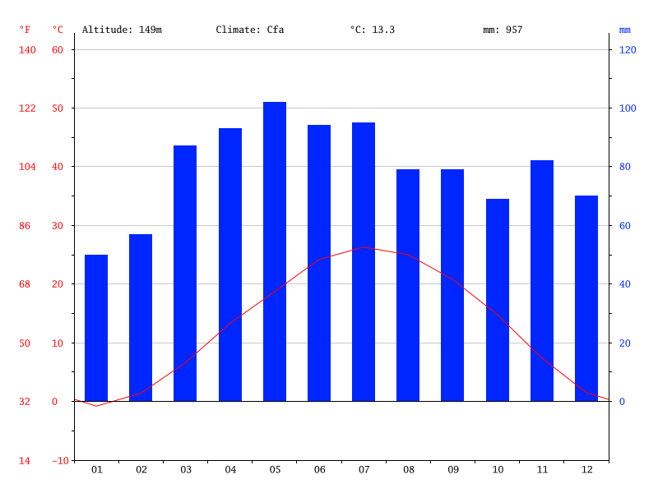

Questions:

- Approximately how many inches of rainfall did Monterey receive in June?_______

2. What was the approximate temperature in January in St. Louis?_____

3. Which location has a greater range of temperatures? Which location has a greater range of rainfall?

4. Give some reasons why there are significant differences in temperature and/or precipitation patterns between the two cities?

Part 3 - Climograph comparison, then and now

Below are historical / recent climographs for Anchorage, Alaska and Hilo, Hawaii.

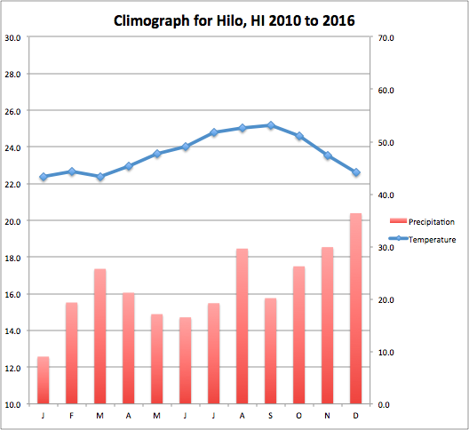
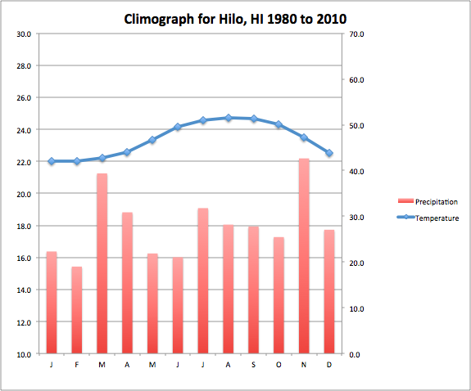

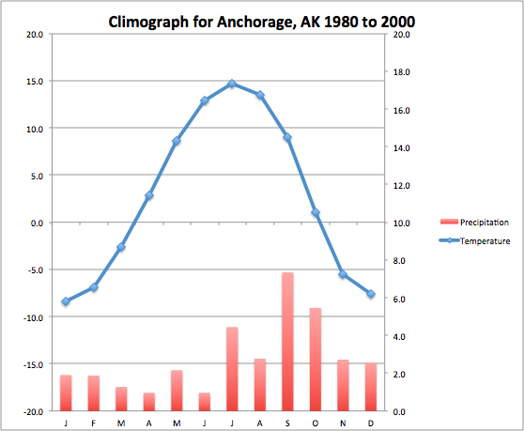
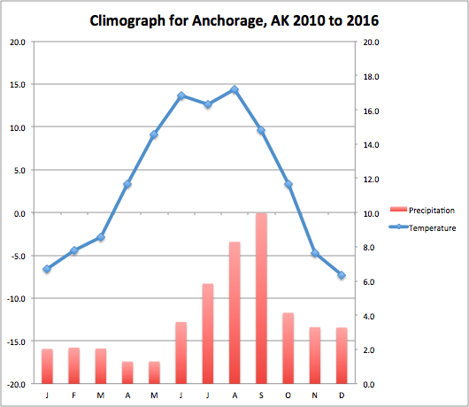

Questions:

- For what range of years is the “historical” climograph data? ____________
- For what range of years is the “recent” climograph data?____________
- Comparing the temperatures throughout the year in Anchorage, what conclusion can you make about the change in average temperatures when comparing historical and recent data? Roughly how many degrees (include units)?

- Comparing the temperatures throughout the year in Hilo, what conclusion can you make about the change in average temperatures when comparing historical and recent data? Roughly how many degrees?

- Comparing the precipitation trends throughout the years in Anchorage, what changes do you note when comparing historical and recent data?

- Comparing the precipitation trends throughout the years in Hilo, what changes do you note when comparing historical and recent data?

Teacher notes:
- When students are done with part one (completing the climograph themselves), hand out part two of the worksheet. Use both the handmade and given climograph to answer the questions. When ready, hand out part three.
- For Part 3: You may edit this word document (not the pdf, though) and include replacement cities for Hilo and Anchorage to suit your needs, should you wish. You will need to compile the data yourself to make new climographs for your desired cities. You can do this yourself, or using the instructions that follow, have your students compile the data and make their own climographs either by hand or in a spreadsheet document such as Excel.

Instructions for compiling climograph data across a specified range of years for a given location in the US. (Note: this is a bit tedious….)

- Go to the following webpage: https://www.ncdc.noaa.gov/cag/time-series/us

2. For temperature data, input the following in the drop down boxes:
Parameter: Temperature
Time Scale: One month
Month: January
Start year: (your choice)
End year: (your choice)
State / Region: (Your choice)
City: (Your choice)

3. In the “Options” box just to the right, you need to repeat the year range you desire. Check the box “Display Base Period” and input the same year range as you selected above.

4. You are ready to display the graph. Click “Plot”.

A graph will appear, and at the top of the graph, just under the title, the average precipitation value for the month is displayed. Record that value on a piece of paper or in a spreadsheet for the month “January”.

Repeat the above process, changing the “month” to February. Click “Plot”. Record the average.

Repeat for every month of the year.

Change parameter to “precipitation” to get average values for each month, as above.

Data and graphs for Hilo and Anchorage comparison.

https://docs.google.com/a/stevensonschool.org/spreadsheets/d/1fAUHqbntKxI_picvkZN6FdgEfBQIAnABhg9m1bfLEGI/edit?usp=sharing

