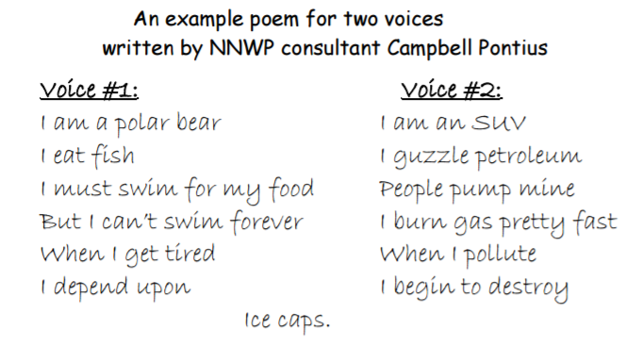
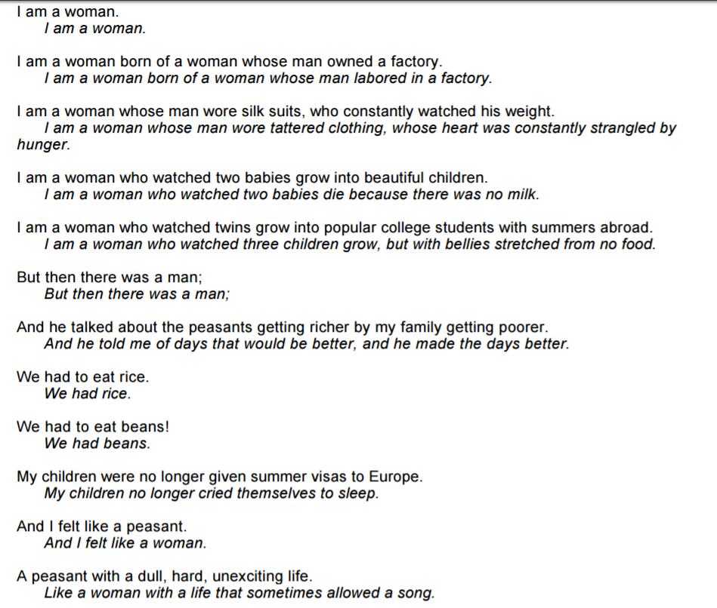
http://carla.umn.edu/cobaltt/lessonplans/attachments/139/poem.pdf

