Name ____________________________________ Bathymetry Importance Intro Spring 2017
Before Day 1 (H/W)
Why should we care about bathymetry? Go to the four sites below and jot down some reasons that knowing bathymetry is important (all links are also on BB)
- http://www.iho.int/srv1/?option=com_content&view=article&id=300&Itemid=744 (you just need to read the first paragraph)
- http://www.marine-conservation.org/media/shining_sea/theme_oceanography.htm (two paragraphs to read and then you could click on a specific area)
- http://oceanservice.noaa.gov/facts/bathymetry.html (just a about ten sentences)
- http://oceanservice.noaa.gov/education/seafloor-mapping/welcome.html (it’s a bit juvenile). Click through the interactive (don’t forget to read the Did You Know sections too). Jot some notes down as you run through it:

Tomorrow I will put you in groups and have you jot down all of your combined reasons on separate notecards.

DAY 2 NOTES
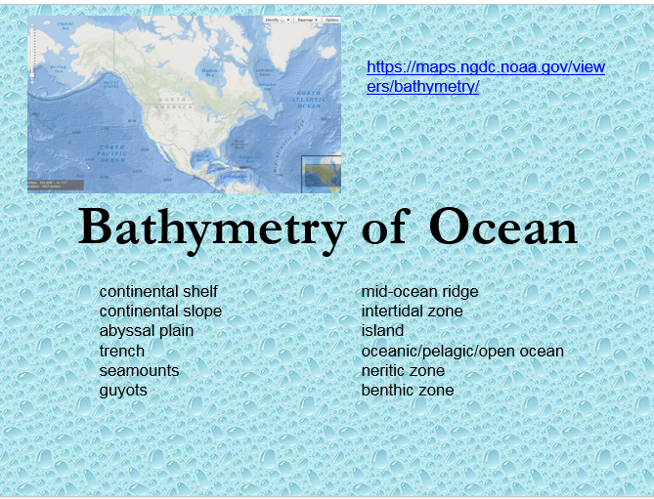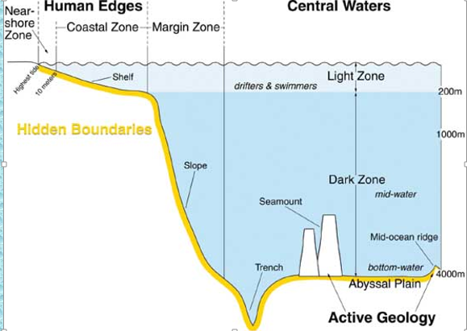

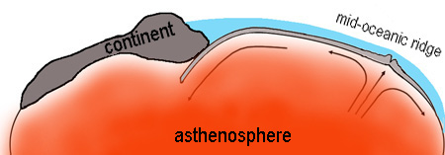

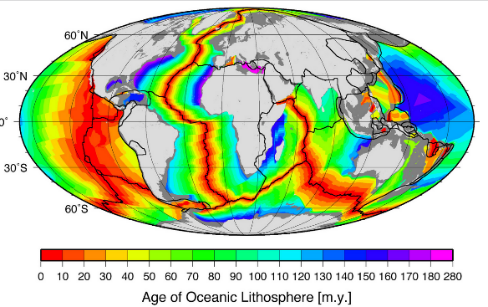

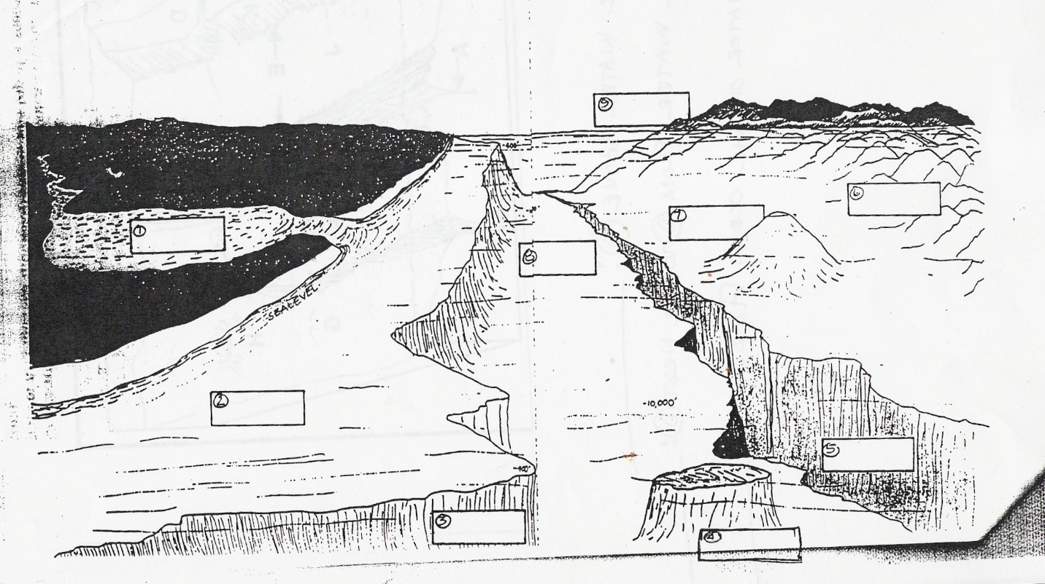

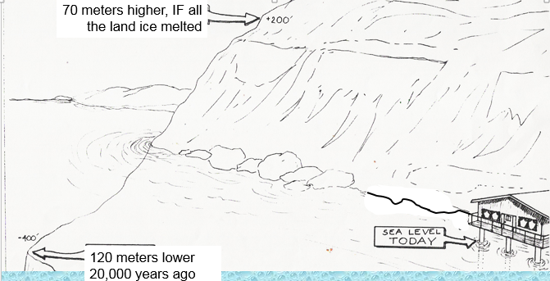

Go back to diagram you drew on the first page and add these labels: neritic, oceanic/pelagic/open ocean, benthic

