Why are the Humpbacks Hanging Out?
Steven Allen, Elizabeth Eubanks
Summary
Scientists doing recent cetacean research around the Antarctic Peninsula have noticed that the Humpbacks whales are staying about a month longer along the Western Peninsula. Students will be asked to come up with a hypothesis for why the whales are staying longer. Then, students will look at and analyze the scientists’ whale tagging data. Students will be asked to engage in a STEAM based, Polar-Ice Data Story on whales’ feeding behaviors. Students will utilize some of the data and use it to create a “hanging Humpback” mobile that will help them visualize the data. Finally, students will extrapolate from this data and determine if the data supports their original hypothesis.
cetaceans, Antarctica, krill
Key Concepts
- Analyzing polar data
- Formulating a hypothesis
- Understanding the relationship between trophic levels in the Antarctic
- Understanding the relationship between environmental change (climate change) and whale behavior
- Meet a polar scientist via film
Objectives
Students will
- Construct a hypothesis to explain a change in whale behavior.
- Analyze and interpret data
- Use mathematics and computational thinking
- Make a model based on krill and whale data
- Obtain, evaluate, and communicate information
- 4 C Skills: Communication, Collaboration, Critical Thinking and Creativity

Materials Included

- Lesson Plan
- Intro Power Point
- Data Work Sheet
- Data Story: Finding Food Lesson
- Finding Food Humpback Whale: EARTH digital Escape
- Answer Key
- Whale, krill and Antarctica templates
- Video

Materials needed
- Computer w/ internet and LCD projector
- Student worksheets (3)
- Art supplies
- Colored pencils
- Scissors
- String, twine, yarn or fishing line
- Hole punch
- Glue
- Recycled cardboard

Procedure
- Distribute student worksheet.
- Introduce them to them to polar scientist Ari Friedlaender via YouTube film clip
- Begin Powerpoint presentation and post Bell Ringer question: What do Humpback whales feed on? Give students a few minutes to write answers, then reveal answer (2nd slide). Note: in the presentation, the krill image allows you to zoom in with a microscope.
- Continue showing Lesson Powerpoint presentation to class up to slide 6.
- Students working in small groups (or individually) should come up with a written hypothesis as to why the Humpback whales of Antarctica’s Western Peninsula are staying longer.
- Give student or group of student the Finding Food: EARTH Digital Escape Ticket. Explain that this is a puzzle and all information on the escape ticket are clues to gaining the answer. The first student to get the correct answer will get a prize (resources pending). Final assessment will contain questions stemmed from information on the ticket. Students may work on the ticket as they work on the Polar-Ice Data Story lesson. Or students may be required to complete the EARTH digital Escape before or after the Data Story Lesson.
- As a class or in groups or as individuals (depending on access to technology) have students work through the Polar-Ice Data Story developed on whale behavior and finding food. http://polar-ice.org/focus-areas/polar-data-stories/finding-food/
- Have student complete the Data Story: Finding Food, Humpback Whale lesson (answer key enclosed). Review, discuss and assesses.
- Have students complete the data table for the mobile.
- Make the mobile based on depth of whale dives and krill concentrations.
  - Distribute template copies of Humpbacks and krill species.
  - Students can research species coloration & color the template accordingly.
  - When they have finished coloring, students will cut out their animals. Use a hole punch to put a hole in each krill and whale. If students want to hang the whale in a diving position, they will need to place the hole off-center and closer to the tail.
  - Using the student worksheets, have students pick out 6 data points representing 6 different hours of krill data. Have students try to get the maximum amount of krill weight. Students should note time, weight and depth for each hour they chose. Have students fill in their data tables and mark values in table on handout.
  - Students should then come up with a workable scale for the depth/length of the string that each krill will hang on. For example, 1cm string = 10 meters of water depth. Have students convert their depths.
  - Using recycled cardboard, have students draw a copy of the Antarctica Peninsula. This will be the top of the mobile where the krill and whales will hang off. Students should punch 12 equally spaced holes across the cardboard peninsula.
  - Students should hang their krill on lengths of string, according to their conversions. This could be done using fishing line, twine or yarn. Make sure students start with the second hole and skip every other hole in order to leave a hole for each corresponding diving whale.
  - Then using the same time selections for the krill data points have students record the maximum whale depth during its corresponding dive. Using the same scale for depth and length convert the maximum whale depth to string length for the mobile.
  - Hang Humpback whales before each krill hung.
- Ask students to identify any patterns or relationships they see in their mobiles. Have student groups share their mobiles and explain the relationships between components.
Note: this is a good stopping point in the lesson.
- Ask students to consider, if krill is shaping whales’ daily behavior, could krill be shaping their seasonal behavior. Could the whales be hanging out longer around the Western Antarctic Peninsula because of the krill?
- Ask students to consider the relationship between Antarctic Peninsula Climate Change Data and whale behavior.
- Continue Powerpoint presentation.
- Have students discuss how close their hypotheses were to the idea that changing sea ice has allowed for the continued feeding by Humpbacks on krill.
- If time allows, have students present their mobiles and explain the relationship between the components.

Assessment
- Collect student worksheets.
- Assess the Humpback/krill mobile based on the following rubric:
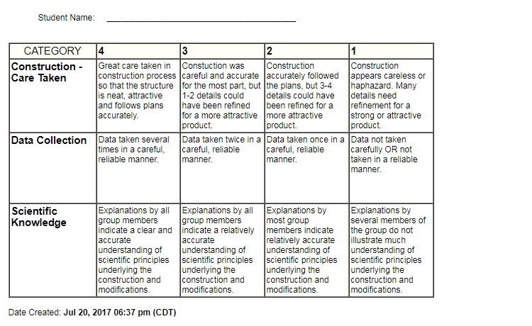
Additional Resources
Extensions or adaptations
Have students consider the long-term effects of climate change with Humpback whales spending a longer time in the Antarctic feeding on krill.

Have students consider the effects of commercial krill fishing on Humpback whales.

