Name: _____________________________

A Whale of a Roller Coaster: Sensor Kinetic Worksheet

How can we see how whales travel throughout the ocean? Scientists use multi-sensor tags to record whales as they dive, eat, and sleep in the ocean. The phone application “Sensor Kinetic” allows you to model the multi-sensor tag that scientist use to track whale movement under the water.

Setting Up the App
Directions - Open the “Sensor Kinetic” application on your mobile device. Follow the directions below to set up your sensor.

1.Click on the > (greater than sign) 2. Click on the “X,Y,Z” button on the
next to Accelerometer Sensor. bottom of the app. It will be replaced with “rotation”.
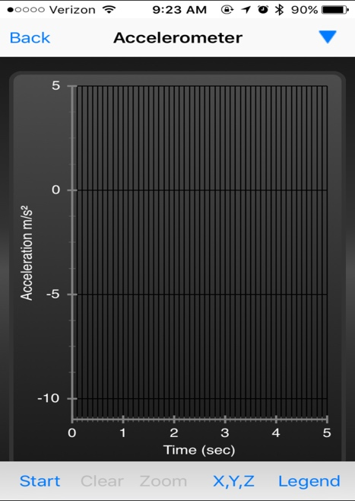

Let’s test to make sure app is working.

Click on the start button in the left bottom
corner of the screen to use the accelerometer.
A red and green line will appear. To
restart the accelerometer, press the stop
button in the bottom left corner and then
press clear.

Your phone is the Humpback Whale in this model! The ‘home button’ of your phone is the front of the whale.
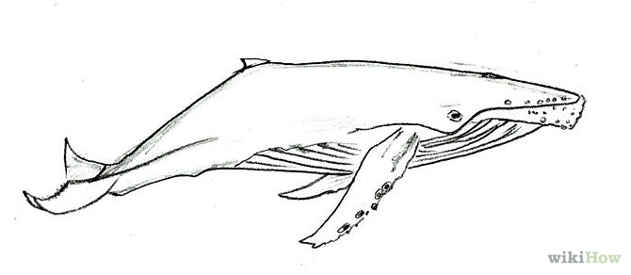

Using the Accelerometer

- Clear the screen to restart the accelerometer. Hold the mobile device with two hands, screen facing the ceiling. Press the start button. Keep the phone in this rest position for four seconds. Press the stop button.
- Did the red or green line show movement from the rest position?

- Draw your accelerometer data below

90

This graph shows your phone (the whale) at rest position.
45
Rotation
0

-45

-90

5
4
3
2
1
0

Time (sec)
- Clear the screen to restart the accelerometer. Hold the mobile device with two hands, screen facing the ceiling. Press the start button and tilt the top of the mobile device towards the floor and back to the starting position. Press the stop button.

- Circle the color of the line that shows movement from the rest position: Red or Green
- Draw your accelerometer data below

90

This graph shows your phone (the whale) diving deeper into the water. *The whales pitch is descending.
45
Rotation
0

-45

-90

5
4
3
2
1
0

Time (sec)

- Clear the screen to restart the accelerometer. Hold the mobile device with two hands, screen facing the ceiling. Press the start button and tilt the front of the mobile device towards the ceiling and back to the starting position. Press the stop button.

- Circle the color of the line that shows movement from the rest position: Red or Green
- Draw your accelerometer data below

90
This graph shows your phone (the whale) swimming up towards the surface of the water. The whales pitch is ascending.

45
Rotation
0

-45

-90

5
4
3
2
1
0

Time (sec)

- Clear the screen to restart the accelerometer. Hold the mobile device with two hands, screen facing the ceiling. Press the start button and tilt the left side of the mobile device towards the floor and back to the starting position. Press the stop button.

- Circle the color of the line that shows movement from the rest position: Red or Green
- Draw your accelerometer data below

90
This graph shows your phone (the whale) making a lateral roll to the left in the water.

45
Rotation
0

-45

-90

5
4
3
2
1
0

Time (sec)

- Clear the screen to restart the accelerometer. Hold the mobile device with two hands, screen facing the ceiling. Press the start button and tilt the right side of the mobile device towards the floor and back to the starting position. Press the stop button.

- Circle the color of the line that shows movement from the rest position: Red or Green
- Draw your accelerometer data below

90
This graph shows your phone (the whale) making a lateral roll to the right in the water.

45
Rotation
0

-45

-90

5
4
3
2
1
0

Time (sec)

Analyzing the Accelerometer Data

- When the red line moves up towards positive 90°, what motion is the whale moving in?

- When the red line moves down towards the negative 90°, what motion is the whale moving?

- When the whale dives deeper into the water, is the pitch ascending or descending?

- When the whale begins to move towards the surface of the water, is the pitch ascending or descending?

- When the green line moves up towards positive 90°, what motion is the whale moving in?

- When the green line moves down towards the negative 90°, what motion is the whale moving?

Use the data below to explain the movement of the whale.

Describe the movement of the whale in terms of depth. (ascending or descending)

Does the whale complete a lateral roll? Left or right?

