Making Observations from Satellite Images

Satellites can be used to look at:
- changes in weather
- scientific research
- Communication
- Navigation
- Military purposes
- Earth observation

We are going to look at earth observation. In this activity you have multiple images of Bathurst Island, Canada. (It is one of the Queen Elizabeth Islands in Nunavut, Canada).

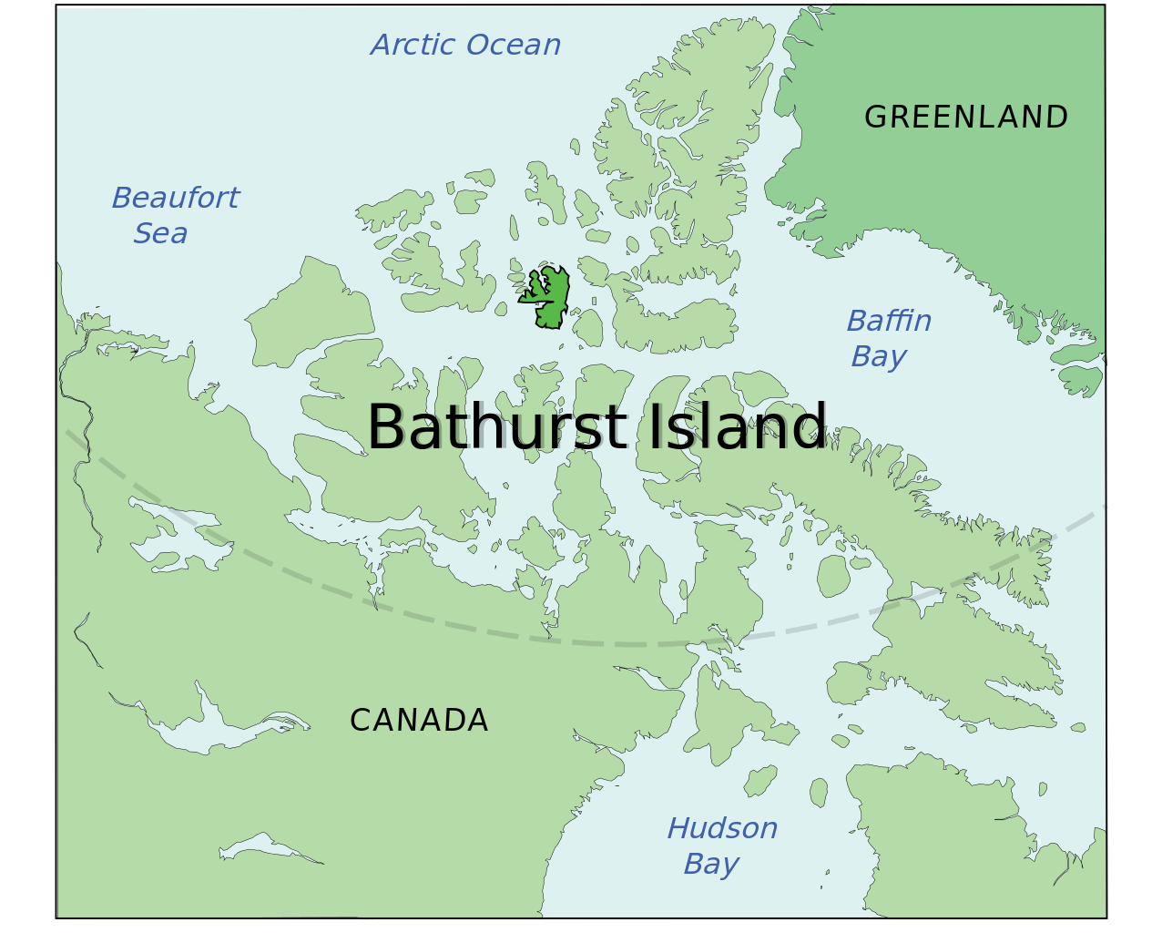

Part 1.
Compare the images and make observations in the table below

Date of image | observations

In your opinion, do you think any of the images are NOT useful for scientific research? Complete the table below with your evidence.

Date of image | observations

Part 2.
Based on your observations make a claim about the ice/snow coverage of this area OVER time. Be sure to include at least three different date observations.

Claim | Evidence | Reasoning

Part 3.
Answer the following questions about the use of satellite technology based on your observations.

- What do you think are the benefits of satellites and satellite imagery. Are images from space always helpful? What are the limitations of satellite images?

- Using the slides (ex. Slide dated 24 & 29 Mar 15), Explain the differences between satellite orbits. How does the orbit of a satellite affect what it can observe?

What are some advantages and disadvantages of using satellite imagery for scientific research?

Advantages | Disadvantages

