Humpback Whales
Making Observations from Drone Images

Drones can be used in a variety of situations to make scientific observations. They can be equipped with a variety of cameras and sensors in order to achieve this. For example an infrared thermometer can be attached to a drone to detect hotspots in landfill sites and potentially prevent a fire.

We are going to look at humpback whales. In this activity you have multiple images of whales taken during different seasons in Antarctica.

Part 1.
Compare the images and make observations in the table below

Image Number | Observations

Part 2. Measure each image using the instructions provided.

Image Number | Measurements of Whale | Did you get it correct? | What was your percentage error?
Percentage error is calculated by:
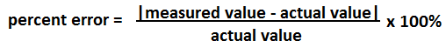

Part 2.
Based on your observations and measurements, make a claim about the body condition of the whale(s) from season to season.
Claim | Evidence | Reasoning

Part 3.
Answer the following questions based on your observations and measurements

- What do you think are the benefits of drones and drone imagery. Are images from the drone always helpful? What are the limitations of drone images?

- Using the information gained from this activity and the information below, form a hypothesis on the following behaviours. Explain your reasoning.

The behavior of humpback whales often falls into four categories:

- Resting – whales stay within the top 10 meters (30 feet) of the water near the surface Traveling – whales move through water 10-50 meters (30-150 feet) below the surface
- Feeding – whales move quickly up and down between the surface and 300+ meters (900+ feet) below the surface
- Exploring – whales move through water more than 50 meters (> 150 feet) below the surface

A whale typically spends some amount of time in each stage per day.
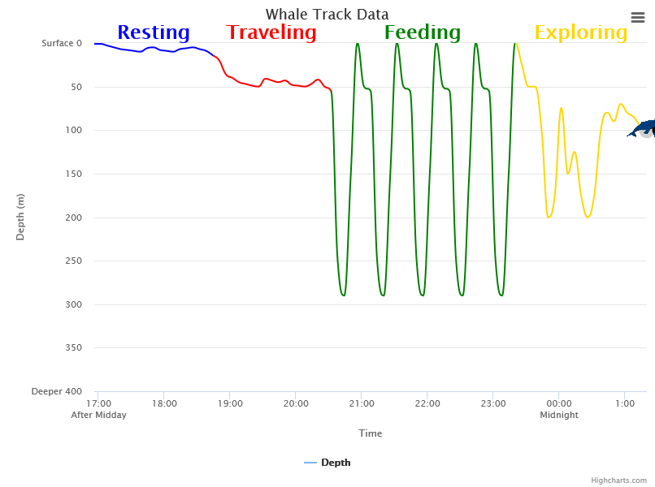
More information can be found at:
http://polar-ice.org/focus-areas/polar-data-stories/finding-food/

  - How do you think the extra body weight affects the whales’ movement in general?

  - How do you think the extra body weight affects the whales’ feeding habits?

  - How do you think the extra body weight affects the whales’ exploring habits?

