Name _________________________________ Marine Science Spring 2017 Bathymetry In-Class Activity

Part I (need to use map in room)
Using the Relief Map hanging on the wall and the Map of the World, answer the following questions:
- List the four major ocean basins?

- The Mariana Trench is just east of what Island nation?

- Off which coast of Australia would you find the Great Barrier Reef (give direction)?

- A (sticky note) is part of what structure?

- What three sea floor structures can you see in the Gulf of Mexico?

- Compare the east coasts of Asia and Africa, which continent has the widest continental shelf?

Part II (handout)
Using the Physiographic Chart of the Sea Floor, use a highlighter to:

- Highlight and label a seamount.
- Highlight the mid-ocean ridge.
- You don’t need your highlighter for this question….
- Most people think that we have four oceans, why do you think there is a push to say that we have one ocean with four ocean basins?

- Why do you think there is a push to name an ocean “the southern ocean?” Using either Google Earth OR this link http://www.earthbrowser.com/ will help.

Part III (a pdf of this is available on BB)
Read the article on Dr. Robert Ballard (pdf on blackboard as well) and then answer the following questions:
- What are two “discoveries” that Dr. Ballard has made?

- What is the biggest feature on the planet?

- What are the limitations of using a “manned” submarine (submersible)?

- What is his advice to women/girls?

More information on his JASON project can be found at https://www.jason.org/

Part IV (link found on BB too)
Go to http://www.youtube.com/watch?v=5rb5HzR26OM (it’s a 2 minute video)
- Why are seamounts considered important habitats?

- What does endemic mean?

- What’s unique about the Davidson Seamount?

Part V (need to use map in room)
Use the Map of the Pacific Ocean and The Earth’s Fractured Surface, answer the following questions:
- Which side (east or west) has the most seamounts?

- Is New Guinea a true island OR a part of the Australian continent (just circle)?

- Which of the Asian Seas is NOT on the continental shelf (look for the seas that are west of Japan and the Philippines)?

- Where are the Galapagos Islands (I’ll sign)? ______________

Part VI (there is a pdf of this available on BB)
Using the Panoramas of the Ocean Floor (pdf on Blackboard), answer the following questions:
- What ocean are you looking at from page 1? ________________________________

- From reading on page 2, before the 1920’s, how did people find out the depth of the ocean?

- From page 2, since the 1920’s describe how the ocean floor depth is measured?

- From page 2, how far into the Atlantic or Pacific Ocean is the U.S. Exclusive Economic zone?

- From the pictures on page 3:
  - The red/yellow (Q) in picture A is part of the continental shelf. What do you think

Structure R is? _____________________

Structure S is? _____________________

- From page 4, picture D, what body of water is the picture showing?

PART VII (links)
Marie Tharp is credited with mapping the ocean floor. Go to http://www.library.arizona.edu/news/entries/view/2801
ALSO She was ahead of her time. Watch the 5 minute video http://www.nytimes.com/video/magazine/1194817114284/marie-tharp-b-1920.html . There is even a book written about her called Soundings: The Story of the Remarkable Woman Who Mapped the Ocean Floor.

- Tell me one thing that she did.

PART VIII
Look at the From Sea to Shining Sea poster, what is something you learned from looking at the poster?

PART IX
Go to: http://topex.ucsd.edu/marine_topo/mar_topo.html
Scroll down until you see
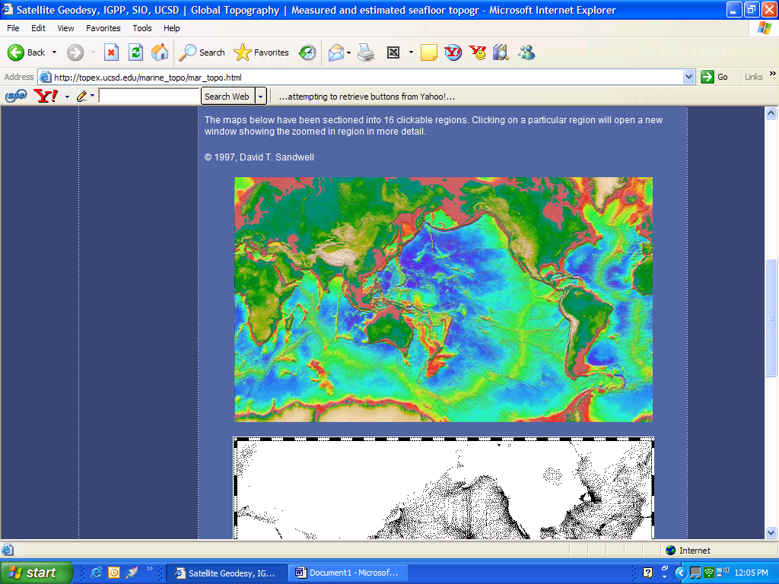
One at a time, click on the west and east coasts of the US to enlarge it.

Once you have clicked on a side, you can click one more time to enlarge it even more.

Use the back arrow to return to the home screen.

What color is the continental shelf? ____________________

Which coast WEST or EAST has the widest continental shelf? _________________

PART X

Go to Google Earth (it should be on your laptop, try all programs)
Rotate the EARTH so you are looking at the Atlantic Ocean (US on left side, Africa on right)
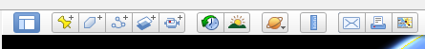
Use this tool to make a path from Florida through the Bahamas through the Cape Verde Islands to Dakar, Senegal (make it a straight line not the squiggles I did for fun☺. You can zoom in to locate any of the spots you need to find.
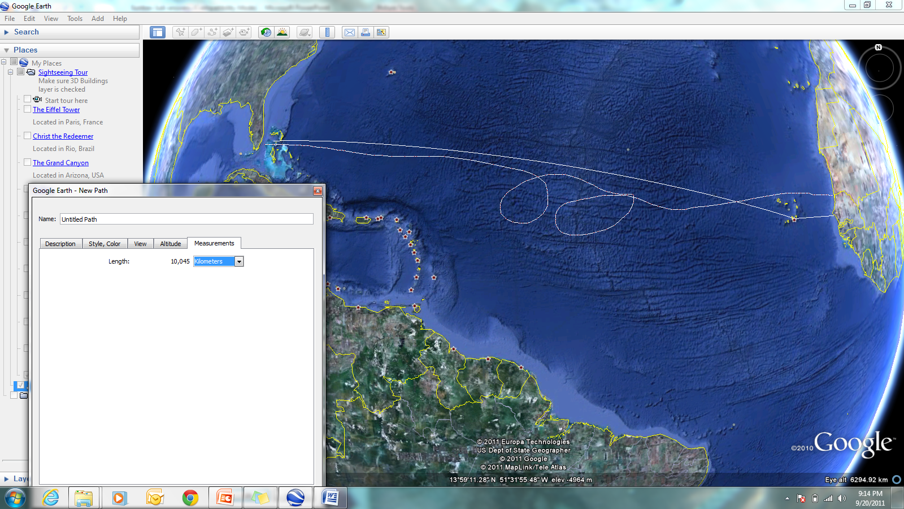

Note: You may need to move this box out of your way by clicking and moving with your mouse.
When your mouse moves over the ocean, a white box square will show up, click and drag the line from the Florida coast to Africa (make sure you go this direction)

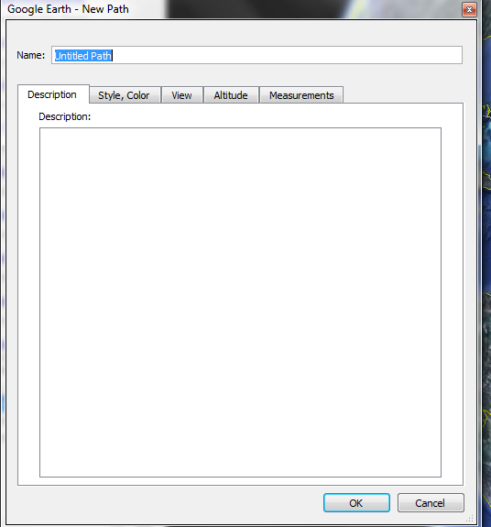
Title it your last name and section (Atlantic or Pacific)
Under Altitude
choose Clamped to the seafloor

Under Measurements
Choose kilometers

Then hit OKAY

You’re almost finished…. Go to EDIT and click on Show Elevation Profile
Finally, click on the email button (under file) and select “Screenshot” and email to me
OR take a screen shot (using the snipping tool) and email the image to me
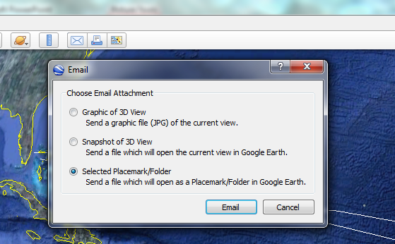
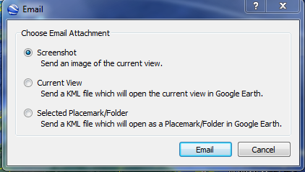

Part IX


