Name ____________KEY_________________ Marine Science Spring 2017

Part I
Using the Relief Map hanging on the wall and the Map of the World, answer the following questions:
- List the four major ocean basins?
Atlantic, Pacific, Arctic and Indian

- The Mariana Trench is just east of what Island nation?
Philippines

- Off which coast of Australia would you find the Great Barrier Reef (give direction)?
East (NE)

- A (sticky note) is part of what structure?
Mid-ocean ridge

- What three sea floor structures can you see in the Gulf of Mexico?
Continental Shelf, Cont Slope and Abyssal Plain

- Compare the east coasts of Asia and Africa, which continent has the widest continental shelf?

Part II
Using the Physiographic Chart of the Sea Floor, use a highlighter to:

- Highlight and label a seamount.
- Highlight the mid-ocean ridge.
- You don’t need your highlighter for this question….
- Most people think that we have four oceans, Why do you think there is a push to say that we have one ocean with four ocean basins?

They are all connected.

- Why do you think there is a push to name an ocean “the southern ocean?” Using either Google Earth or this link http://www.earthbrowser.com/ will help.
Also go to http://oceanservice.noaa.gov/facts/howmanyoceans.html

The majority of the southern hemisphere is ocean. The Pacific, Atlantic and Indian oceans all connect in the south.

Part III
Read the article on Dr. Robert Ballard (pdf on blackboard as well) and then answer the following questions:
- What are two “discoveries” that Dr. Ballard has made?
Wreck of the Titanic, mid-ocean ridge, hydrothermal vents

- What is the biggest feature on the planet?
Mid-ocean ridge

- What are the limitations of using a “manned” submarine (submersible)?
Physical limitations (looooong time needed to get down, limited time to explore, dangerous)

- What is his advice to women/girls?
Get into physical sciences and engineering.

More information on his JASON project can be found at https://www.jason.org/

Part IV
Go to http://www.youtube.com/watch?v=5rb5HzR26OM (it’s a 2 minute video)
- Why are seamounts considered important habitats?
Variety of organisms like sponges and corals that are provide habitat (13 new species found)

- What does endemic mean?

Restricted to a certain area (like in this case the Davidson Seamount)

- What’s unique about the Davidson Seamount?

13 new species were found (and even though they are not necessarily edenmic)

Part V
Use the Map of the Pacific Ocean and The Earth’s Fractured Surface, answer the following questions:
- Which side (east or west) has the most seamounts?

- Is New Guinea a true island OR a part of the Australian continent (just circle)?
http://maps.nationalgeographic.com/maps/print-collection/pacific-ocean-floor.html

- Which of the Asian Seas is NOT on the continental shelf (look for the seas that are west of Japan and the Philippines)? NOT on the continental shelf: Sea of Japan (East Sea), South China Sea
ON continental shelf: East China Sea, Yellow Sea
http://maps.nationalgeographic.com/maps/print-collection/pacific-ocean-floor.html

- Where are the Galapagos Islands (I’ll sign)? ______________
Part VI
Using the Panoramas of the Ocean Floor (pdf on Blackboard), answer the following questions:
- What ocean are you looking at from page 1? ____Pacific___________

- From reading on page 2, before the 1920’s, how did people find out the depth of the ocean?
Dropped a line over boats with a weight tied to the end

- From page 2, since the 1920’s describe how is the ocean floor depth measured?
Sonar (acoustics)

- From page 2, how far into the Atlantic or Pacific Ocean is the U.S. Exclusive Economic zone?
200 miles

- From the pictures on page 3:
  - The red/yellow (Q) in picture A is part of the continental shelf. What do you think

Structure R is? __continental slope___

Structure S is? ______abyssal plain_______________

- From page 4, picture D, what body of water is the picture showing? Gulf of Mexico

PART VII
Marie Tharp is credited with mapping the ocean floor. Go to http://www.library.arizona.edu/news/entries/view/2801

- Tell me one thing that she did.

She was ahead of her time. You can find out more about her with a 5 minute video (it is worth watching☺ http://www.nytimes.com/video/magazine/1194817114284/marie-tharp-b-1920.html . There is even a book written about her called Soundings: The Story of the Remarkable Woman Who Mapped the Ocean Floor.

Mapped the ocean by using earthquake data (showed mid-ocean ridge)

PART VIII
Look at the From Sea to Shining Sea poster, what is something you learned from looking at the poster?

Answers will vary

PART IX
Go to: http://topex.ucsd.edu/marine_topo/mar_topo.html
Scroll down until you see
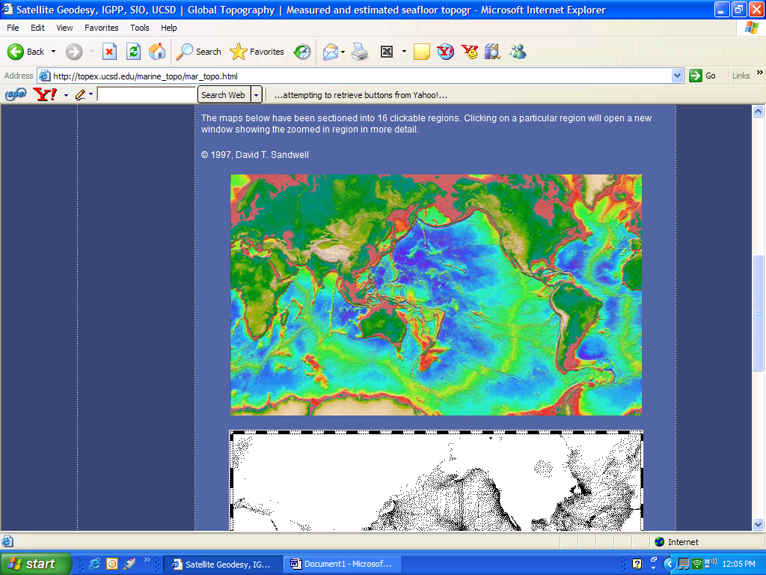
One at a time, click on the west and east coasts of the US to enlarge it.

Once you have clicked on a side, you can click one more time to enlarge it even more.

Use the back arrow to return to the home screen.

What color is the continental shelf? ___Pink_______

Which coast WEST or EAST has the widest continental shelf? ___East______

PART X

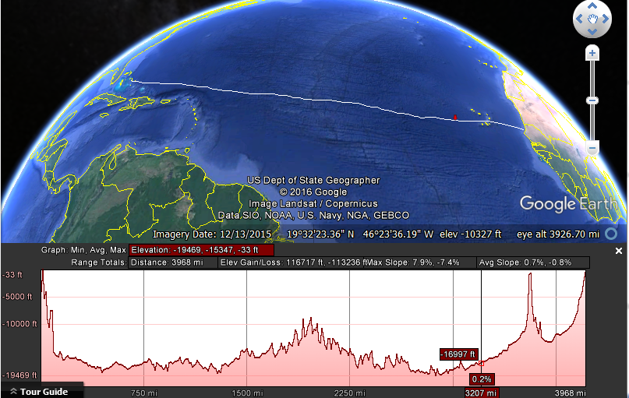

Part IX


