You are on a large ice-covered ocean. Are you in the Arctic or Antarctic?  Answer: Arctic | 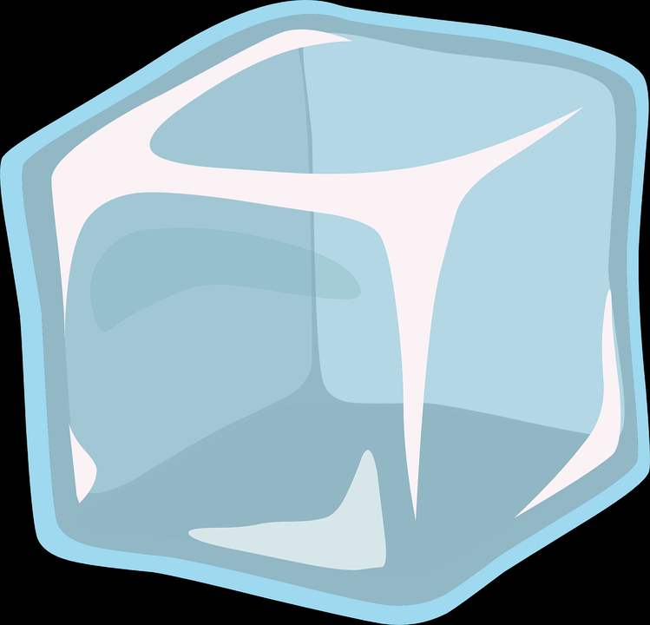
You are cruising across the Southern Ocean on the USCGC Palmer. Are you sailing to the Arctic or Antarctica?

Answer: Antarctica
The global ocean conveyer belt is dependent upon both polar regions. True or False

Answer: True
Name a summer month in the Arctic Region.

Answer:
June, July, August, September
There are no 4th of July fireworks to view with your research team because the sun does not set in this location in July. Arctic or Antarctic?
Answer: Arctic
The air temperature is much colder in Antarctica than the Arctic. True or false?

Answer: True
The Greenland ice sheet contains 10% of the world’s ice. Where is the other main (90%)ice sheet located?

Answer: Antarctica
Ocean productivity is higher in July or December in the Arctic? Why?
Answer: July, sun drives productivity for phytoplankton
Scientist predict that the Arctic will be ice-free year round in which time period?
3 years, 30 years, 300 years

Answer: 30 years
Why do icebergs float?
Ice is more dense than water.
Ice is less dense than water.

Answer: Ice is less dense than water.
You are on an ice-covered continent. Are you in the Arctic or Antarctic?

Answer: Antarctic
You are cruising across the smallest ocean on the USCGC Healy. Are you sailing to the Arctic or Antarctic?

Answer: Arctic
Your research team is drilling through a 2 kilometer thick ice sheet? Are you in the Arctic or Antarctica?

Answer: Antarctica
Name a winter month in Antarctica.

Answer:
June, July, August, September
It is New Year’s Eve at the South Pole. Will you enjoy fireworks? Why or Why not?
Answer: No, the sun is out 24 hours per day on December 31
In which polar region are you likely to find the Tundra biome where vegetation such as shrubs exist?

Answer: Arctic
Sea ice shrinks and expands throughout the seasons. In which month is the Arctic sea ice the least?
June or September

Answer: September
Where is a glacier located? Over ocean or land?

Answer: Land
Is sea ice made of mostly fresh or salt water?

Answer: Fresh
Glaciers can be found in Peru and Argentina in
South America. True or false?

Answer: True

