Name _________________________________________ Fall 2016 Zoology
Go to http://jellywatch.org/ (also can get the JellyWatch app on your smartphone).
You can register for the site (that way you can access your own postings easier). You can register from your laptop or from your smartphone.
Click on the Why at the bottom of the page OR go to http://jellywatch.org/why
For a video run-through watch the https://www.youtube.com/watch?v=AHcdhguSeCg (3:45)…..obviously I do not have a future in Hollywood, but the video will give you an overview of why it is important and how to use it.
Great background info on jellies can be found on the site at http://jellywatch.org/blooms/facts
- List three facts that you learned from this site (3pts) :

Scroll down to the map on the homepage. It will look something like this
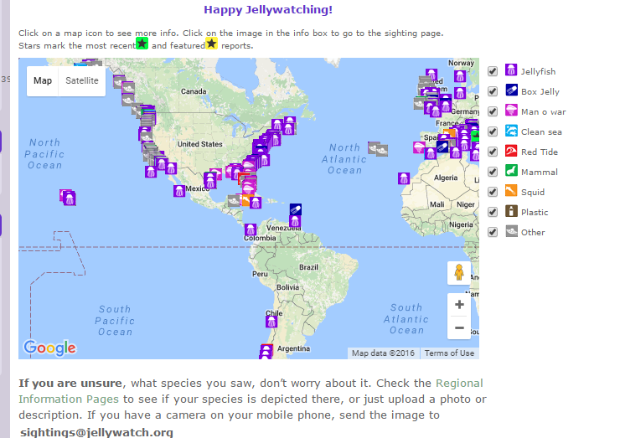
You can use the + and – buttons to zoom in or out. You can also turn off some of the layers of the map (like plastic or other) if you want to focus on some aspect of sea life in general.

Zoom in on a location of your choice, and record a siting.
For example I clicked on a siting of the coast of Charleston, SC. Then I clicked on the picture to get more data. Delete my pictures and insert yours, both the summary (like pic on left) and the more specific info (like picture and map on right) (3 pts)
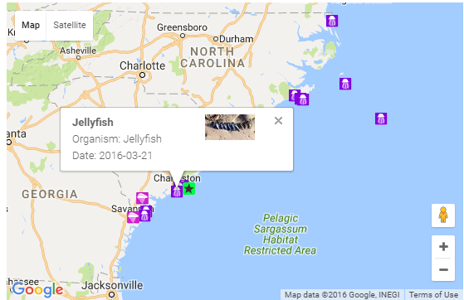 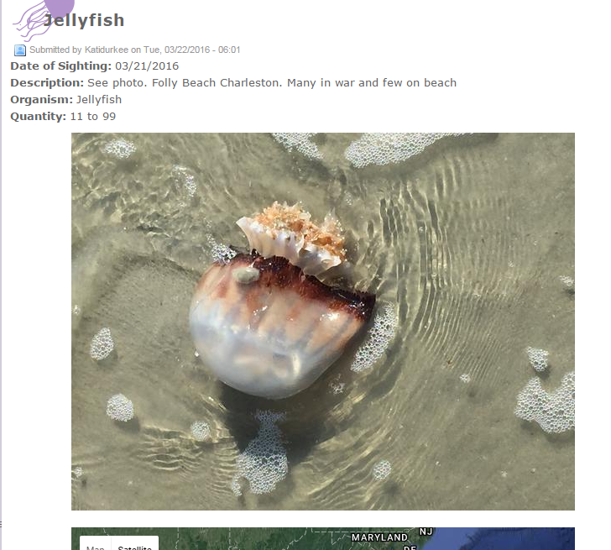 There is a map below the picture

Click on the List Sightings tab on the left side and record what the most recent sighting. Click on the entry (do this by clicking on the Title of it). Copy and paste the information on this sighting below. 2 pts

You can download the data that is on the JellyWatch site and then clean it up to find out what you want. I put directions for doing this on Blackboard under Invertebrates, Cnidarians, JellyWatch. If you follow the directions and delete everything but Velella velella with images, email me the excel sheet, you will receive +2 on the assignment.

You will receive a JellyWatch sticker when you turn this assignment in on Monday. Also anyone at school (including you) who Marks a New Sighting, will receive a sticker and have their name on the Citizen Scientist wall outside my room.

