Why are the Humpbacks Hanging Out?

Name(s):_____________________________________Per._______________
Bell Ringer: What do you think Humpback whales eat in Antarctica?

Hypothesis on why Humpbacks are hanging out longer in Antarctica:
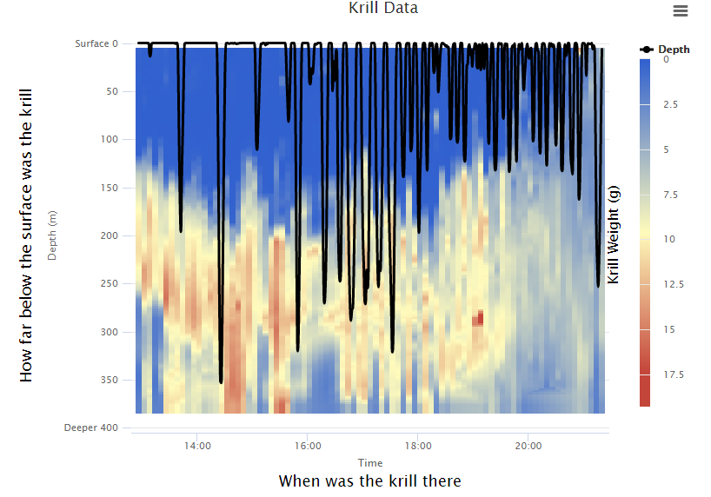
Remember: This is one graph overlaid on another and the black lines represent the diving whales.
Use the Krill Data graph and Whale Diving overlay from the Data Story “Finding Food?” (slide 5-Let’s Compare) to fill in the information below. http://polar-ice.org/focus-areas/polar-data-stories/finding-food/
 | Time | Krill weight | Krill depth  (m) | Length of string for krill (cm) | Whale dive depth (m) | Length of string for Humpback (cm)
Data point 1
Data point 2
Data point 3
Data point 4
Data point 5
Data point 6

Do your scale conversions below:

Consider this: If krill is shaping whales’ daily behavior, could krill be shaping their seasonal behavior. Could the whales be hanging out longer around the Western Antarctic Peninsula because of the krill?

