32 Shades of Water Final Assessment
Name:
Date:
Period/ Class:
Directions: Make a prediction then look at the FloatVIZ 6.0 graphs provided or that you created. If you created your own graph please include the variables that you used to create your graph.

- Make a prediction, what do you think the color of water would be in the Southern Ocean, the North Atlantic, Hawaii and the California Current. Why do you expect the water to be that color in each location? Draw/ color your prediction (make sure you label).
- Do you expect the color change over the span of two years worth of data in the same location? Why or why not?
- Look at the graphs for each location.
- Use the Claims, Evidence, Reasoning flowchart to explain what the graphs show.
- Draw/ color your response after analyzing the data.
- Questions for analysis:
  - How would the color change in different locations? Why or why not?
  - How close does the graph match your prediction?
  - Do you see any seasonal changes?
  - What could you do differently?
  - What other variables might affect the color of the water that were not discussed here?
  - What can the color of water tell us about ocean conditions? Explain your reasoning.
  - What are the limitations of using the color of water for ocean observations?
  - Is it necessary to use multiple forms of data to make a claim? Why or why not? Explain your reasoning using the ocean color as your example.
  - How can this information be used to inform policy making decisions on how best to use marine and freshwater coastal resources?
  - How has your thinking changed over time? Use specific examples

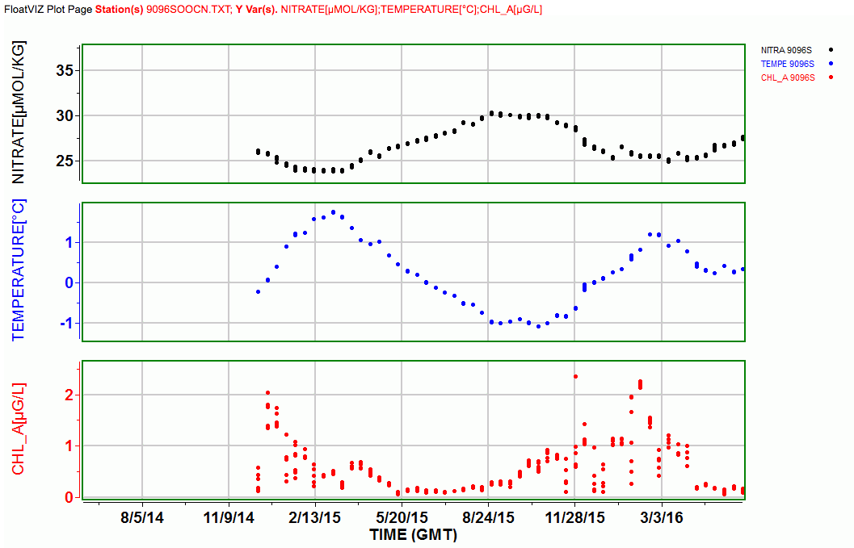
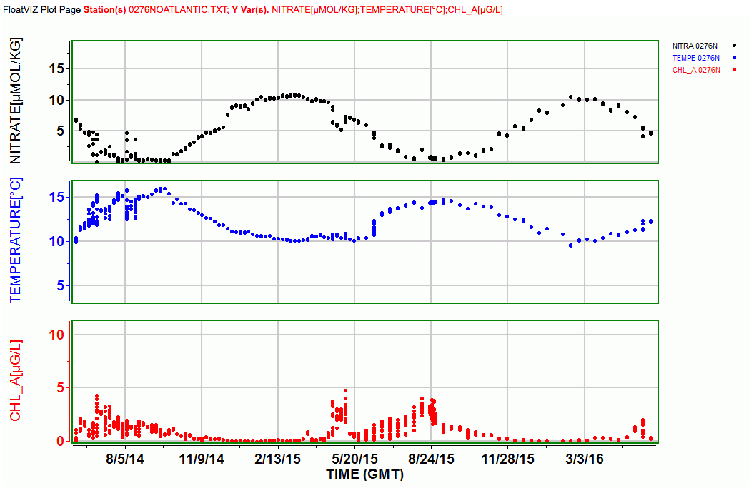
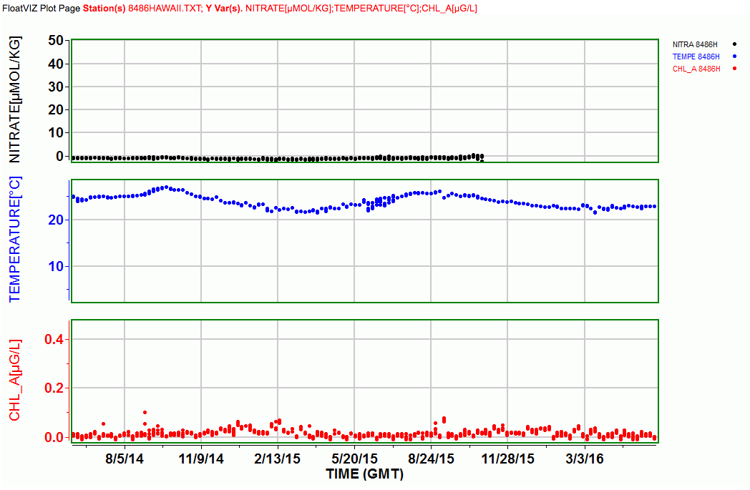

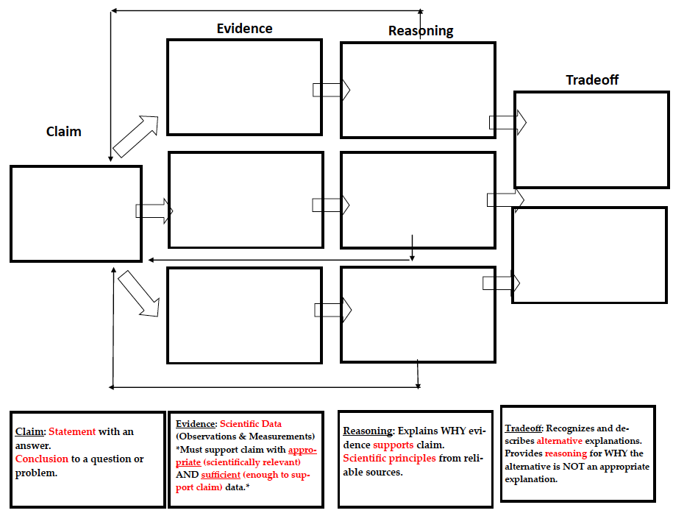
Credit to Katrina Alegado
Engaging in Argument from Evidence: Proficiency Scale
“Engaging in argument from evidence by constructing a convincing argument that supports or refutes claims.”
- Construct, use and/or present an oral and written argument supported by empirical evidence and scientific reasoning to support or refute an explanation or a model for a phenomenon or a solution to a problem.
This is one of the science and engineering practices of the NGSS. This practice has many connections to the CCSS:
RST.6-8.1 Cite specific text evidence to support analysis of science and technical texts.
WHST.6-8.1 Write arguments focused on discipline specific content.
WHST.6-8.9 Draw evidence from informational texts to support analysis reflection and research.

Proficiency Scale for engaging in argument from evidence
3 is the STANDARD. This is the learning goal.
1-2 are the Learning Targets- the intended learning written in student friendly language.
4
3.5 | In addition to score 3.0 performance, partial success at 4.0 content.
3 | I can write an argument using relevant evidence and scientific reasoning to support a claim..
2.5 | No errors at 2.0 and partial success at 3.0.
2
1.5 | Partial success at 2.0.
1

Resources:
- Using Common Core Standards p. 48-49: This section explains how to break down the learning goal and gives a generic proficiency scale.
- Using Common Core Standards p. 130-131: These pages give a proficiency scale for the ELA writing standard of argumentation.
- Pages 35, 64 and 152 from the Supporting Grade 5-8 Students in Constructing Evidence in Science.

Credit to Katrina Alegado for rubric

Claim, Evidence, Reasoning, Tradeoff Rubric
4 | I can write an argument using relevant evidence and scientific reasoning to support a claim:  -Position/Claim: Writes a statement that answers a question/responds to the problem in a complete complex sentence.  -Evidence: Three pieces of relevant and sufficient scientific data that fully supports the claim.  -Reasoning: Justifies why the evidence supports the claim using 3 scientific principles and higher level thinking.  -Tradeoff: Student fully describes trade-off of his/her decision with a concluding sentence.
3.5 | In addition to score 3.0 performance, partial success at 4.0 content.
3 | I can write an argument using relevant evidence and scientific reasoning to support a claim:  -Position/Claim: Writes a statement that answers a question/responds to the problem.  -Evidence: Two pieces of relevant and sufficient scientific data that supports the claim.  -Reasoning: Justifies why the evidence supports the claim using 2 scientific principles.  -Tradeoff: Student describes a trade-off of his/her decision.
2.5 | No errors at 2.0 and partial success at 3.0
2 | I can write an argument using evidence and reasoning to support a claim.  -Position/Claim: Writes a statement that partially answers a question/responds to the problem.  -Evidence: Data only partially supports the claim.  -Reasoning: Explanation provides partial scientific evidence to support the claim.  -Tradeoff: Student does not fully describe the tradeoff of his/her decision.
1.5 | Partial success at 2.0.
1 | I can write an argument using evidence and reasoning to support a claim.  -Position/Claim: Claim does not answer the question/respond to the problem.  -Evidence: No scientific data to support the claim.  -Reasoning: Evidence does not use scientific principles to support the claim.  -Tradeoff: No tradeoff is explained.

