Is the Sea Really Blue?
Name:
Date:
Period:
http://www.bbc.com/earth/story/201505226-is-the-sea-really-blue
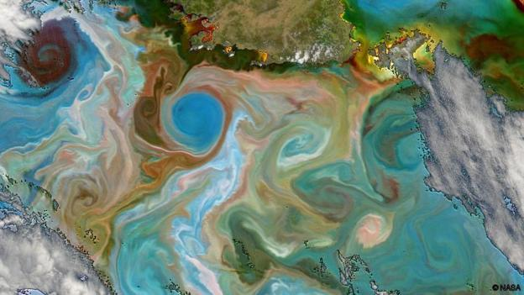

Before you make your claim, make a prediction:
- What colors do you see of the coast of Tasmania?
- What would account for such variation in color?
Make your claim:
- Read the article linked above.
- Use the claims, reasoning, evidence and tradeoffs flow chart to explain the possible variation of the ocean colors.
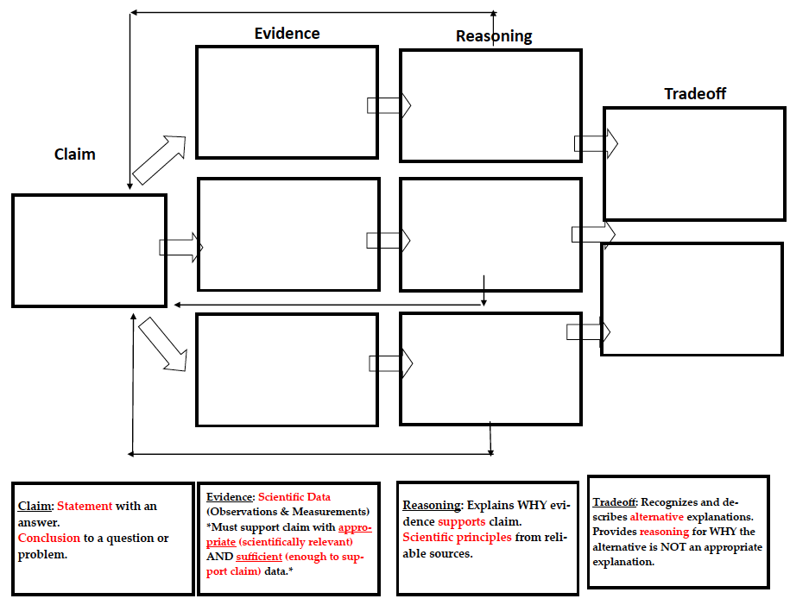

After your make your claim:
5) Is the sea really blue?
6) How has your thinking changed? Explain!

Engaging in Argument from Evidence: Proficiency Scale
“Engaging in argument from evidence by constructing a convincing argument that supports or refutes claims.”
- Construct, use and/or present an oral and written argument supported by empirical evidence and scientific reasoning to support or refute an explanation or a model for a phenomenon or a solution to a problem.
This is one of the science and engineering practices of the NGSS. This practice has many connections to the CCSS:
RST.6-8.1 Cite specific text evidence to support analysis of science and technical texts.
WHST.6-8.1 Write arguments focused on discipline specific content.
WHST.6-8.9 Draw evidence from informational texts to support analysis reflection and research.

Proficiency Scale for engaging in argument from evidence
3 is the STANDARD. This is the learning goal.
1-2 are the Learning Targets- the intended learning written in student friendly language.
4
3.5 | In addition to score 3.0 performance, partial success at 4.0 content.
3 | I can write an argument using relevant evidence and scientific reasoning to support a claim..
2.5 | No errors at 2.0 and partial success at 3.0.
2
1.5 | Partial success at 2.0.
1

Resources:
- Using Common Core Standards p. 48-49: This section explains how to break down the learning goal and gives a generic proficiency scale.
- Using Common Core Standards p. 130-131: These pages give a proficiency scale for the ELA writing standard of argumentation.
- Pages 35, 64 and 152 from the Supporting Grade 5-8 Students in Constructing Evidence in Science.

Credit to Katrina Alegado for rubric

Claim, Evidence, Reasoning, Tradeoff Rubric
4 | I can write an argument using relevant evidence and scientific reasoning to support a claim:  -Position/Claim: Writes a statement that answers a question/responds to the problem in a complete complex sentence.  -Evidence: Three pieces of relevant and sufficient scientific data that fully supports the claim.  -Reasoning: Justifies why the evidence supports the claim using 3 scientific principles and higher level thinking.  -Tradeoff: Student fully describes trade-off of his/her decision with a concluding sentence.
3.5 | In addition to score 3.0 performance, partial success at 4.0 content.
3 | I can write an argument using relevant evidence and scientific reasoning to support a claim:  -Position/Claim: Writes a statement that answers a question/responds to the problem.  -Evidence: Two pieces of relevant and sufficient scientific data that supports the claim.  -Reasoning: Justifies why the evidence supports the claim using 2 scientific principles.  -Tradeoff: Student describes a trade-off of his/her decision.
2.5 | No errors at 2.0 and partial success at 3.0
2 | I can write an argument using evidence and reasoning to support a claim.  -Position/Claim: Writes a statement that partially answers a question/responds to the problem.  -Evidence: Data only partially supports the claim.  -Reasoning: Explanation provides partial scientific evidence to support the claim.  -Tradeoff: Student does not fully describe the tradeoff of his/her decision.
1.5 | Partial success at 2.0.
1 | I can write an argument using evidence and reasoning to support a claim.  -Position/Claim: Claim does not answer the question/respond to the problem.  -Evidence: No scientific data to support the claim.  -Reasoning: Evidence does not use scientific principles to support the claim.  -Tradeoff: No tradeoff is explained.

