Bobbin’ Along
How can we measure the “health” of the oceans?
Kathy Couchon, Jill Lytle, Deirdre Gonzales
Summary
If we want to know if conditions in the oceans change in the future, it important have good data on current conditions. Students will use ocean profiling float data, a data set collected by floats deployed through the world’s oceans, to analyze chemical and biological measurements of ocean “health.” Students will learn how to navigate the FloatViz 6.0 website. Students will work in groups to define a question that they can explore using the data set, such as, “how does the pH of the oceans vary with depth?” Students will gather evidence (data) using FloatViz 6.0 and then prepare a Claim-Evidence-Reasoning presentation.

TAGS: data analysis, CER, climate change
Key Concepts
- Differences and advantages/disadvantages of discrete versus continuous data sets
- Ocean water conditions (biological and chemical) vary across time, geographic location and depth
- Data collected over various locations and over time will provide a more complete picture of current conditions and form a basis for understanding changes over time and with respect to global climate change
Objectives
Students will be able to:
- Ask questions and construct explanations
- Analyze and interpret data
- Engage in argument from evidence
- Obtain, evaluate, and communicate information
Materials
- Computers, for each student, or for groups of students
- STUDENT HANDOUT: Student Handout for Bobbin' Around Lesson
- Ken Johnson’s Presentation Ocean Observing, Chemistry, Climate, and Robots (PPT | PDF)
- Background on floats: MBARI: Chemical Sensor Group, Kenneth Johnson P.I.
- Youtube Argo Floats video:Argo Floats : How do we measure the ocean?

Procedure
PART 1: Discrete versus continuous data collection.
1. Show students the first and last screenshot from a short video clip. Have them record descriptions and make a conclusion about what happened based on the two photos. Then, play entire clip. Have students revise descriptions and conclusions. Use this as an analogy to discuss the differences between discrete and continuous data and the advantages/disadvantage of both.
Two Suggested videos to use as introductions to this discussion:
- Tiny Hamster Eating Tiny Burritos
Start at the very beginning and pause it (be careful, the title comes up FAST!) https://www.youtube.com/watch?v=JOCtdw9FG-s
Then show an image from time 1:03 https://youtu.be/JOCtdw9FG-s?t=1m3s
Give students 2 minutes to write down what they think happened in the intervening 1 minutes and 2 seconds. There is a section on the STUDENT HANDOUT for the students to write their descriptions. When time is up, have them share what they think happened with their neighbor, or with the class (warning, some of the students are likely to have seen this video), then show them the entire video. After they have seen the entire video, have them revise their previous story. Again, there is a section on the STUDENT HANDOUT for this part of the lesson.
- David Gallo’s Underwater Astonishments TED Talk
The whole video is amazing, and quick, but for the purposes of this lesson, show the still image starting at 4:22 https://youtu.be/-Hi5muM44NE?t=4m22s
Then show the image from 4:32 https://youtu.be/-Hi5muM44NE?t=4m32s
Give students 2 minutes to write down what they think happened in the intervening 10 seconds. When the time is up, have them share what they think happened with their neighbor, or with the class, then show them the last minute video. (You actually may want to show the entire video - it is quick, and engaging.) After they have seen the entire video, have them revise their previous story.
2. After showing the video(s) lead a class discussion about the disadvantage of discrete data vs. continuous data. Then discuss why, if continuous data is so much preferable scientifically, why don’t scientists always collect continuous data? Because there are technical limitations in data collection (for example, the poles freeze in the winter, so floats cannot continuously transmit data) and cost (a scientific expedition to the Southern Ocean could cost up to $100,000 per day.)

PART 2: Initial Data Exploration. Teacher-led procedure to access, navigate and utilize the FloatViz 6.0 data set. This will be used to illustrate differences between discrete and continuous data and as an example of the types of data that can be analyzed using FloatViz 6.0
1. Have students open the FloatViz 6.0 data set. Have everyone set the following parameters:
What dates? Week ending on End date
Change dates Start date: 12/17/2014 Stop date: 12/24/2014
Choose the following floats: 8486Hawaii, 7642NoPacific, 0276NoAtlantic, 9096SoOcn
(Students can use Control F to open a search box to search for specific float numbers)
Choose Date for X-axis and choose Temperature (℃) for Y-axis
Turn Y-stack option to Off
Change the Max. Depth setting to 30 m
All other options should stay in default settings.
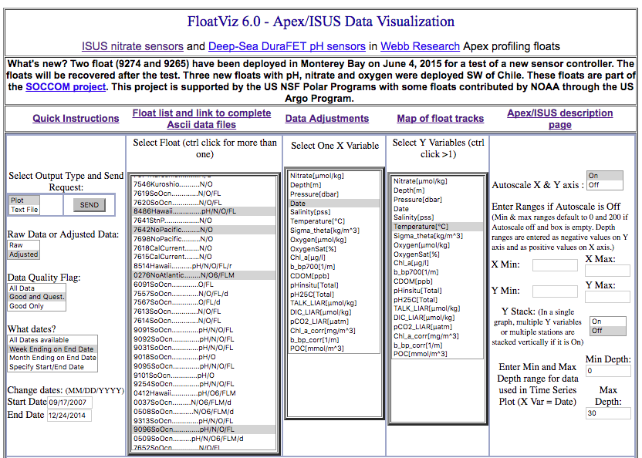
2. Click on SEND, in top left portion of screen. At this point each student should have generated a graph with one temperature measurement for each of the four locations. In groups, students can use this graph to answer the questions on the STUDENT HANDOUT.
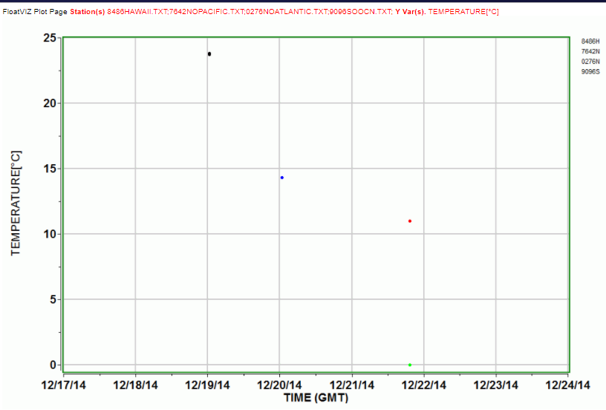
3. Next, have students close the graph and return to the FloatViz 6.0 page with the settings. Change the What dates? Month ending on End date and then click on SEND to generate a new graph.
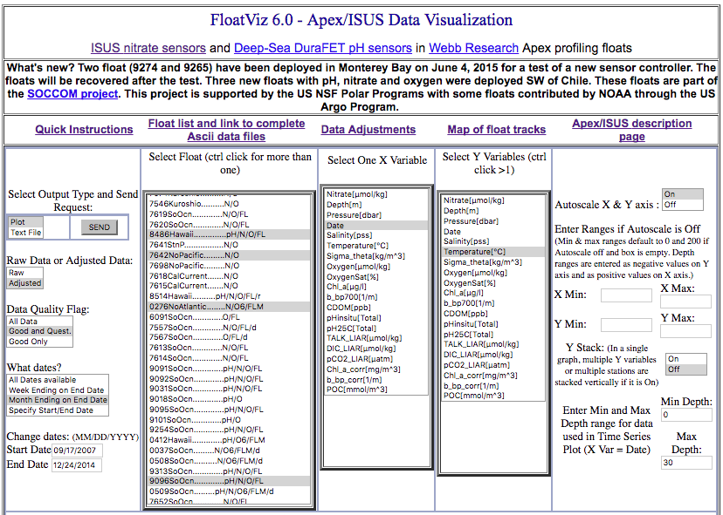
Students should now revisit the questions on the STUDENT HANDOUT and add new information based on the second graph they made.
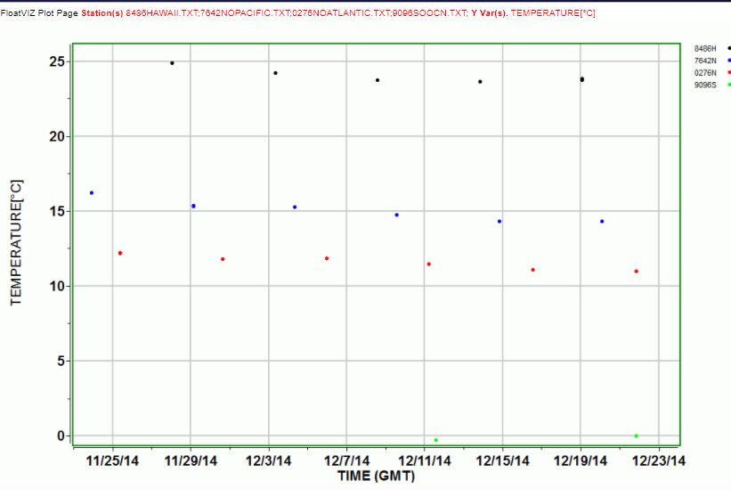
4. Next, have students close the graph and return to the FloatViz 6.0 page with the settings. Change the What dates? All available dates and then click on SEND to generate a new graph.
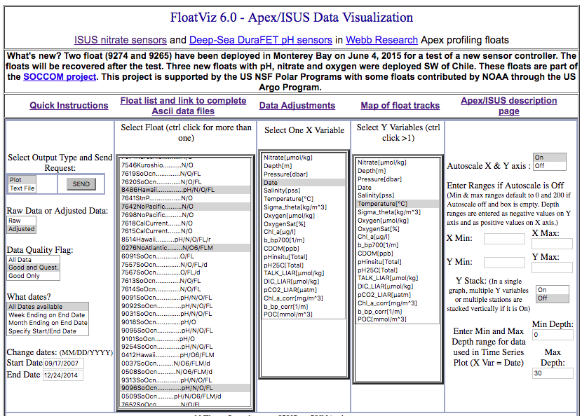
Students should now revisit the questions on the STUDENT HANDOUT and add new information based on the third graph they made.
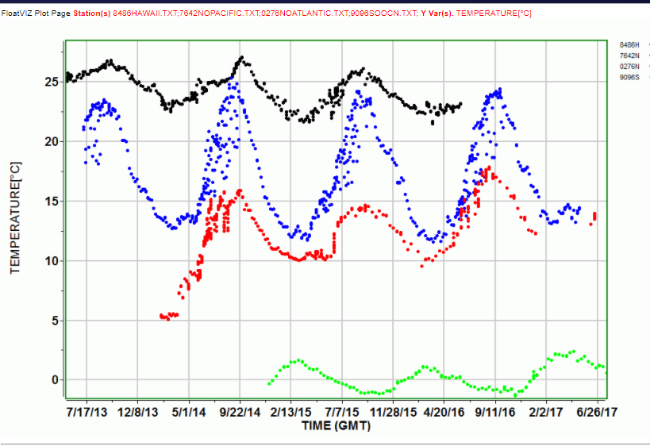
PART 3: Student Exploration
1. Have students play with FloatViz 6.0 data set. Give student groups time to change the settings and generate graphs. This is also an opportunity to discuss the measurements. See the Biogeochemical ARGO website for additional information on measurements. Click on Measurements on the left-hand menu and select a variable.
2. Brainstorm questions that can be explored using the data set. Each group should decide on one testable question. For groups that are struggling to define a testable question, you can suggest that they choose time as the independent variable (on the x-axis) and another variable to graph as the dependent variable (on the y-axis) and/or that they choose more than one float to make comparisons between locations.
Possible questions:
- How do chlorophyll levels vary seasonally at one location? Between locations?
- Is there a correlation between dissolved CO₂ and pH levels?
- Do pH levels vary between tropical, temperate and polar regions?
- What is the relationship between nitrate levels and chlorophyll?
- Between chlorophyll and dissolved O₂?
- Are CO₂ levels higher in polar oceans than in temperate/tropical oceans?
- How do pH levels vary with depth?

3. Once each group has decided on one question, they should work together, using FloatViz 6.0, to create graphs and analyze data to help answer the question. Based on the graphs they generate, the group should develop a claim (a statement that answers the question and that they can back up using their data). Students should use PART 3 of the student handout as a working draft to organize their work and to list the graphs they generate and save to use as evidence.

4. As a group, the students should write a summary paragraph that will provide the reasoning, essentially linking the evidence to their claim. In this well-written paragraph, the students should explain their graphs and how/why their graphs provide evidence for their claim.

5. The final product is a Claim-Evidence-Reasoning (CER) presentation (Google Slides or poster) and a classroom gallery walk. Each group should make a small Google Slides presentation, using work from PART 3 as a draft. One suggestion is to have one member of each group stay with their poster to answer questions and make clarifications, while the other members travel the room to evaluate other posters. The product could be a Google Slides deck or a PowerPoint presentation.

Possible questions for student evaluators:
- Why did you choose these specific locations/dates?
- Did you find anything unexpected?
- What would be your next question?
Assessment
The teacher can use the CER presentations and the students’ participation, in their groups in collecting their evidence, as well as in the gallery walk, to assess students.
- Formative assessments—
  - Observation of student participation in groups creating and analyzing graphs
  - Gallery Walk presentations/observations/questioners
- Summative assessments—
  - CER (Claim-Evidence-Reasoning posters)
  - CER Rubric
- For more information: https://facultyinnovate.utexas.edu/teaching/check-learning/methods

Additional Resources
Video clip: PBS NOW Ocean Tipping Point
Background readings:
Nature article - Ken Johnson interviewed
Science article -Deep ocean under climate change

Primer on Climate Change Science by the National Association of Clean Air Agencies
http://4cleanair.org/sites/default/files/NACAAClimateSciencePrimerpost_1.pdf
Claim Evidence Reasoning:
Claim Evidence Reasoning CER/NGSS Curriculum - Activate Learning
Scientist information:
Ken Johnson

Extensions or adaptations
- Have student investigate the locations of the ARGO floats. They could even take the text data of the coordinates and map the locations.
- Have students research what is known about the relationships between specific variables, such as nitrate levels and chlorophyll levels, or CO₂ levels and pH
- Discuss the differences between correlation and cause and effect relationships
- Discuss how these data can help us understand the health of the oceans with respect to global climate change
- Use What's the Bigger Picture? EARTH-MBARI lesson to use art to help communicate scientific data.

