Baleen whales are filter feeders. Would they eat shrimp-like critters like krill or fish like arctic cod?  Answer: Krill | 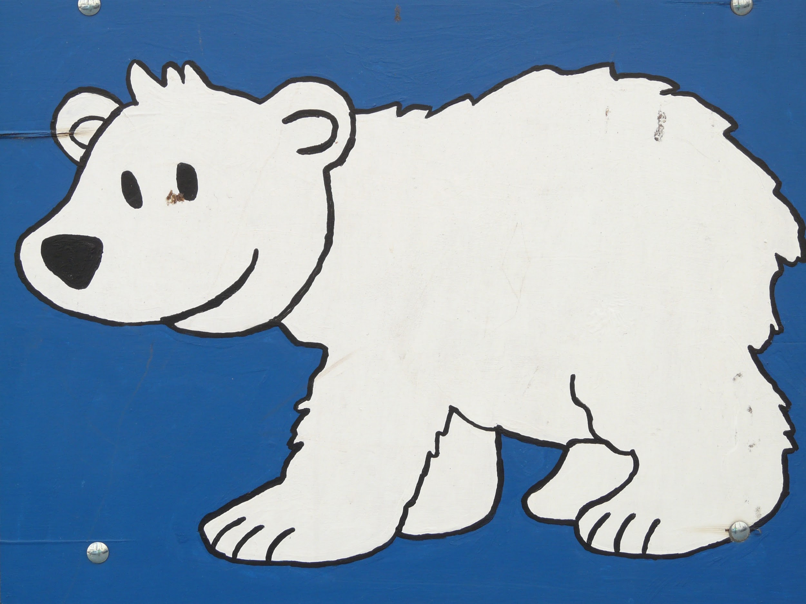
Put these organisms into a food chain: humpback whales, phytoplankton, krill

Answer: Phytoplankton => Krill => Humpback whales
Penguins and polar bears are found in the Arctic. True or false?

Answer: False, only polar bear
Caribou, reindeer, fox and bears are found in which polar region? Arctic or Antarctic?

Answer: Arctic
Microbes are found in the Dry Valleys of Antarctica. They are easily studied by scientists out in the field. True or False.
Answer: False, microbes are not easily studied
Penguins are naturally found only in Antarctica. True or False.

Answer: False- Galapagos,New Zealand, South Africa
Which of the following is NOT a mammal?
Polar bear? Penguin? Arctic fox?

Answer: Penguin
Antarctica has no terrestrial mammals. Name an aquatic mammal found around Antarctica.

Answer: Whales, seals, sea lions, walruses, dolphins, porpoises
Young krill (shrimp-like crustaceans) need sea ice to survive in the winter. What aspect of global climate change will affect them most?

Answer: Melting sea ice
Which polar region food web has no terrestrial mammals? Arctic or Antarctic?

Answer: Antarctic
Which animal is a top predator in Antarctica - orca or polar bear?

Answer: Orca
Polar bears need sea ice to hunt their prey. What aspect of global climate change will affect them most?

Answer: Melting sea ice
Whales are legally hunted at both poles? True or false
Answer: True - Japan for scientific research, Norway, Canada/US culturally
Which of the following is NOT a mammal?
Walrus? Krill? Humpback whale?

Answer: Krill

