Accessing and Analyzing Authentic MBARI Real-Time Data
Patrick Murray
Summary
Students in Computer Science Essentials, a first course in high school Computer Science, will access the MBARI data set and create a graph as part of a final student project. Students then design, code, and debug a Python program to create their own graph that matches the MBARI graph.
Keywords: Computer Science, Python, MBARI data.
Key Concepts
- HS-ETS1-1. Analyze a major global challenge to specify qualitative and quantitative criteria and constraints for solutions that account for societal needs and wants.
- HS-ETS1-2. Design a solution to a complex real-world problem by breaking it down into smaller, more manageable problems that can be solved through engineering.
- HS-ETS1-3. Evaluate a solution to a complex real-world problem based on prioritized criteria and trade-offs that account for a range of constraints, including cost, safety, reliability, and aesthetics as well as possible social, cultural, and environmental impacts.
- HS-ETS1-4. Use a computer simulation to model the impact of proposed solutions to a complex real-world problem with numerous criteria and constraints on interactions within and between systems relevant to the problem.
- Computer Science Standards
- 9.3.IT-SUP.3 Apply appropriate troubleshooting techniques in resolving hardware, software, and configuration problems.
- 9.3.IT-PRG-4. Demonstrate the effective use of software development tools to develop software application.
- 9.3.IT-PRG-5. Demonstrate the effective use of software development tools to design software applications.

Objectives
Include clear, measurable statements of what students will be able to do, such as:
- Students will access the MBARI website.
- Students will select appropriate categories and run a simple report.
- Students will screen grab their selected report, using it as a reference.
- Students will rerun the report to get the text data file.
- Students will design, code and debug a Python program to produce the exact same report using the text data file as input.
Materials
- Computer
- Internet Access
- Python Development Environment 3.6.1
Procedure
- Students will access the MBARI website.
http://www.mbari.org/science/upper-ocean-systems/chemical-sensor-group/floatviz/
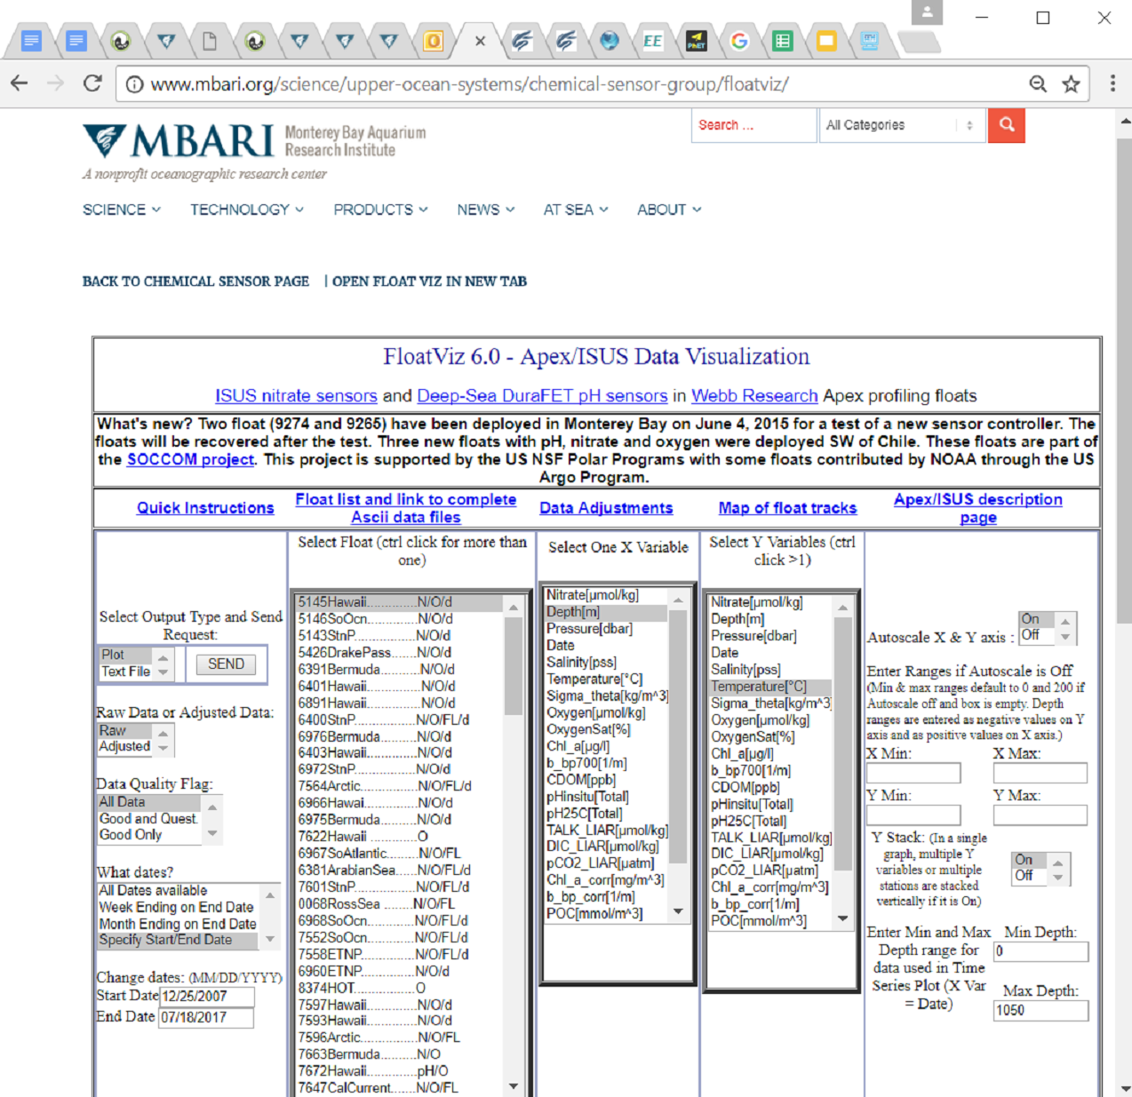
Courtesy of MBARI

2. Students will select appropriate categories and run a simple report. For Example, 5145Hawaii, Depth, Temperature, Raw, for 12/25/2007 to 12/25/2007.
3. Students will screen grab their selected report, using it as a reference. For Example
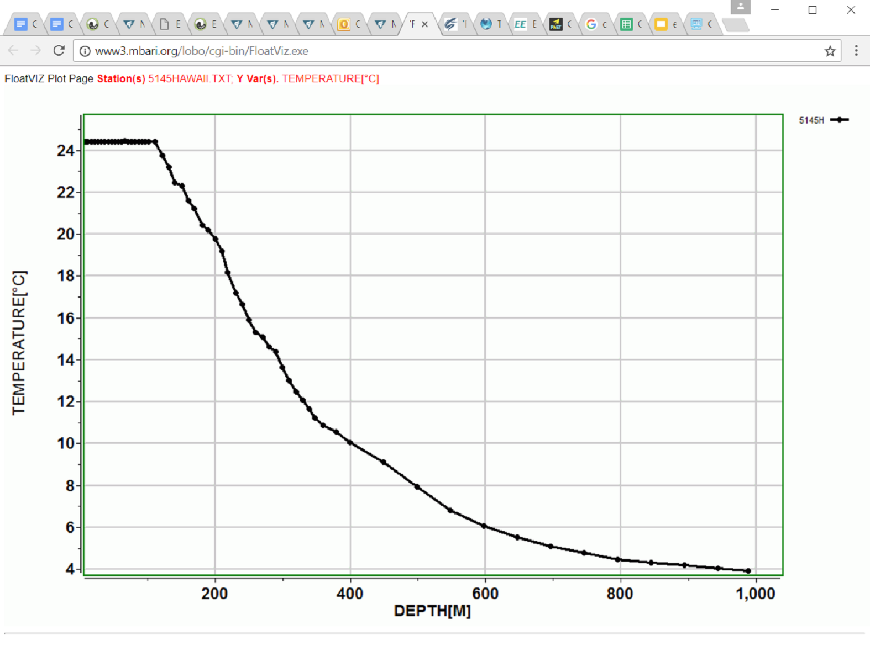
Courtesy of MBARI
4. Students will rerun the report to get the text data file. For Example,
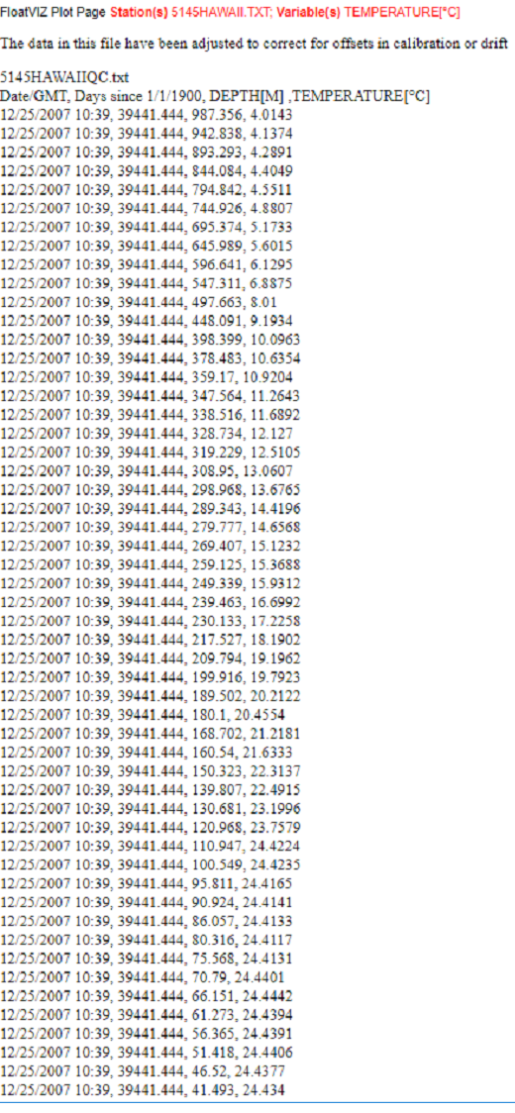Courtesy of MBARI

5. Students will design, code and debug a Python program to produce the exact same report using the text data file as input. For Example:
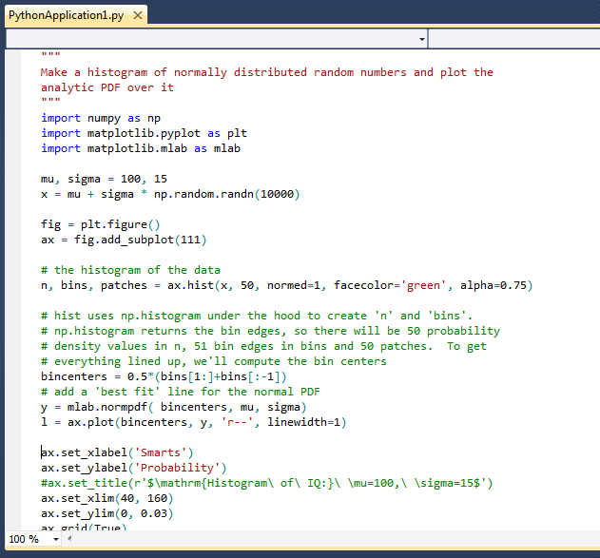
Courtesy of codeguru.com

Assessment
- 1. Students will print a screen grab of the options selected for the report about to be run from the MBARI site. The Options selected shall create simply one set of data points drawing only one line.
- 2. Students will print a screen grab of the report once its run.
- 3. Students will print a screen grab of the data run from the same report
- 4. Students will turn in the file data associated with the data file of the same report graphed.
- 5. Students will turn in a Python Program that prints the same report.
- 6. Students will turn in the report printout from Python
- Scoring Rubric - 20 points total
- 1. 1 pt - screen grab of options selected.
- 2. 1 pt - screen grab of report run.
- 3. 1 pt - screen grab of data. 2 points. data must match graph.
- 4. 1 pt - file of data. 2 pts - one-to-one correspondence of points to graph.
- 5. 3 pt. proper design. 3 pts. proper coding. 3 pts proper documentation. 3 pts graph quality

Additional Resources
No additional resources
Extensions or adaptations
1. Using Java instead of Python.
2. Creating more challenging graphs.
3. Graphing data from the work of others.

