How Does Temperature Affect Water Quality?
Get Your Feet Wet

Using Real Data to Introduce Water Quality Concepts



Before you start

Place the station sheets around the room to allow for the gallery crawl.

Step 1

Ask and see if anyone knows what it means to be “in hot water?”
Ask if anyone has ever been in “hot water”.
Ask how it happened?

Step 2

Explain that today they will be examining water temperature and how it relates to water quality.
Ask the students to predict how temperature will affect the quality of water
Ask the students if they can identify other the factors that will affect water quality

Step 3

Explain to the students that they will be focusing on temperature, salinity levels, dissolved oxygen levels, pH level, chlorophyll level, and turbidity level. Next give the students a study guide/data sheet.

Step 4

Ask the students to first review the vocabulary terms at the top of the page.
Ask the students to predict the relationship between temperature and each of the five other variables. Record your predictions in the table provided.

Step 5

Break the class into groups. Assign each group to a station. Identify each station and provide instruction for the carrying out the gallery crawl.

Close

When finished get back together in a large group setting and compare notes, answer questions, and clear up misconceptions.
Ask how the data at each station could change over time.
Ask if certain conditions could provided you with skewed or “bad data”.
And finally ask the students to explain how something as simple as a slight change in the temperature of an ecosystem, can affect the organism in that ecosystem.

Name ___________________________________ Date _____________________________ Class _________________

Vocabulary

1.Dissolved Oxygen: oxygen dissolved in water, dissolved oxygen is important for fish and other aquatic animals
2.Percent Saturation: amount dissolved expressed as a percent of the amount which can be dissolved
3.pH: measure of how acidic or basic a solution is
4.Salinity: a measure of the amount of salts dissolved in seawater
5.Temperature: the average kinetic energy of the individual particles, a measure of how hot or cold something is
6.Turbidity: the cloudiness or haziness of a fluid caused by individual particles (suspended solids) that are generally invisible to the naked eye, similar to smoke in air.

 |  | In the space below predict how temperature will relate to each of the variables. | In the space below describe how temperature related to each of the variables.
Station 1 | Depth
Station 2 | Turbidity
Station 3 | Dissolved Oxygen
Station 4 | pH
Station 5 | Salinity
Station 6 | Percent Saturation

Station One: Water Depth
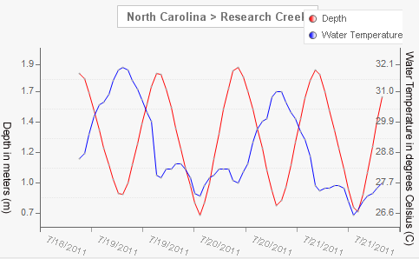

Look at the graph above. What is the relationship of water temperature to water depth? Write your answer in the space provided on your study guide.

Station Two: Turbidity
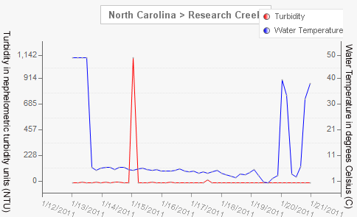

Look at the graph above. What is the relationship of water temperature to turbidity? Write your answer in the space provided on your study guide.

Station Three: Dissolved Oxygen
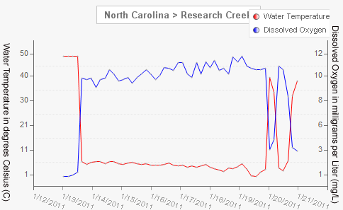

Look at the graph above. What is the relationship of water temperature to dissolved oxygen? Write your answer in the space provided on your study guide.

Station Four: pH
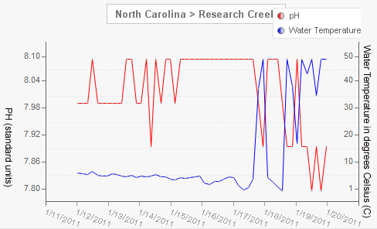

Look at the graph above. What is the relationship of water temperature to pH? Write your answer in the space provided on your study guide.

Station Five: Salinity
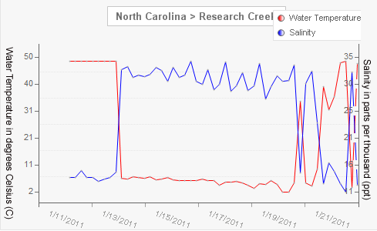

Look at the graph above. What is the relationship of water temperature to salinity? Write your answer in the space provided on your study guide.

Station Six: Percent Saturation
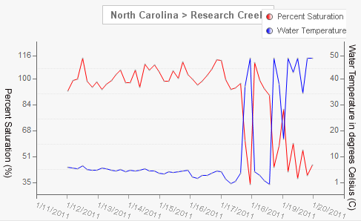

Look at the graph above. What is the relationship of water temperature to percent saturation? Write your answer in the space provided on your study guide.

