- Locating the Latitude and Longitude Data in the OCEARCH Tracking Map: (These directions were written based on screens shown in the Firefox® web browser.)

- Open the web browser to the OCEARCH website. (www.ocearch.org)
- Select the 3-Horizontal Stripes located in the upper-right corner of the browser window as shown in Figure 1 – Accessing Latitude-Longitude Data.
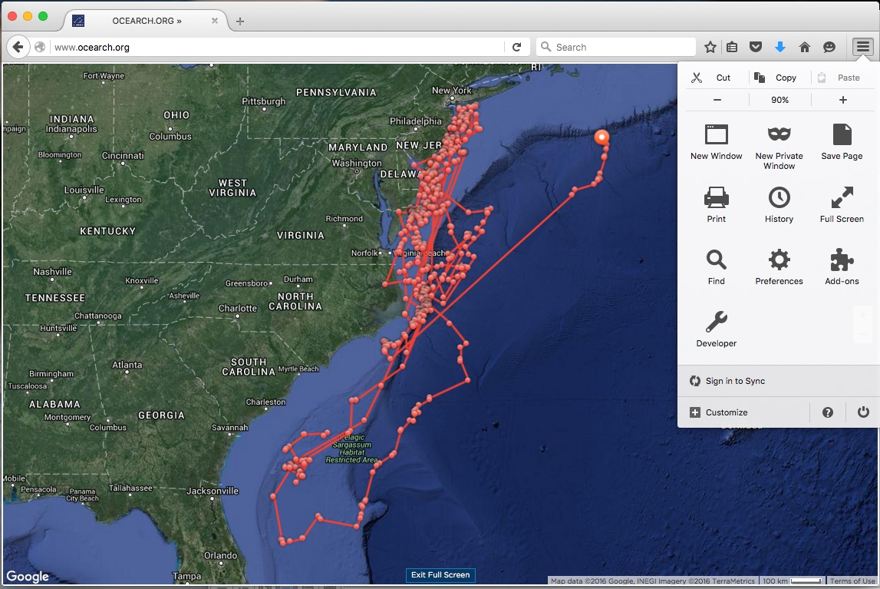
Figure 1 – Accessing Latitude-Longitude Data

- From the drop-down menu, select Developer Tools as shown in Figure 2 – Developer Tools.
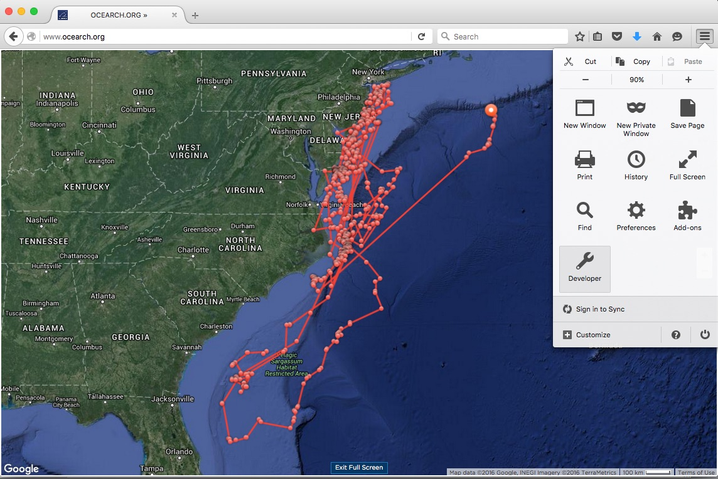
Figure 2 – Developer Tools

- From the Developer Tools side menu, select Network as shown in Figure 3 – Network. This will load the files used in these tracking maps.
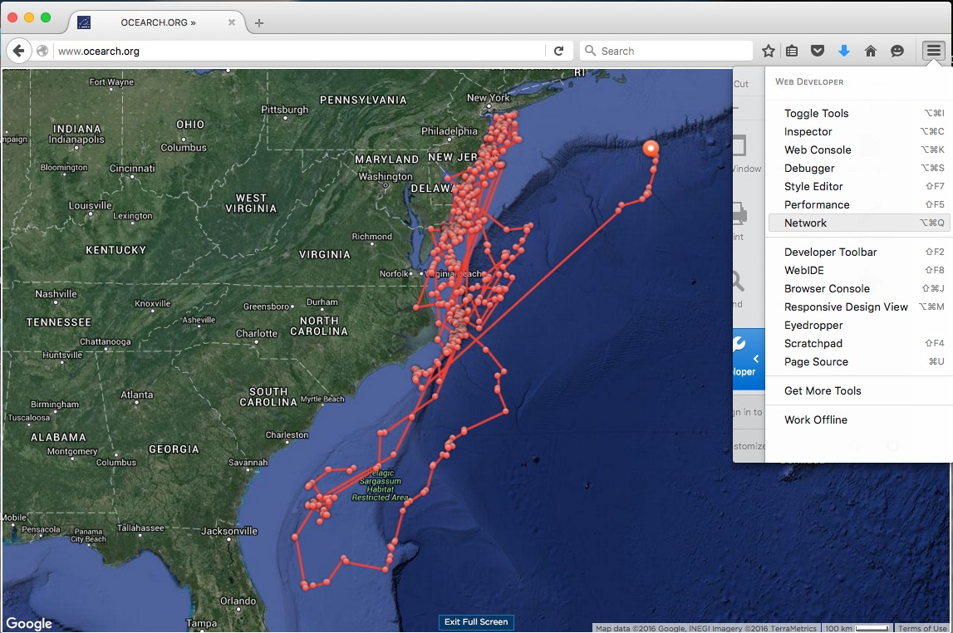
Figure 3 - Network

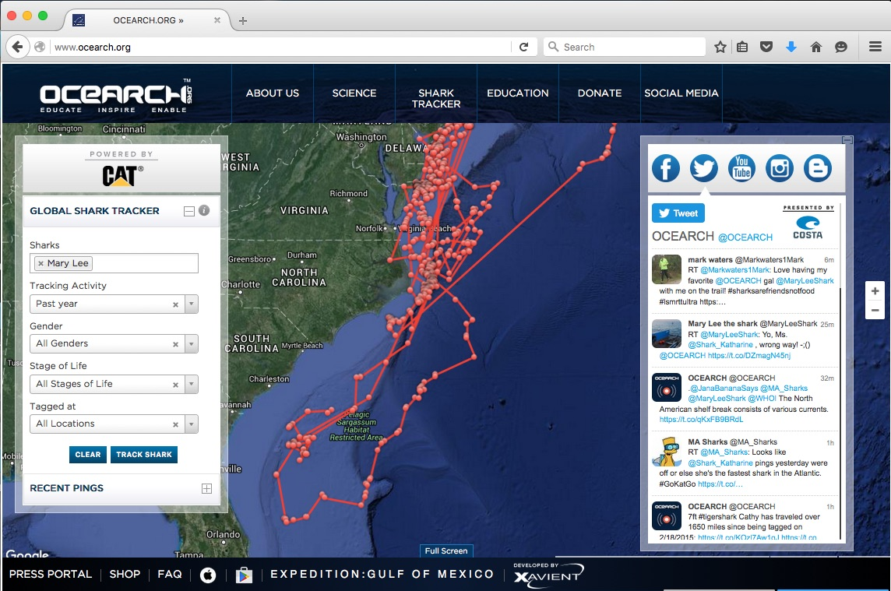
- Locate the Global Shark Tracker menu on the left side of the OCEARCH map and select the following from each field as shown in Figure 4 – Opening OCEARCH Tracking Map:

Sharks: (Select the shark you want to track using the drop-down list. For this example, Mary Lee has been selected.)
Tracking Activity: Past Year
Gender: (Not applicable to this activity)
Stages of Life: (Not applicable to this activity)
Tagged at: (Not applicable to this activity)

Figure 4 – Opening OCEARCH Tracking Map

- Select the Track Shark button at the bottom of this menu. The shark’s tracking lines and “ping” data points will appear on the map.
- Locate and select the Full Screen button located at the bottom of the map. This will display a clear map with the tracking lines and data point. The ZOOM IN/OUT buttons can also be used to assist in locating specific data points.
- After the files have finished loading, locate the json file in the Type column as shown in Figure 5 – Shark File. (TIP: Sort for file type by clicking the column heading: Type. Then, scroll down alphabetically to locate the json file.)
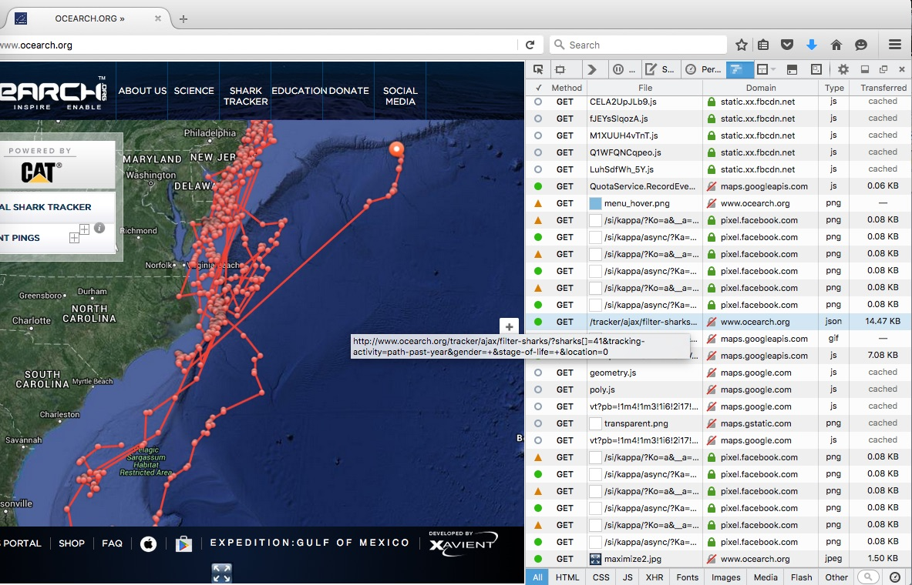
Figure 5 – Shark File

- Next, select the Response tab shown below the file list to locate information about the shark you are tracking. Record this information on your Data Sheet.
- Next, select the arrow to the left of the Ping data as shown in Figure 6 – Response and Ping Data. This will display a list of Object links, starting with Object 0 and continuing in descending chronological order for each ping recorded during the past year for this shark. (In this example, Mary Lee has over 500 Objects, or Pings.)
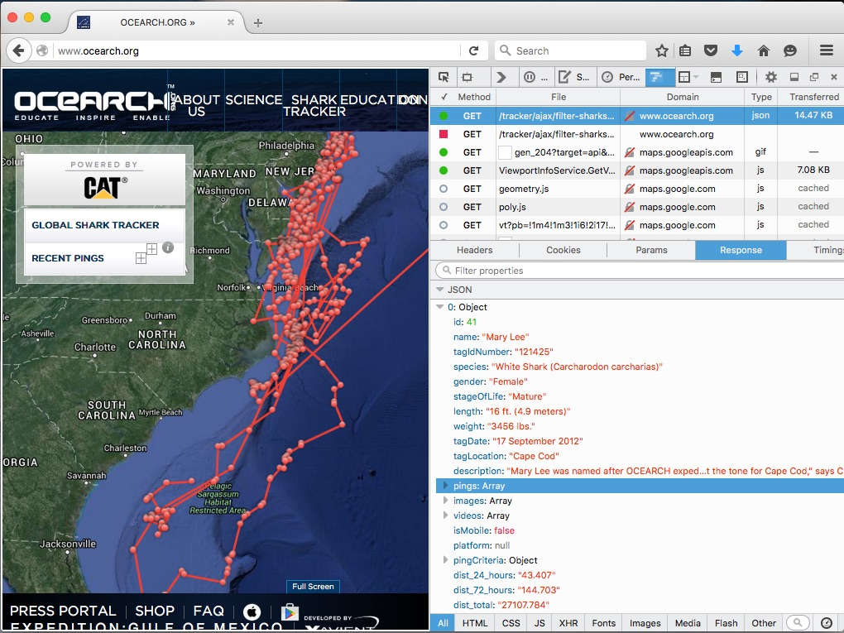
Figure 6 – Response and Ping Data

- Scroll to the bottom of the Ping data and locate the final Object for January 2015 by selecting the arrows to open the data set for each Object, as shown in Figure 7 – Object Data, and record the following:
  - Date (EX: January 30, 2015)
  - Time (EX: 9:07 AM)
  - Latitude (EX: 31.07643)
  - Longitude (EX: -78.5413)

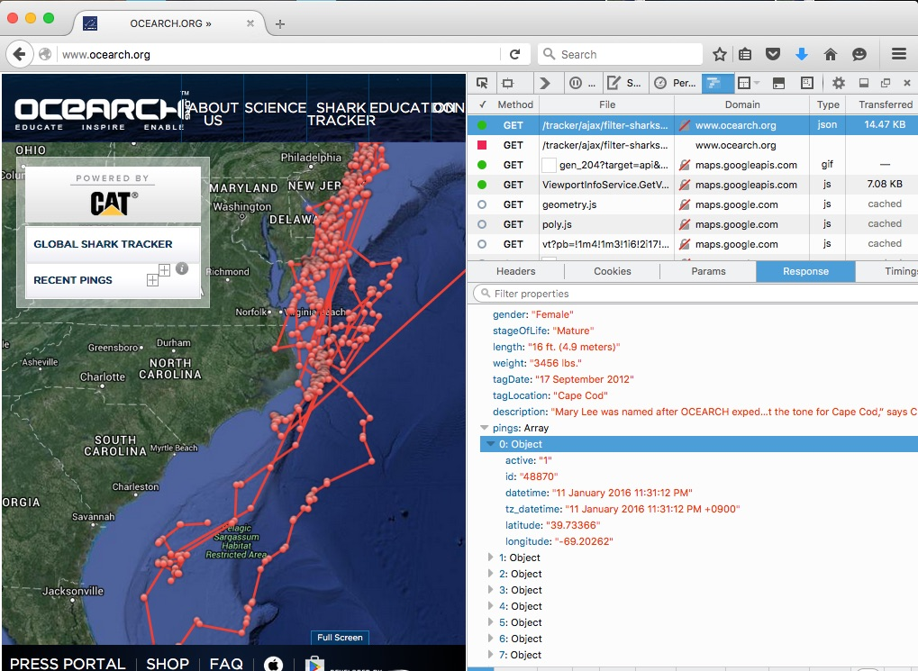
Figure 7 – Object Data

- Scroll upward to locate the final day for each of the 12 months between January 2015 and December 2015 for the shark you are tracking and repeat Step 11 for each data point.
*********************
Troubleshooting:
- Can’t find Full Screen button on OCEARCH map: Click and drag to enlarge the window the OCEARCH map is displayed on and the Full Screen button should appear at the bottom of the map.
- Selecting Network does not load the data files: Click Refresh on your browser or click the Reload button in the Developer Tools; then re-enter the information in the OCEARCH Tracking Menu for the shark you want to track.
*********************

- Merging OCEARCH Tracking Data with NANOOS (NVS – NANOOS Visualization System Climatology Data for Sea Surface Temperature (SST) – (Data from 2015 was accessed for this example.)
- Open the NANOOS Climatology Website: (http://nvs.nanoos.org/Climatology)
- Use the Toggle arrows in the upper-left corner of the map to re-center the map over the East Coast of the US as shown in Figure 8 – NANOOS – NVS Climatology Page.
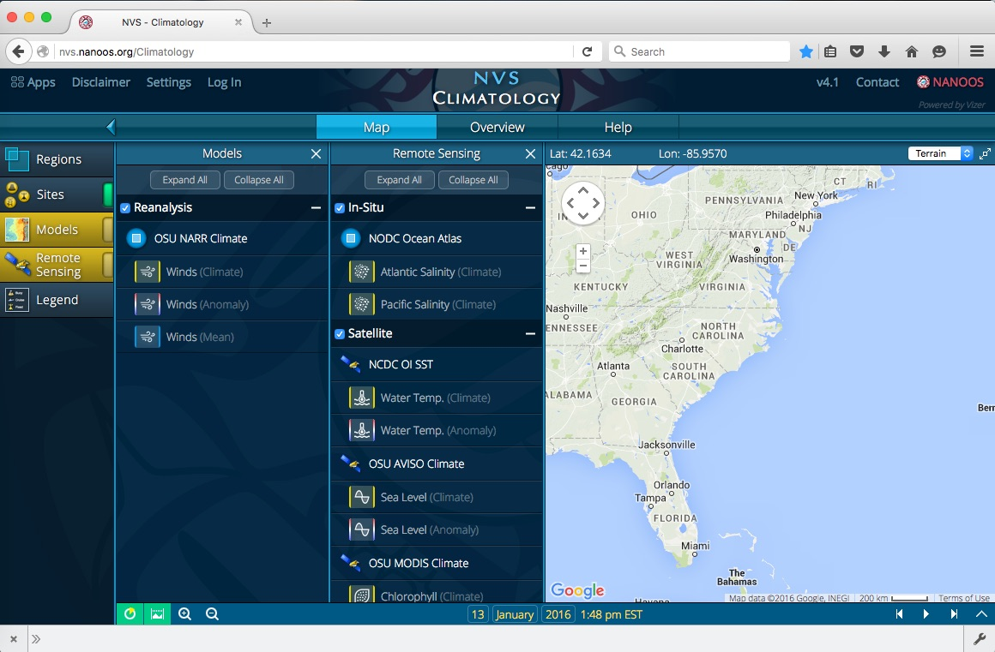
Figure 8 – NANOOS – NVS Climatology Page

- Look below the Remote Sensing column on the left side of the map and select the Water Temp. (Climate) tab found beneath the Satellite and NCDC OI SST section. (See Figure 9 – Water Temp. Climate Data)
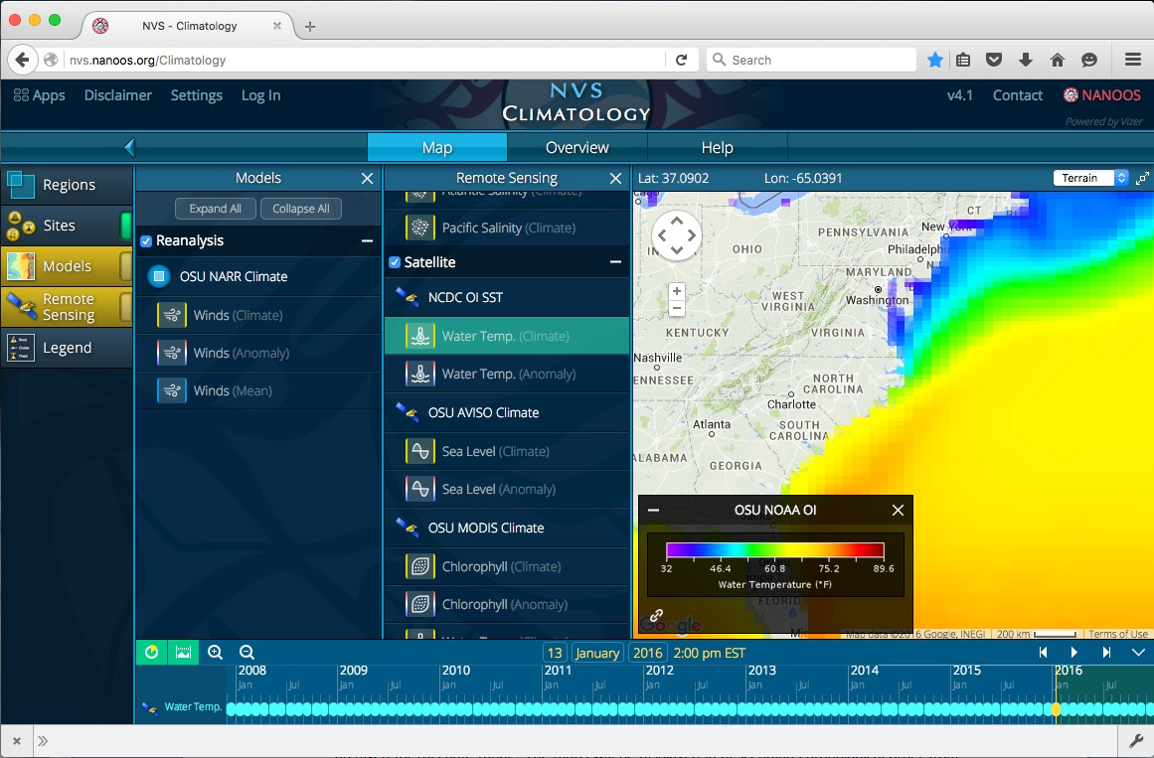
Figure 9 – Water Temp. Climate Data

- Use the Toggle Map Size button in the top-right corner of the map to enlarge the map size as shown in Figure 10 – Enlarged Map View. Use the Toggle arrows (used in Step 2) to re-center the map if needed.
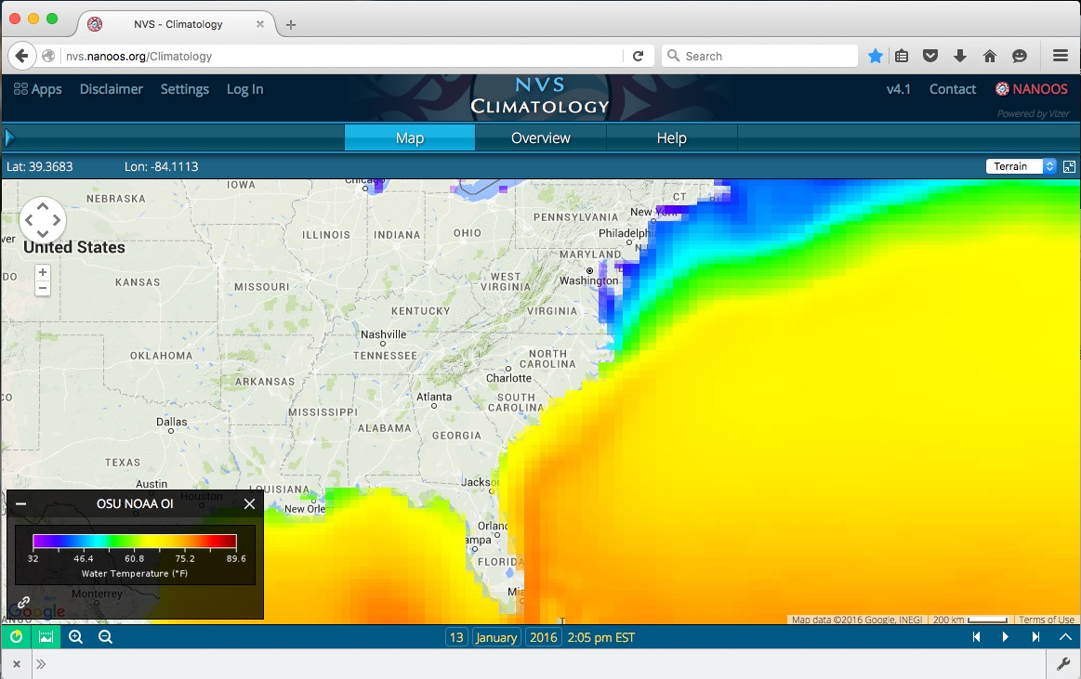
Figure 10 – Enlarged Map View

- Change the Date and Time shown at the bottom of the map to match the first data “ping” point recorded on your Data Sheet. Use the cursor to locate the Latitude and Longitude for the first data point. Observe changes to the “Lat:” and “Lon:” fields, which are located in the upper-left corner of the NVS map. The example shown in Figure 11 is for 30JAN2015 at 9:00AM for Lat: 31.3161 and Lon: -78.5303.
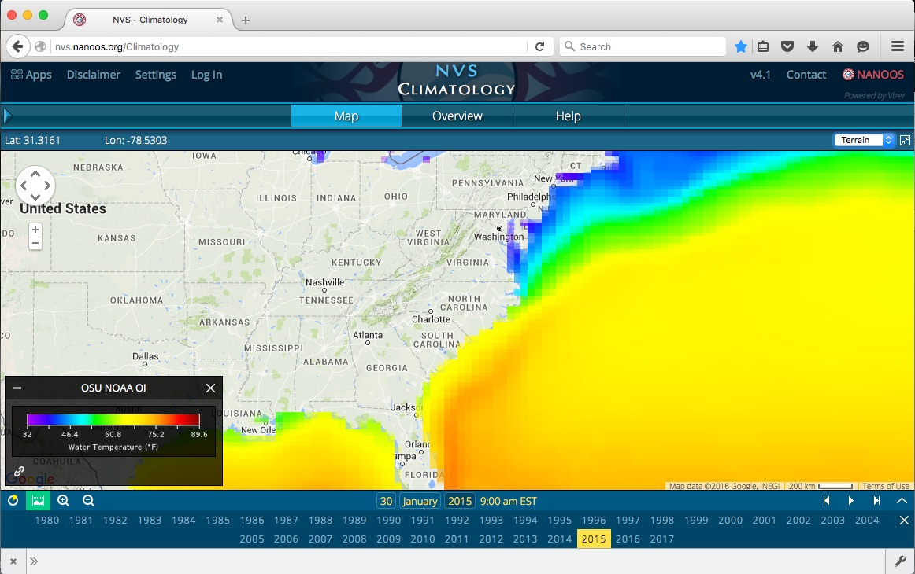
Figure 11 – 30JAN2015 at 9:00AM (Lat: 31.3161; Lon: -78.5303)

- Repeat Step 5 for each data point recorded on your Data Sheet.

OCEARCH Android/IOS Phone/Tablet Tutorial:
Navigating OCEARCH: The OCEARCH Application HOME screen includes a global map noting the last known location of each shark that has been tagged by OCEARCH. An ORANGE CIRCLE indicates the shark’s location has been recorded in the past 30 days. A BLUE CIRCLE indicates the shark’s location was recorded more than 30 days ago. The HOME screen can be zoomed in to locate a specific shark.
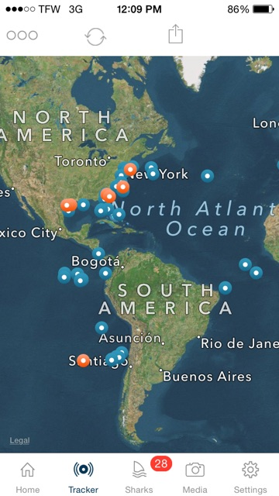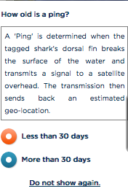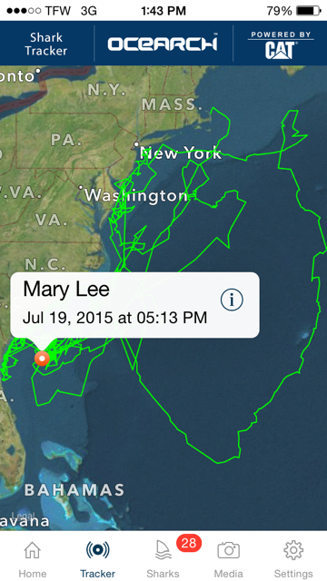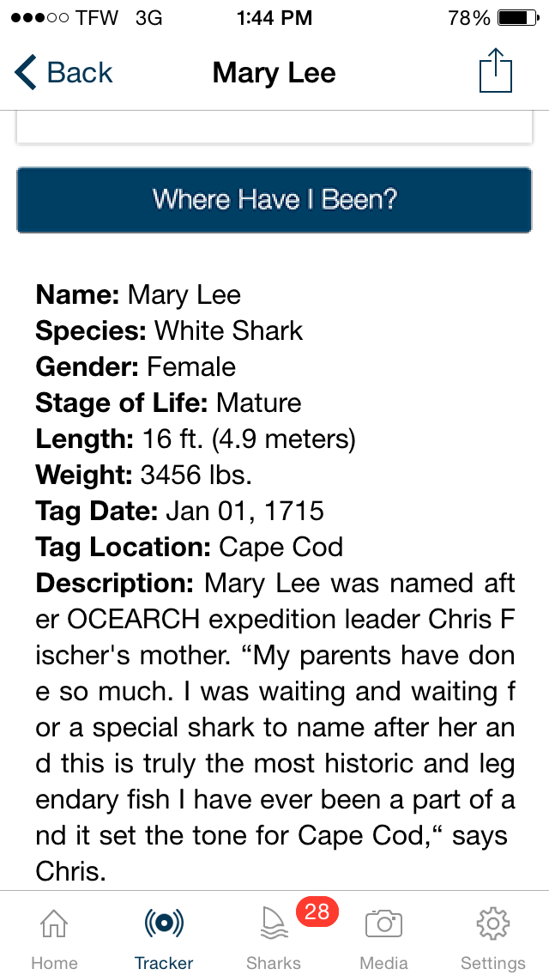
Use a TAP on the selected circle to open a pop-out box for the shark. The pop-out box includes the shark’s NAME, the DATE and TIME of the last recorded PING, and 2 icons: (+) and (i). The (+) icon opens the tracking map for this shark. The (i) icon will open a new window containing detailed information about the shark. From the shark information screen, students can select the SETTINGS button to set the applications default to their shark selection. If students want to keep up with more than one shark, be sure the DEFAULT SETTING is “All Sharks”. The SHARKS (fin icon) button can be selected to see a list of all sharks with recent pings. The TRACKER button can be selected to return to the Global Tracker Map. The HOME button provides information about OCEARCH and links to the Social Media sites operated by OCEARCH, including Twitter, Facebook, Instagram, and Google Plus.

OCEARCH currently does not provide a latitude/longitude overlay for their mapping data. Students will need to compare their tracking map to a similar map of their location using Google Earth software. Use the computer mouse (or finger on a tablet device) to locate the LATITUDE/LONGITUDE coordinates that most closely match the OCEARCH ping location.
