Seeing Sound

Summary
In this lesson students will read about the properties of waves as they relate to sound. Students will also experience demonstrations of how longitudinal and transverse waves move through a medium. Students will also be introduced to spectrograms and how they allow for us to study sounds. They will then apply this knowledge to try and match spectrograms to the correct source.
Waves, spectrogram, wavelength, amplitude,
Key Concepts
- Students will be introduced to wave length, frequency, amplitude, transverse and longitudinal waves, and spectrograms.
Common Core State Standards
CCSS.ELA-LITERACY.RI.4.2
Determine the main idea of a text and explain how it is supported by key details; summarize the text.
CCSS.ELA-LITERACY.RI.4.4
Determine the meaning of general academic and domain-specific words or phrases in a text relevant to a grade 4 topic or subject area.
CCSS.ELA-LITERACY.RI.4.7
Interpret information presented visually, orally, or quantitatively (e.g., in charts, graphs, diagrams, time lines, animations, or interactive elements on Web pages) and explain how the information contributes to an understanding of the text in which it appears.
Next Generation Science Standards
4-PS4-1 Develop a model of waves to describe patterns in terms of amplitude and wavelength and that waves can cause objects to move.

Objectives
- Students will analyze spectrograms to predict the source animal.
- Students will develop their understanding and use of vocabulary relating to waves.
Materials
- www.dosits.org (science of sound)
- Wave modeling spring or slinky
- Spectrogram matching cards (appendix A)
- Science journals
Procedure
- Start the lesson by playing a few samples of everyday sounds. Have students identify them. How did you know what made the sound? Then tell the students that they will be learning about sound today and how we can describe AND show what we hear.
- Introduce students to www.dosits.org. (If you are having students read along on their own device, give them a short tour of the website, then direct them to What is Sound? (http://www.dosits.org/science/sound/whatissound/)
- Read through what is sound with the students. Focus on the vocabulary (wave, equilibrium, medium, longitudinal wave, transverse wave, and parallel). Have students complete the vocabulary template for each word. .Model the difference of transverse and longitudinal waves with the wave modeling spring. It is important that students can get a visual representation of the difference.
*If you do not have a modeling spring, you can use a slinky, a jump rope, or a bungee cord.
4. Guide your students through How do you characterize sounds? (http://www.dosits.org/science/sound/characterizesound/) Intensity/amplitude, frequency, and wave length have extension pages that go more in depth and will assist in developing this new vocabulary.
5. Play several sounds from the sound gallery of (http://www.dosits.org/audio/interactive/ ). Have a discussion about the sound wave properties, such as does the sound have a high or low frequency? Use this opportunity to familiarize the students with the spectrograph. You could compare two sounds and discuss which has higher amplitude. You could also have students describe what they hear and work as a group to translate their observations into the lesson vocabulary. The objective of this section of the lesson is to apply the vocabulary they have just learned.

6. Distribute match card sets (You will want to cut them apart Appendix B). Encourage students to think about what they know about sound and what they have learned in this lesson. The objective is to match the spectrograph to the correct animal.
Play each sample that goes with each spectrogram so that students can connect the audio with the visual. Then let students work individually or in small groups to pair the spectrogram with the correct animal. Encourage students to explain their reasoning and evidence.
7. The Reveal- Display each animal then play the corresponding spectrogram. Students will self-assess their pairings. Students will write a journal response discussing their results. What observations have you made about sound? Spectrograms? Have students share their journal entry with a partner.

Assessment
- Students will create a sort that matches the correct spectrogram with the correct animal based on their knowledge of wave properties.
- Students will write journal entries recording their observations
- Use of vocabulary in discussion
Additional Resources

Name that Sound Powerpoint

http://www.dosits.org/resources/ Class activities and teacher resources

http://www.hum.uu.nl/uilots/lab/courseware/phonetics/spectrogram/spectrogram.html - What is a spectrogram?

http://www.ducksters.com/science/sound101.php

http://www.kidsdiscover.com/spotlight/sound-and-vibration/

https://www.youtube.com/watch?v=ACeUO4ufx2I Bill Nye demonstration video

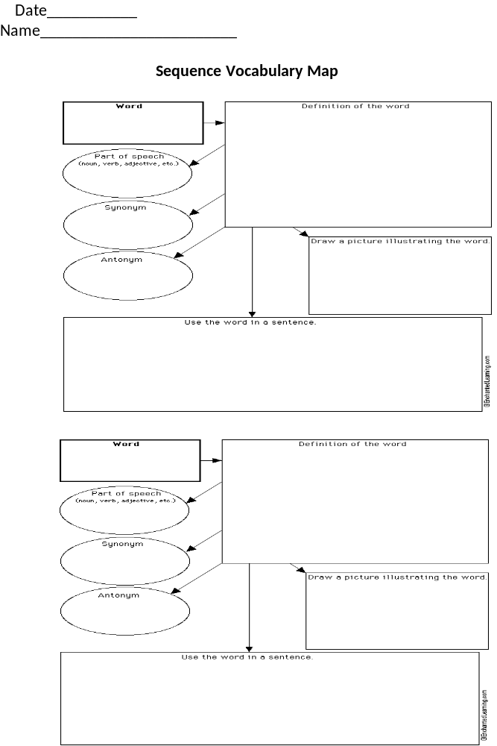
Appendix A
Cards for Matching

Undersea Earthquake

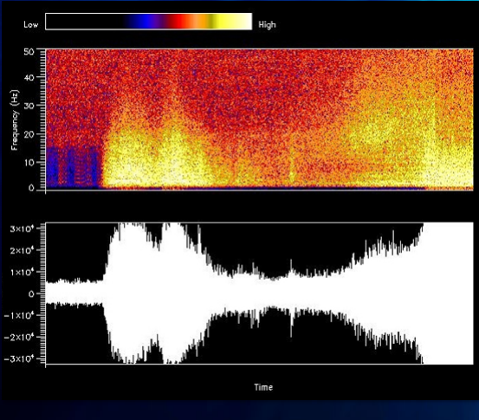

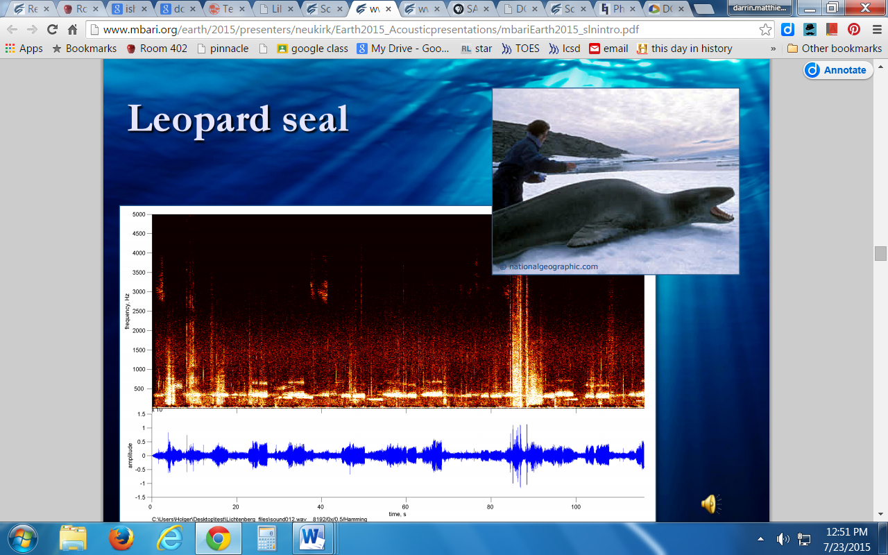
Leopard Seal

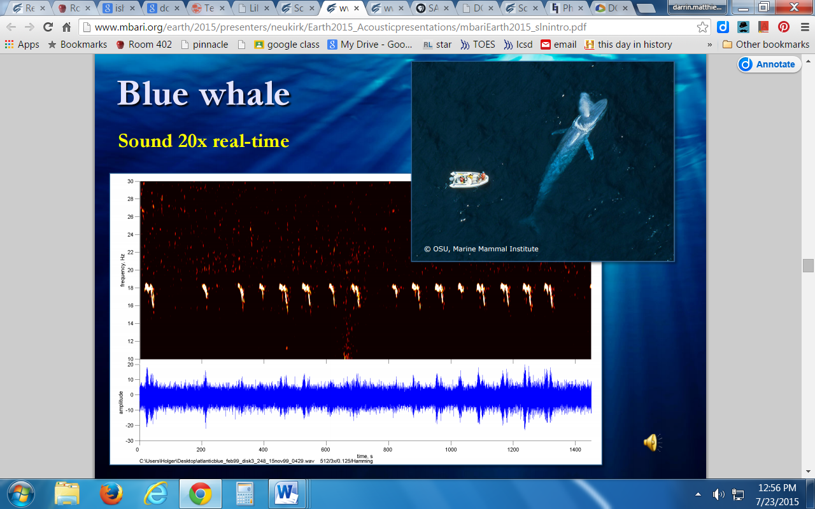 Blue Whale

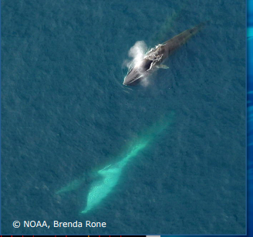 Fin Whale

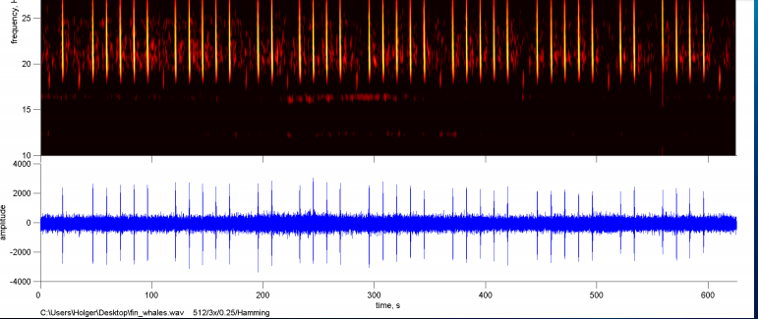

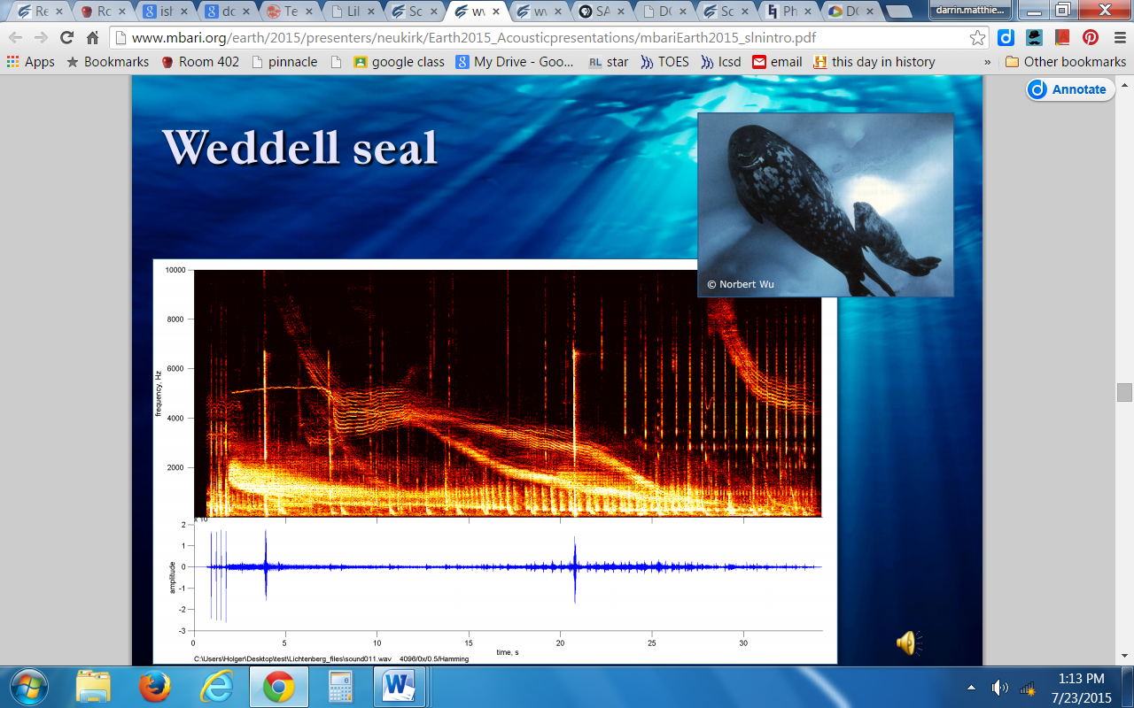 Weddell Seal

