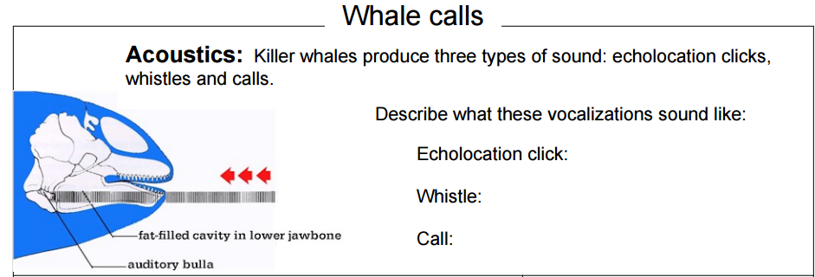

Read about Killer Whales (Orcas) at <http://www.dosits.org/audio/marinemammals/toothedwhales/killerwhale/>

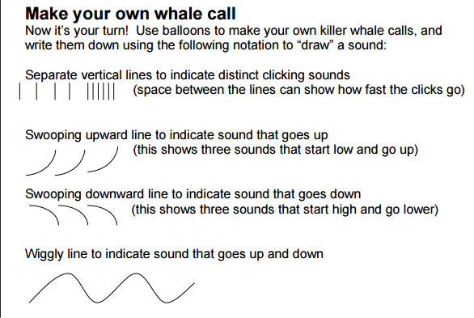

**Notation of your whale call:**