Directions for gathering and graphing the LTER data set to find the diet of Adelie penguins off Palmer Station, Antarctica.

Directions for working with LTER data
Go to http://pal.lternet.edu/data
Click on Data, then Click on Go to Catalog (see below)

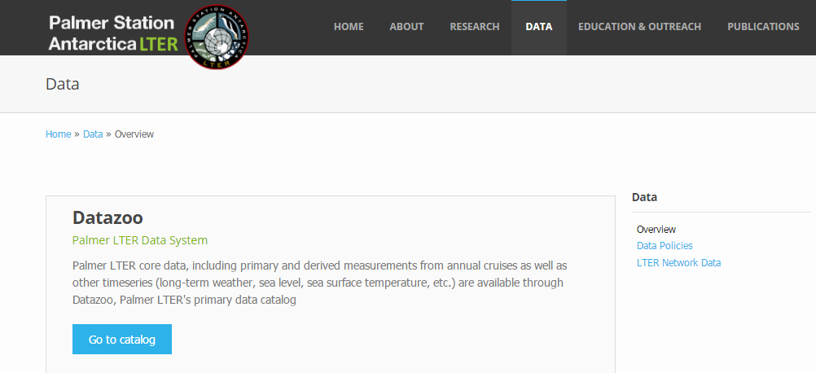
You will need to log in (this is only for the site to keep track of who is using it).

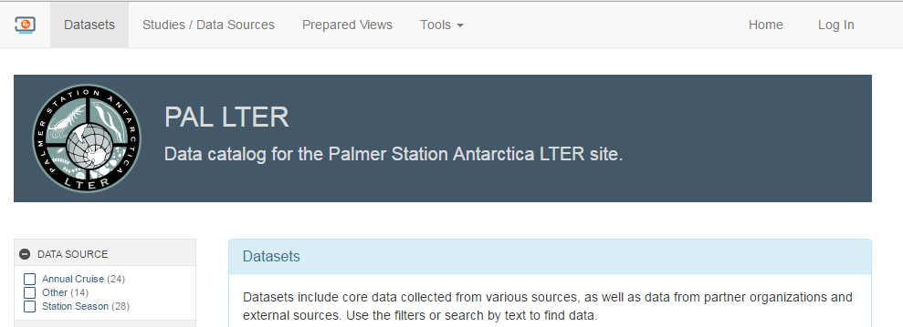
Scroll down to the Public Users. Enter name and email address. Under USE, use the drop down menu to Education (K12) as seen below.

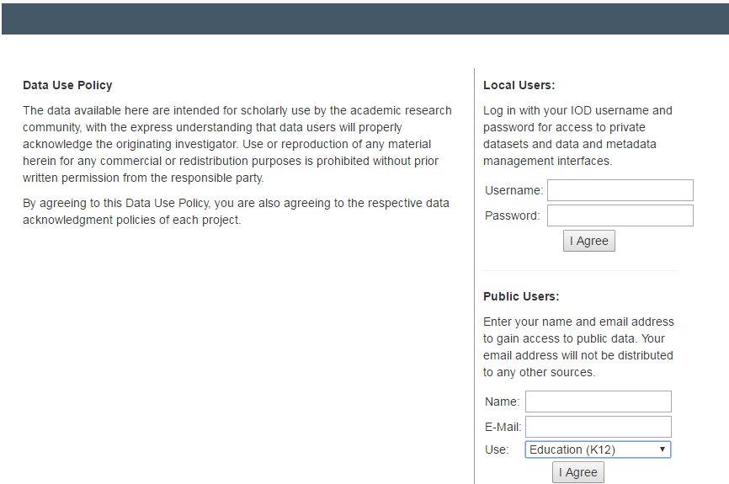
Once you have hit I Agree, you will need click on Return to previous page
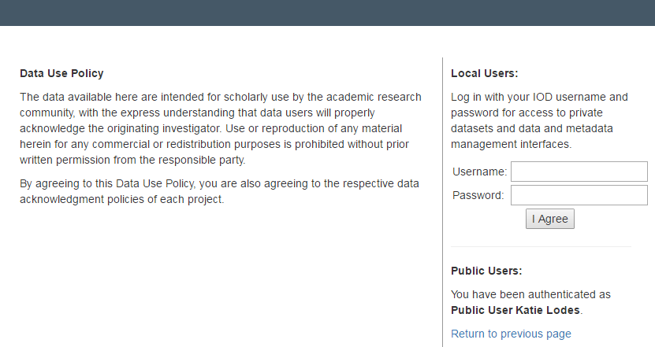
Enter “adelie diet” in the Submit box
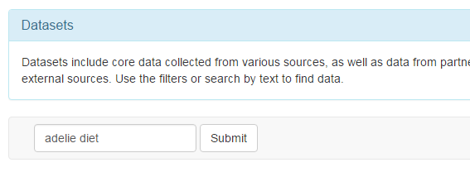
Then pick
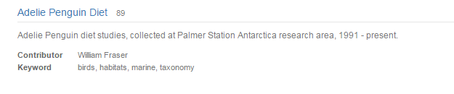
And then click on DATA and select Download
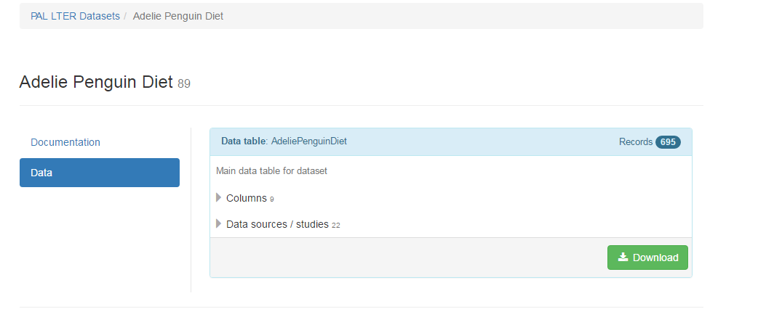

This is a tricky part! Once the screen below shows up, you are going to UNSELECT (by clicking on). See below:
Then select DOWNLOAD

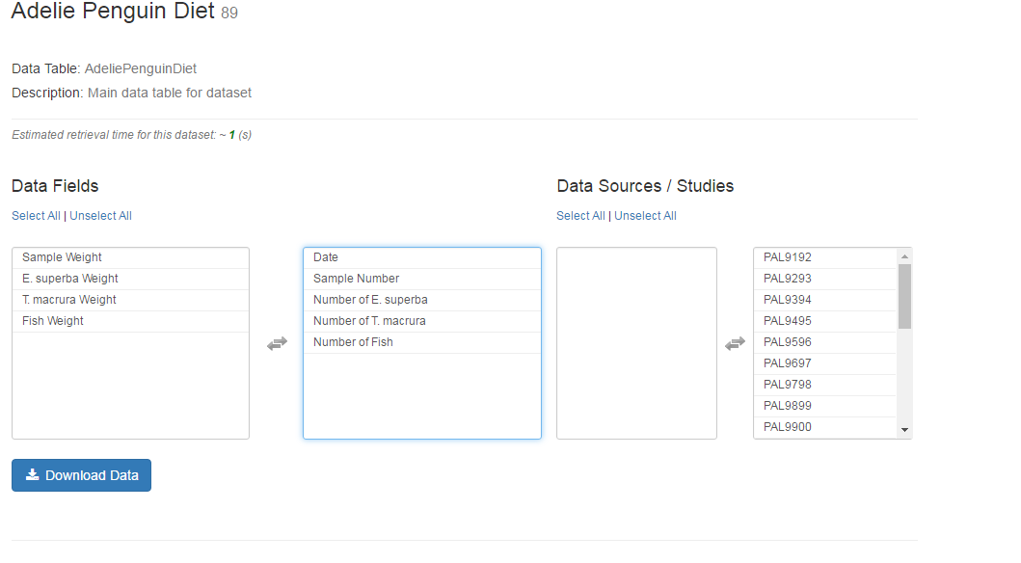
You will have choices when downloaded, select Download XLS (it will save to your computer)
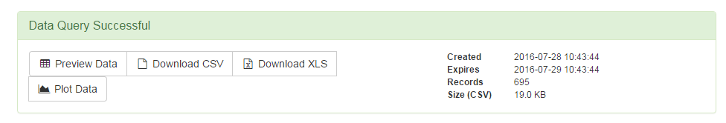
This is a very large data set (like 650+ rows) but is very manageable.
To total each of the food types from 1992-2013, add Total to the spreadsheet (see below).
Also highlight the col
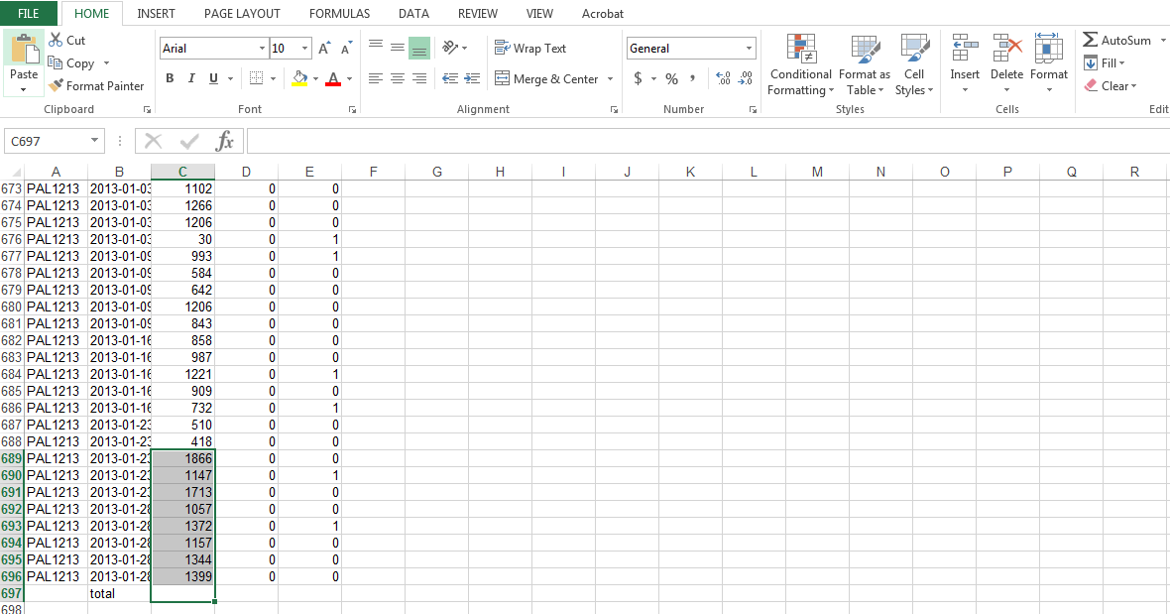
Do this for each column. The final output will look like
Both the E. superba and T. macrura are species of krill so we will need to combine their numbers.
To do this, scroll down to the bottom, and type in the formula as seen below.
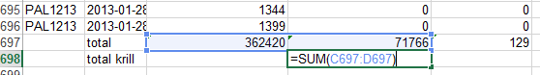
You also need to calculate the total number of food items for the penguins. Just highlight the totals for all three columns, and use the function.
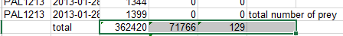
Finally, to get the % of the Adelie penguins’ diet that is krill vs fish to compare from data collected in the 1970s and 1980s. Follow
