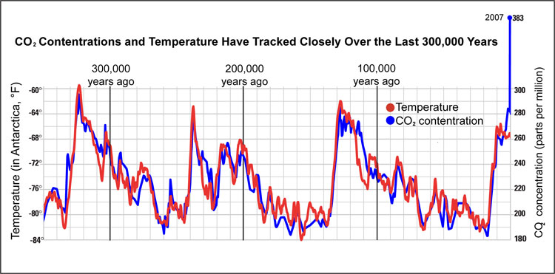

Credit: Image modified and courtesy of the Marian Koshland Science Museum of the National Academy of Sciences. http://www.koshland-science-museum.org/

