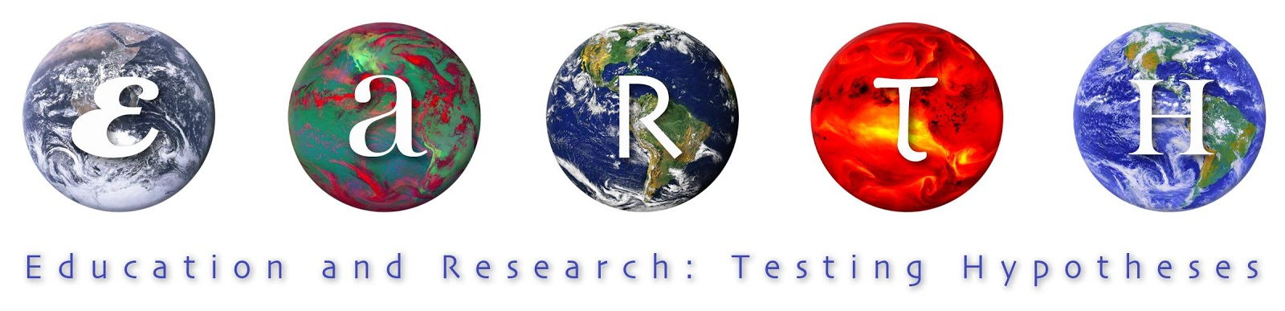

Carbon Cycle Infographic
Piktochart or PicCollage
Student Handout

You will use the Piktochart or PicCollage website to prepare a poster that visually explains your part of the Carbon Cycle.
You will be assigned one topic: atmosphere; photosynthesis; cellular respiration; run off; decay & decomposition; coal, oil & gas; burning fossil fuels; vegetation; wildfires; deep ocean circulation; dissolved carbon, and ocean acidification.

Your poster must include: (* adjusted for some students)
- a “catchy” title
- a short description of that part of the cycle
- at least one visual element (photo, graph, diagram, etc.) that shows carbon in your part of the carbon cycle
- * a short description of the human impact on your part of the carbon cycle - 1 bad way humans are affecting that segment and 1 good way that humans are making things better
- * the different forms that carbon is found in your part of the carbon cycle
- at least one “fun fact” you found out about your part of the carbon cycle
- * a link to an online news event that discusses your part of the carbon cycle
* Be sure you cite ALL of your resources on your poster.

Creativity is required but you MUST make sure that each element of your poster is scientifically sound!

Your topic is _________________________________

If you choose to use Piktochart: view these tutorials to help you get started
http://support.piktochart.com/hc/en-us/sections/200528804-Video-Tutorials

To start your Piktochart, go to:
http://piktochart.com/ and click "Start for free”

Select INFOGRAPHIC as shown below:

Select “CREATE YOUR OWN INFOGRAPHIC” AND THEN GIVE IT A NAME

Begin creating your project, including these requirements:
- a “catchy” title
- a short description of that part of the cycle
- at least one visual element (photo, graph, diagram, etc.) that shows carbon in your part of the carbon cycle
- a short description of the human impact on your part of the carbon cycle - 2 bad ways humans are affecting that segment and 1 good way that humans are making things better
- the different forms that carbon is found in your part of the carbon cycle
- at least one “fun fact” you found out about your part of the carbon cycle
- a link to an online news event that discusses your part of the carbon cycle

Carbon Cycle Research Project Grading Rubric:

CATEGORY | 4 | 3 | 2 | 1
Title | The title is clearly identified and stated. | The title is identified, but is stated in a somewhat unclear manner. | The title is partially identified, and is stated in a somewhat unclear manner. | The title is erroneous or irrelevant.
Photo or Graphic or Diagram | Images are creative and clear and concise. Images are labeled neatly and accurately. | Images are included and are labeled neatly and accurately. | Images are included and are labeled. | Needed image are missing OR are missing important labels.
Carbon Activity within your topic | Description describes the information learned and some future applications to real life situations. | Description describes the information learned and a possible application to a real life situation. | Description describes the information learned. | No Description is written.
Human Impact | Description describes the information learned and some future applications to real life situations. | Description describes the information learned and a possible application to a real life situation. | Description describes the information learned. | No Description is written.
Fun Fact | Professional looking and accurate representation of the information. | Accurate representation of the information. | Information may be incomplete or in accurately represented. | Information is inaccurate or missing.
Current or Past News Event | Clearly describes current or past news event including data and dates. | Describes current or past news event. | Poorly Describes current or past news event . | No Description is written.
Background Sources/ Academic Honesty | Several reputable background sources were used and cited correctly. Material is translated into student's own words. | A few reputable background sources are used and cited correctly. Material is translated into student's own words. | A few background sources are used and cited correctly, but some are not reputable sources. Material is translated into student's own words. | Material is directly copied rather than put into students own words and/or background sources are cited incorrectly.

Research Graphic Organizer

Name: ________________________________

My Carbon Cycle topic is: ______________________________________

“catchy” title of my project

description of my part of the cycle
photograph, picture, diagram or graph showing my part of the cycle
how humans impact my part of the cycle in a bad way
how humans impact my part of the cycle in a good way
the forms that carbon can be found in
“fun fact” about my part of the cycle
a link to online news, to know more about my part of the cycle

