Name ______________________________________

WARM Buoy Diagram with costs listed per piece of equipment.
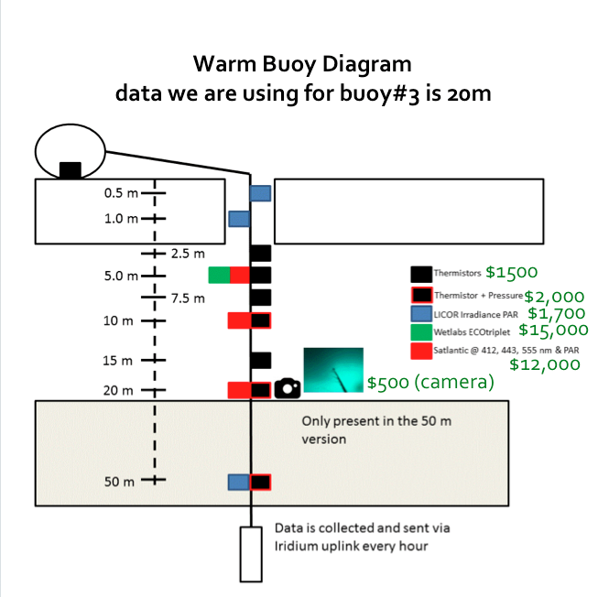

Engineering Criteria
Help Dr. Hill create a way to incorporate a surface camera that will give her team pictures from above the ice. The biggest challenge is that everything is put into place when the sea ice is present andsea ice melts between late July –August and the camera must stay afloat and point towards the sea ice and not be in contact with the main buoy. Coming into contact with the main buoy may alter data collection.

