Lesson Plan—Tag, You’re It!

Summary
This lesson provides a guideline for students to become Citizen Scientists as they explore relationships between migratory patterns in marine organisms with short and long-term changes in Sea Surface Temperature (SST). This lesson simulates a LTER (Long Term Ecological Research) study by allowing students to track shark migratory patterns over time using the OCEARCH Shark Tracker software and applications and NANOOS Visualization System (NVS) Climatology data sets. Students will compare OCEARCH’s satellite tracking data for pelagic apex predators (sharks) with NVS’s SST maps to observe for patterns and trends in migratory behaviour.
[TAGS: Shark tagging; SST (Sea Surface Temperature); IOOS; Satellite tracking. LTER: Long Term Ecological Research Study; Citizen Science]

Key Concepts
- Remote Sensing Satellite Technology
- Marine Mammal Tagging and Types of Tags
- Mapping Skills/GPS Coordinates
- Long Term Tracking
- Migratory Patterns, Seasonal as well as Climate Change

Objectives
Students will:
- Observe and identify rationale and reasoning behind shark tagging.
- Associate patterns of movement over time.
- Identify various types of tags used to track and monitor aquatic organisms.
- Record latitude and longitude coordinates associated with migratory patterns of sharks and note the correlating date and time.
- Observe and identify real-time Sea Surface Temperature measurements using NVS Climatology maps.
- Demonstrate analytical skills to compare shark migratory patterns with Sea Surface Temperature, both short and long term observations.
- Communicate findings by using a visual display format.

Materials
- “Scientists in Sarasota Studying Great White Sharks” Video (https://youtu.be/VG4wxYH3TW0) – This news report includes video footage of the tagging process and provides an excellent overview of the rationale behind shark tagging.
- https://www.youtube.com/watch?v=VRTNQpXEZE4 Sea Turtle, BBC Wildlife, 2 min.
- https://www.youtube.com/watch?v=AuIRdK5IfNo Tiger Shark, BBC Animals, 2 min.
- https://www.youtube.com/watch?v=Ha8aBKlxSPc Census of Marine Life, 4 min.
- OCEARCH Shark Tracking App (Download from iTunes or Google Play) or use the website: http://www.ocearch.org/
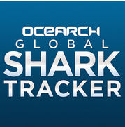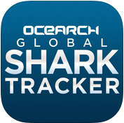
- TOPP (Tagging of Pelagic Predators) website http://gtopp.org/ or use the Shark Net app:
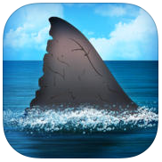
- OOI (Ocean Observations Initiative) website http://oceanobservatories.org/
- http://www.nanoos.org/
- http://secoora.org/
- Shark Tracking Data Sheet (included in lesson materials)
- Google Earth Software
- NANOOS’s Visualization System (NVS) Climatology data sets
- Computers, tablets, or Smart phones

Procedure
- Hook—“Scientists in Sarasota Studying Great White Sharks” Video to introduce the students to the idea of marine mammal tracking and to peak their interest in the idea of marine mammal tagging and tracking.
- Have students view additional video clips to gain a better understanding of the types of technology used and the rationale for tagging aquatic animals. Other options include:
- https://www.youtube.com/watch?v=VRTNQpXEZE4 - Sea Turtle, BBC Wildlife, 2 min.
- https://www.youtube.com/watch?v=AuIRdK5IfNo - Tiger Shark, BBC Animals, 2 min.
- https://www.youtube.com/watch?v=Ha8aBKlxSPc - Census of Marine Life, 4 min.
- Brainstorm the reasons behind tagging marine mammals. Derive a list of reasons on chart paper or on the Smartboard/ActivBoard.
- Break the students up into 5-6 groups. Using the Satellite Tagging Sorting Cards, sort the cards into two columns of corresponding descriptions and images.
- Explore the TOPP (Tagging of Pelagic Predators) website for the Pacific Ocean. http://gtopp.org/
- Explore the OCEARCH (Global Shark Tracker) website for the Atlantic Ocean. http://www.ocearch.org/
- As a class, decide on an animal to follow and track on each of these websites.
- Using the data tracker worksheet, either the lower level or higher level tracking sheet. Take data daily for the TOPP shark and the OCEARCH shark.
- Compare the tagged animals over the course of a few months or the entire school year. Collect the real-time data on the animal’s location, path and also the sea surface temperature.
- Utilizing a large wall map or bulletin board, the students could update the location daily of the two sharks, making a visual data tracker.
- Sea surface temperatures could be graphed on the Pacific and Atlantic locations daily.

Extensions: Explore the OOI, NANOOS and SECOORA websites to analyze and correlate the data of sea surface temperatures currently and in the past, relative to the paths of the animals.
http://oceanobservatories.org/
http://www.nanoos.org/
http://secoora.org/

Assessment
- Performance—Data collected accurately and completely on a daily basis. Appropriate correlations made and Findings clearly communicated.
- Product—Visual display to communicate findings.

Additional Resources
Articles/Research:
University of California Santa Cruz—Tracking Marine Predators http://news.ucsc.edu/2011/06/costa-topp.html
UC Santa Cruz Cape Fur Seal Study
http://currents.ucsc.edu/06-07/07-17/seals.asp
Engineering and Technology—Tracking Wildlife
http://eandt.theiet.org/magazine/2014/07/keeping-track.cfm
The Tribune—Hopkins Marine Station
http://www.sanluisobispo.com/2013/11/09/2774730/researchers-track-great-white.html
The Scientist—Dolled-Up Turtles
http://www.the-scientist.com/?articles.view/articleNo/32922/title/Dolled-Up-Turtles/
US Army Corp of Engineers—PIT tagging
http://www.nwd.usace.army.mil/Media/FactSheets/FactSheetArticleView/tabid/2128/Article/475828/anadromous-fish-evaluation-program.aspx
University of St. Andrews—Shark Ecology and Tagging
https://synergy.st-andrews.ac.uk/sharks/tools/
Fish Louisiana—Tina Tagging
http://www.fishla.org/fisheries-management/tagging-programs/tuna-tagging/
WHOI Marine Mammal Center—Manatees
http://www.whoi.edu/page.do?pid=126458&tid=3622&cid=32367

TOPP (Tagging of Pelagic Predators) website http://gtopp.org/
OOI (Ocean Observations Initiative) website http://oceanobservatories.org/
http://www.nanoos.org/
http://secoora.org/

OCEARCH Tutorial:
Navigating OCEARCH: The OCEARCH Application HOME screen includes a global map noting the last known location of each shark that has been tagged by OCEARCH. An ORANGE CIRCLE indicates the shark’s location has been recorded in the past 30 days. A BLUE CIRCLE indicates the shark’s location was recorded more than 30 days ago. The HOME screen can be zoomed in to locate a specific shark.
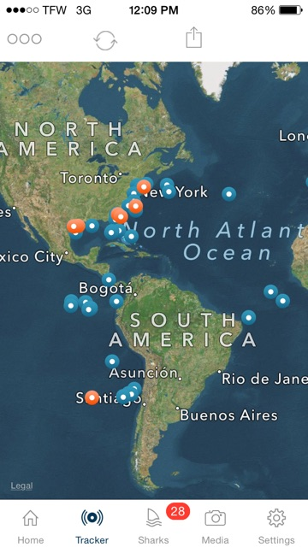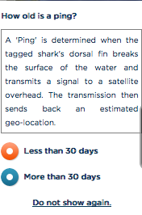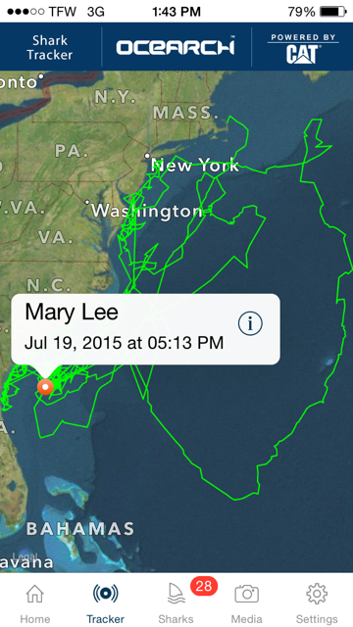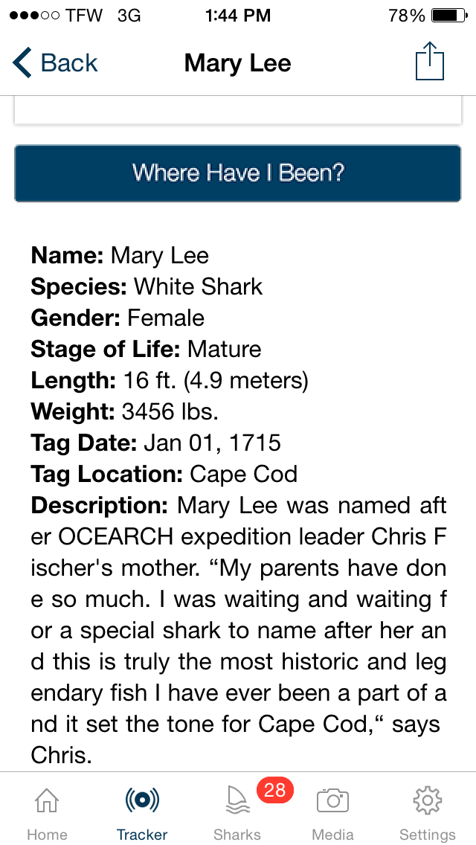
Use a TAP on the selected circle to open a pop-out box for the shark. The pop-out box includes the shark’s NAME, the DATE and TIME of the last recorded PING, and 2 icons: (+) and (i). The (+) icon opens the tracking map for this shark. The (i) icon will open a new window containing detailed information about the shark. From the shark information screen, students can select the SETTINGS button to set the applications default to their shark selection. If students want to keep up with more than one shark, be sure the DEFAULT SETTING is “All Sharks”. The SHARKS (fin icon) button can be selected to see a list of all sharks with recent pings. The TRACKER button can be selected to return to the Global Tracker Map. The HOME button provides information about OCEARCH and links to the Social Media sites operated by OCEARH, including Twitter, Facebook, Instagram, and Google Plus.

OCEARCH currently does not provide a latitude/longitude overlay for their mapping data. Students will need to compare their tracking map to a similar map of their location using Google Earth software. Use the computer mouse (or finger on a tablet device) to locate the LATITUDE/LONGITUDE coordinates that most closely match the OCEARCH ping location.
