TUTORIAL FOR PENGUIN DATA USING XCEL SPREADSHEETS

Open the Adelie Penguin Dataset and generate a graph using the following steps:

- Highlight the Adelie column and select CHARTS in the menu bar.
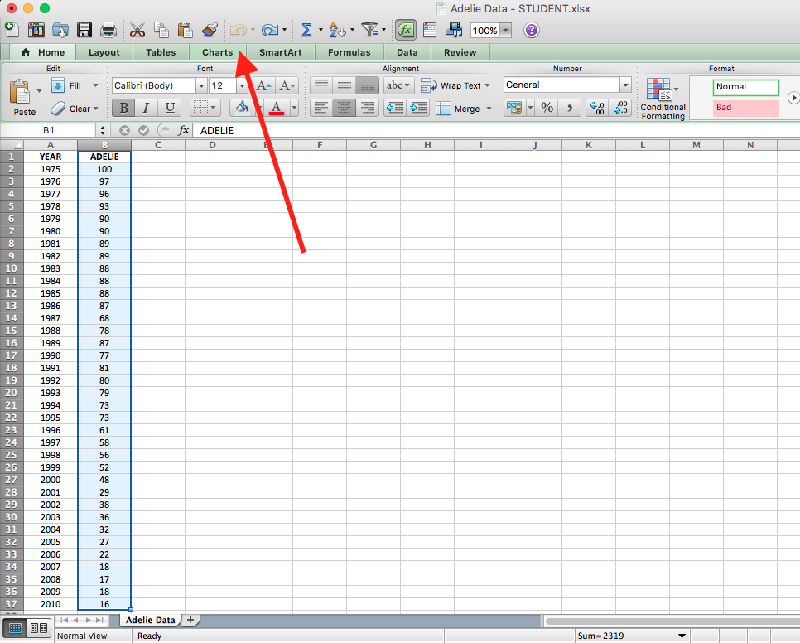

- Select LINE graph to generate your graph.
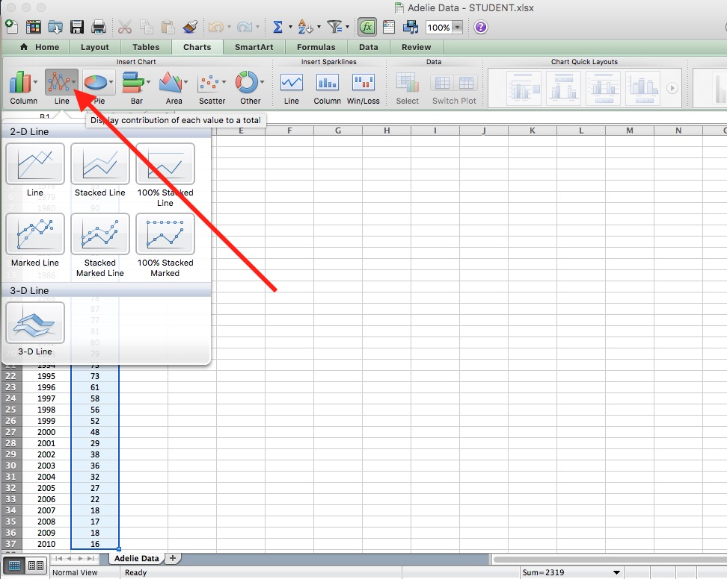

- Move your chart/graph to a new sheet by right-clicking on any blank space within the chart margin and selecting Move Chart:
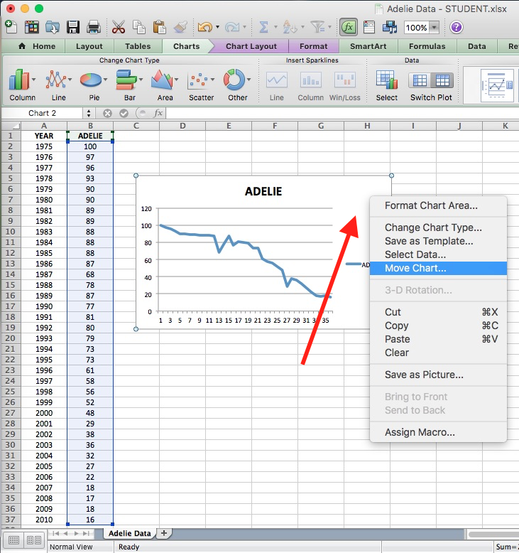

- Select
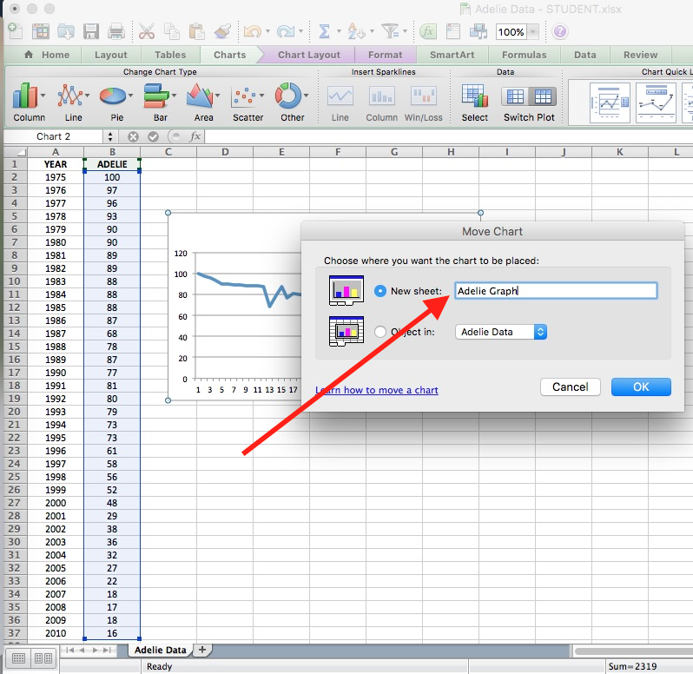

- Correct the scale on the Y-axis (if necessary) for a range of 0 to 100 by right-clicking on the Y-axis and selecting Format Axis:
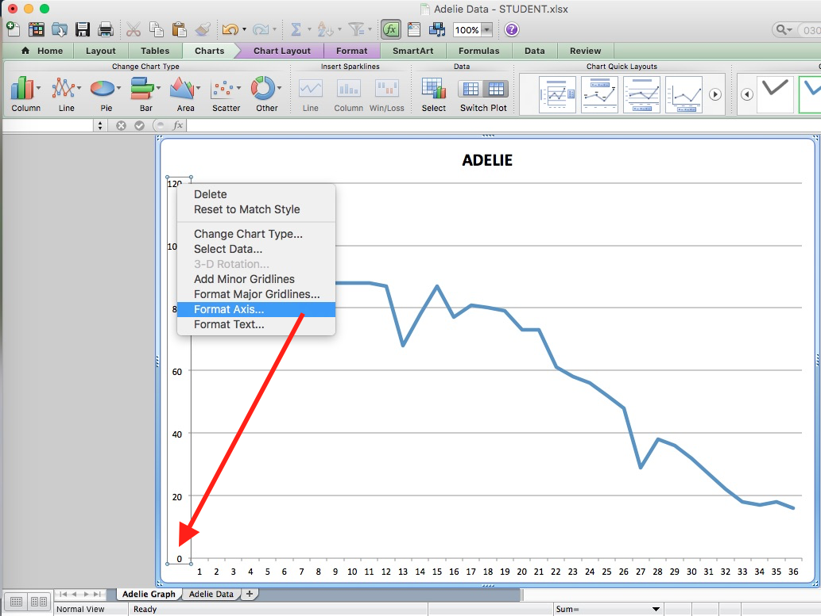

- (Optional) If Scale is not set to 0 – 100, change as shown below):
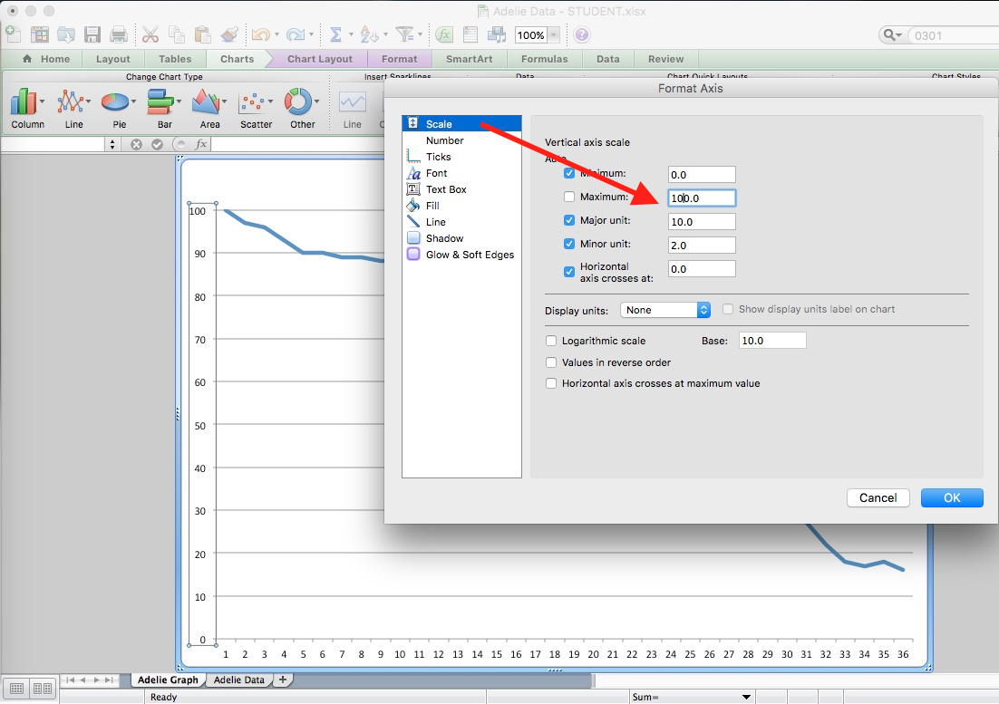

- Label the Y-axis by selecting Axis Titles… Vertical Title… and then typing the Y-axis label in the textbox:
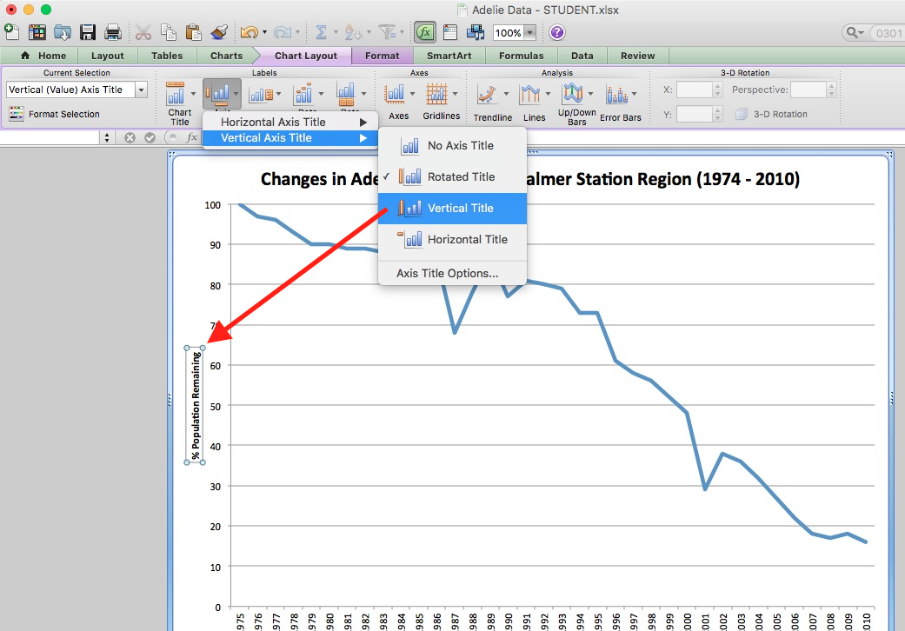

- Change the X-axis data to include the YEAR by right-clicking on the X-axis and selecting Select Data from the pop-up menu:
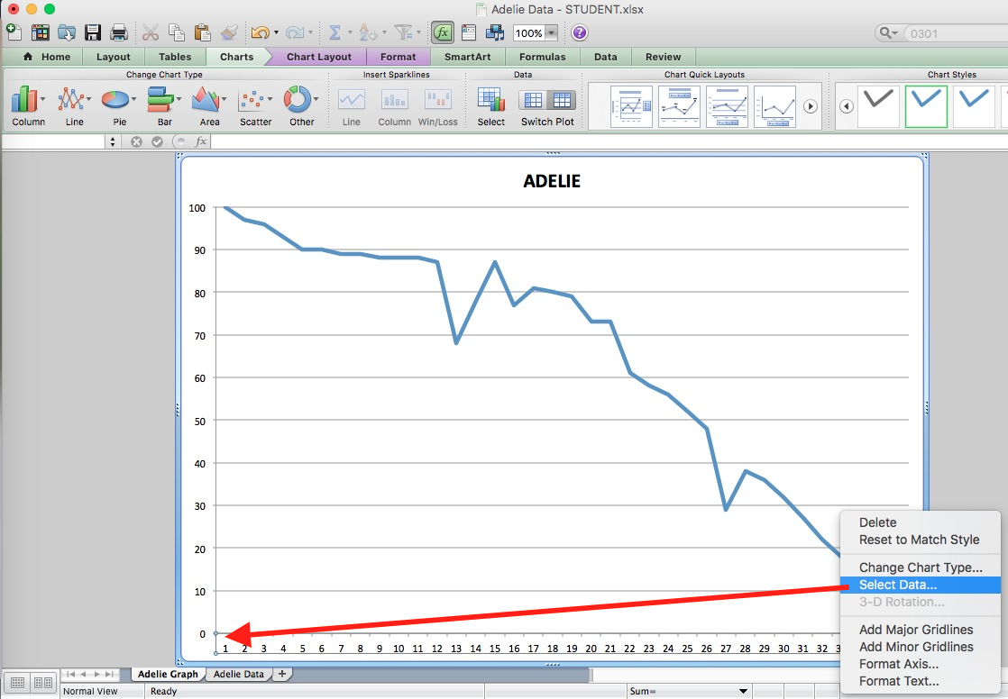

- Set the Date Range using the 3 steps shown in the figure below:
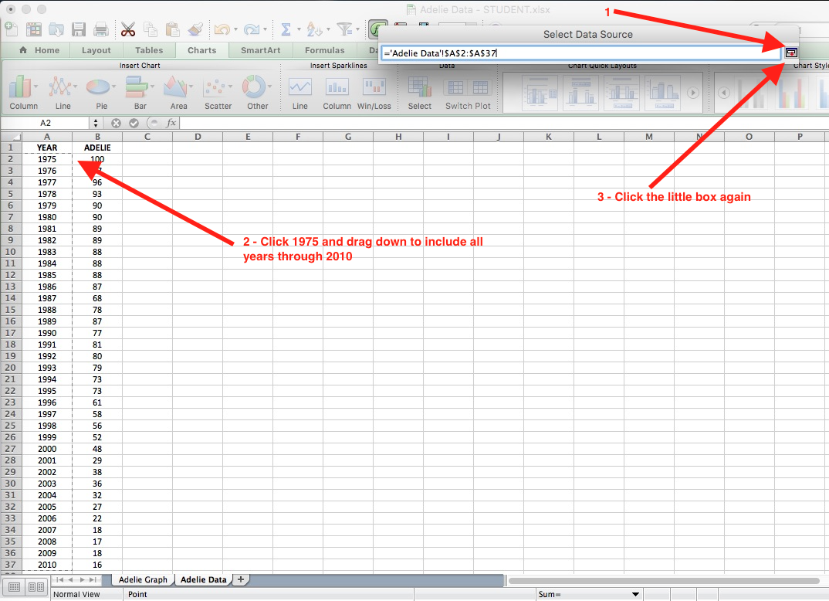

- Change the Chart Title by selecting Chart Title, then Title Above Chart. Type the chart title in the textbox: (Changes in Adelie Population in Palmer Station Region (1974 - 2010)
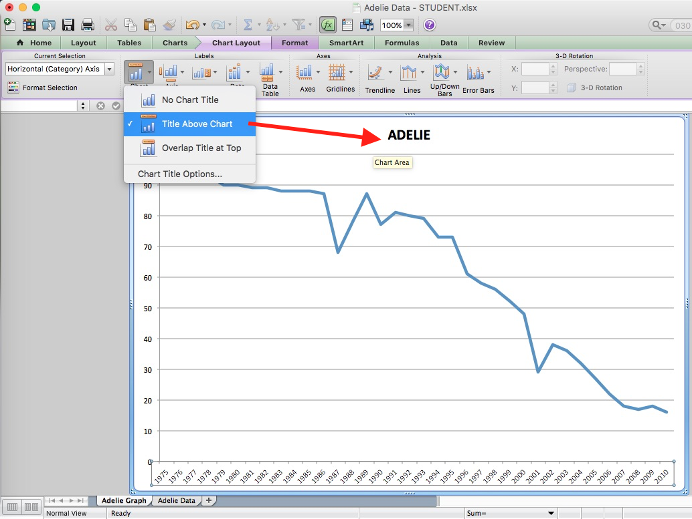

***Use the directions provided for the Adelie Penguin Data Set to complete charts for each penguin species.

DATA SOURCE: Ducklow, H. W., K. Baker, D. G. Martinson, Q. L.B., R. M. Ross, R. C. Smith, S. E. Stammerjohn, M. Vernet, and W. R. Fraser. 2007. Marine pelagic ecosystems: the West Antarctic Peninsula. Philosophical Transactions of the Royal Society of London 362:67-94. https://lternet.edu/node/157 .

