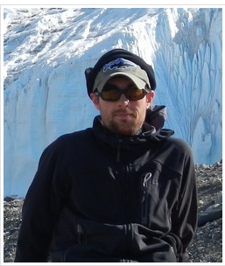  Adam Wlostowski  PhD Student  Developing Earth and Ecosystem models for Antarctic Dry Valleys | 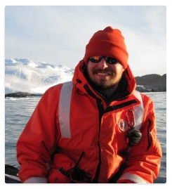  Dr. Travis N. Miles  Physical Oceanography, Ocean Observing Systems Storms and Climate Change
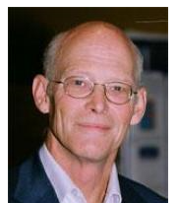  Dr. Robert Key  Research Oceanographer  Large-scale ocean circulation and global climate change | 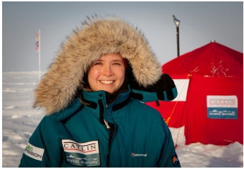  Dr. Victoria Hill  Old Dominion University  Oceanography, Climatology, Geography
Dr. Oscar Schofield  Rutgers University  Ecology, Oceanography | 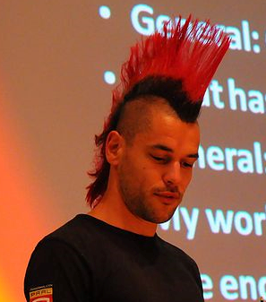  Dr. Sjoerd Groeskamp  Physical Oceanographer

