A Whale of a Tale:
Using BLAST to Identify the Source of Mitochondrial DNA from Whales

Scenario #1

Background
A businesswoman purchases an old building on the waterfront in Nantucket, Massachusetts. She plans to tear down the building and create a series of shops. When the contractor begins demolition, they discover a huge graveyard of whale bones. For more than a century, between 1750 and 1850, Nantucket was the headquarters of the global whale oil business.
It wasn’t until 1972 that Congress passed the Marine Mammal protection act making it illegal to kill any marine mammals in US water and in 1986 the International Whaling Commission banned commercial whaling.

The businesswomen contacted the local historical society and finds out that several whales were hunted to near extinction during that era.
According to WhaleNet, http://whale.wheelock.edu/whalenet-stuff/ser_population.html

1. Northern Right Whales population dropped from 10,000 to 350 (96.5%)
2. Blue whale population dropped to 14,000 from 228,000 (94%)
3. Humpback numbers went from 115,000 to 10,000 (91.3%)
The whale most prized for their oil was the Sperm whale, but their numbers only dropped by 20%.

The businesswomen hires you-a local geneticists to analyze the DNA of the whalebones to see what species of whales are in the graveyard. You choose to look at the mitochondrial DNA using BLAST. This tool from the National Center for Biotechnology Information allows you to compare the unknown mtDNA nucleotide sequences with a database of known sequences.
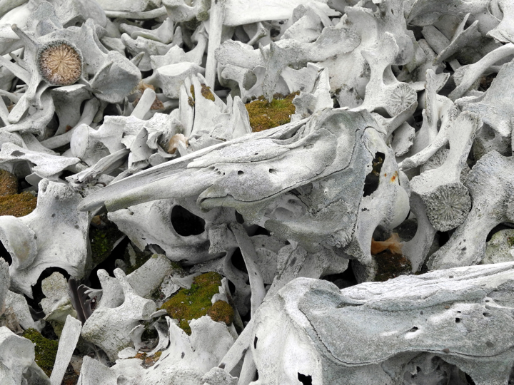

Photo by China Crisis

Based on your knowledge of Whaling in New England, what type of whales do you think will find?

