Date: March 27 2015
3 days after deployment.
Location: Latitude 71.94, Longitude -149.40
Temp: -1.60 Celsius
Notice the clear water, you can see the next sensor 10 m above the camera as a black dot.
Notice the fish!!!
You are looking at the light filtering through to the underside of the ice pack, the dark line on the ice is a crack.
Date: April 10 2015
Location: Latitude 71.78, Longitude -156.61
Temp: -1.70 Celsius

The water here is looking a little darker, this means that there is some material absorbing light, probably low amounts of phytoplankton
Date: April 24 2015
Location: Latitude 71.69, Longitude -158.33
Temp: -1.73 Celsius

Notice the bright spot in the corner, this is a melt pond on the surface of the ice, it lets through more light than bare ice.

Date: May 8 2015
Location: Latitude 71.96, Longitude -160.13
Temp: -1.74 Celsius

The bright spot in the corner it still there, this is a melt pond on the surface of the ice, it lets through more light than bare ice.

Date: May 22 2015
Location: Latitude 72.64, Longitude -161.71
Temp: -1.75 Celsius

You can see that the clarity of the water is reduced, as you can barely see the next sensor up the wire. The water also looks greener, this is due to the growth of phytoplankton in the water column.

Date: June 5 2015
Location: Latitude 72.92, Longitude -164.77
Temp: -1.70 Celsius

You can see that the clarity of the water is reduced, as you can barely see the next sensor up the wire. The water also looks greener, this is due to the continued growth of phytoplankton in the water column.

Date: June 19 2015
Location: Latitude 73.69, Longitude -164.26
Temp: -1.56 Celsius

Notice the algae that is streaming off the cable, this is most likely Melosira a common algae that grows on the bottom of the ice. Also see the brighter spot at the center of the image, this is another melt pond.

Date: July 03 2015
Location: Latitude 73.69, Longitude -167.54
Temp: -1.43 Celsius

The ice is melting, you can see the strange shapes on the ice above the camera, this is the ice floe melting away.

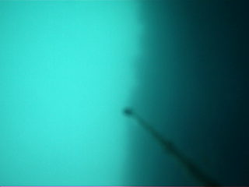 | Date: July 17 2015  Location: Latitude 74.25, Longitude -170.28  Temp: -1.24 Celsius  The ice is melting, you can see the edge of the floe as a dark line.
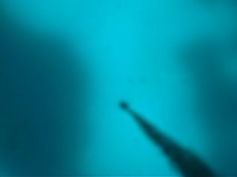 | Date: July 31 2015  Location: Latitude 73.94, Longitude -173.92  Temp: -0.84 Celsius  Now the buoy seems to be right in the middle of an area of melt. The dark areas are ice.
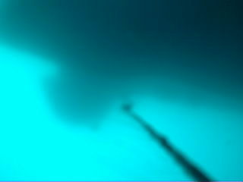 | Date: August 14 2015  Location: Latitude 74.14, Longitude -177.77  Temp: -0.15 Celsius  Now the buoy seems to be right in the middle of an area of melt. The dark areas are ice.
Date: September 11 2015
Location: Latitude 74.37, Longitude 174.76
Temp: 0.93 Celsius

The buoy has melted out of the ice and is in open water. The water has warmed from -1.7 to +0.93 celsius

Date: September 25 2015
Location: Latitude 74.229, Longitude 175.82
Temp: 0.4 Celsius

The buoy has melted out of the ice and is in open water. Notice that the water has started to cool again.

Date: October 9 2015
Location: Latitude 74.61, Longitude 176.03
Temp: - 0.88 Celsius

The buoy has melted out of the ice and is in open water. Water temperature is now below freezing again.

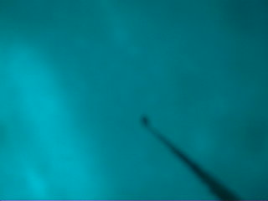 | Date: October 23 2015  Location: Latitude 75.29, Longitude 171.376  Temp: -1.52 Celsius  Ice is forming at the surface, the buoy will be frozen into this ice.
Date: November 6 2015
Location: Latitude 75.56, Longitude 169.87
Temp: -1.50 Celsius

Ice has formed at the surface, the buoy is now trapped again for the winter. Notice how dark it now is.

Date: November 20 2015
Location: Latitude 75.27, Longitude 171.04
Temp: -1.60 Celsius

Polar winter, the sun does not rise above the horizon, it is now dark until spring.

