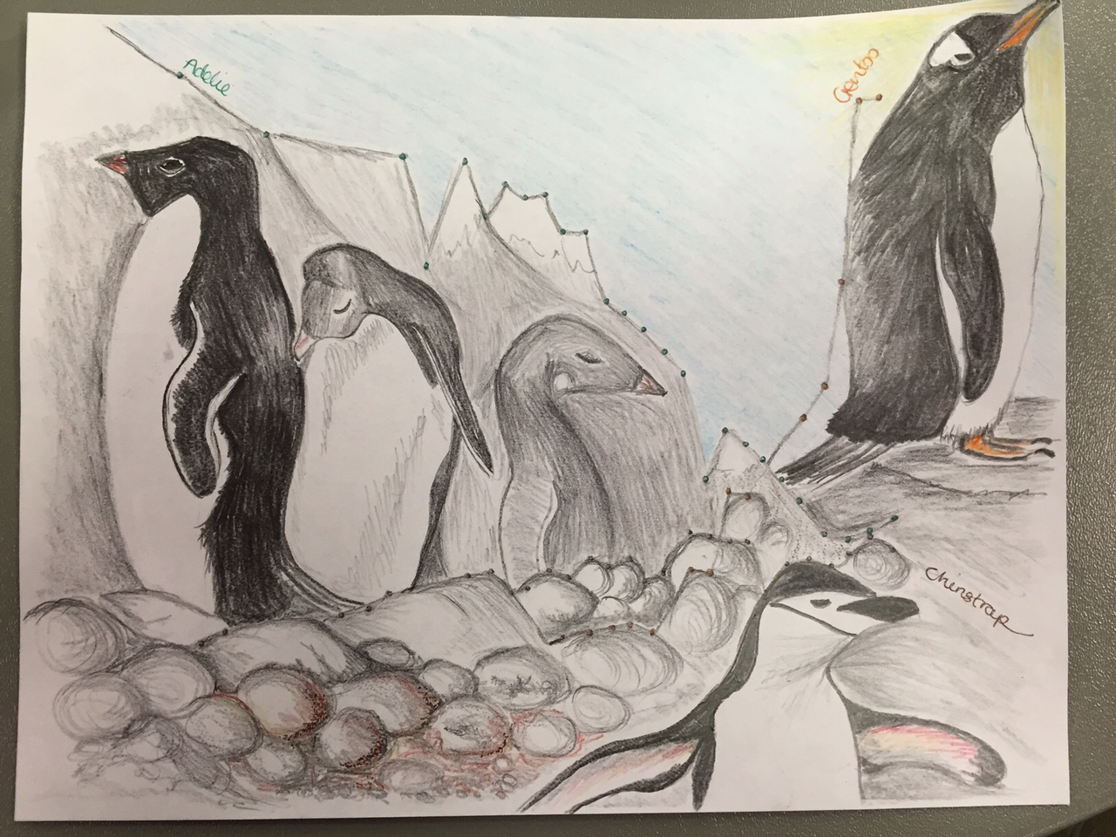

The picture illustrates the percentage changes in penguin population in Antarctica from 1975 to 2010. The Adelie penguin is decreasing in number and this is shown by the penguins gradually fading into the background. The Chinstrap penguin is enjoying a slight increase in numbers and The Gentoo penguin is rapidly increasing in numbers. The changes in population is due to the changing availability of Krill, a key food source for the penguins. Warming waters, less sea-ice cover and more whale and seal numbers was cited as reducing the abundance of krill, the main food source for the penguins.
Sources
http://www.bbc.com/news/science-environment-13036795
http://pal.lternet.edu/images/sci-research/transformational_science/3.4.png

