Name: Date: Period:

Identifying Endemic and Cosmopolitan Diatoms
Procedures:
1. Access the Antarctic Freshwater Diatoms database: http://huey.colorado.edu/diatoms/samples/index.php

2. Get into groups of 2-4 students.

3. Select a particular body of water from the following list:

Adams Stream
Aiken Creek
Andersen Creek
Bartlette Creek
Blue Lake
Bohner Stream
Bowles Creek
Canada Stream
Commonwealth Stream
Crescent Stream
Delta Stream
Garwood Stream
Green Creek

4. Populate data for the particular body of water, click on the first count for the waterbody you are analyzing. Identify the body of water on google earth and mark it on the Antarctic map, using the latitude and longitude information from the header information provided once data is populated.

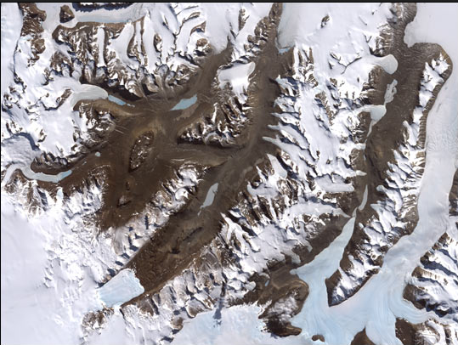
http://eoimages.gsfc.nasa.gov/images/imagerecords/2000/2140/landsat7_dry_valley.jpg

5. Create an excel sheet or google sheet, copy and paste at least three of the available counts for that body of water in the sheet. BE SURE TO LABEL THE DATA FOR EACH COUNT.

6. In an additional column, categorize whether each taxa is endemic or cosmopolitan using the provided resources sheet. See example data sheet provided. Use the taxa index http://huey.colorado.edu/diatoms/taxa/index.php
to decide if the diatom is endemic (found in McMurdo (MCM) or it is cosmopolitan, found elsewhere in addition to McMurdo (O).)

7. Summarize the count data for each taxon from each of the three count samples you selected. A partial number indicates a portion or fragment of a diatom as the cell walls are made of glass!!
Respond to the following questions:
How many of the same species are found in each of your three count samples?

How many different species are found in each of your three count samples?

How many total species?

How many total individuals?

How many endemic species?

How many cosmopolitan species?

What other conclusions can you make from analyzing the data?

8. Create a pie chart to indicate the quantity of endemic and cosmopolitan species proportionate to the sample size. Be sure your pie chart includes the follow: Labels, titles and a legend. Turn in your pie chart with your responses.

Compare your group’s data to another group’s data. Do you notice any similarities and/ or differences? Describe and provide specific examples.

9. Select three endemic and three cosmopolitan diatom species from your data sheet and go to the taxa index http://huey.colorado.edu/diatoms/taxa/index.php

10. Use the table provided below to record your observations.
Endemic or Cosmopolitan:  Location:  Species name:  Observation/ description:  Drawing: | Endemic or Cosmopolitan:  Location:  Species name:  Observation/ description:  Drawing: | Endemic or Cosmopolitan:  Location:  Species name:  Observation/ description:  Drawing:
Endemic or Cosmopolitan:  Location:  Species name:  Observation/ description:  Drawing: | Endemic or Cosmopolitan:  Location:  Species name:  Observation/ description:  Drawing: | Endemic or Cosmopolitan:  Location:  Species name:  Observation/ description:  Drawing:

11. Summarize your observations by responding to the following questions.

Are there physical characteristics that endemic species have in common?

Are there physical characteristics that cosmopolitan species have in common?

Are there physical characteristics that are different between endemic and cosmopolitan species?

Hypothesis what kind of physical characteristics could contribute to the survival of an endemic or cosmopolitan species.

