Follow the steps below to mine data for your selected year and location

Step 1
Click on the link -http://cdiac.esd.ornl.gov/oceans/

Step 2
Scroll down and Click on Subsurface Bottle Data ( box highlighted on the screenshot) OR GLODAPv2 (skip step 3, go to step 4)
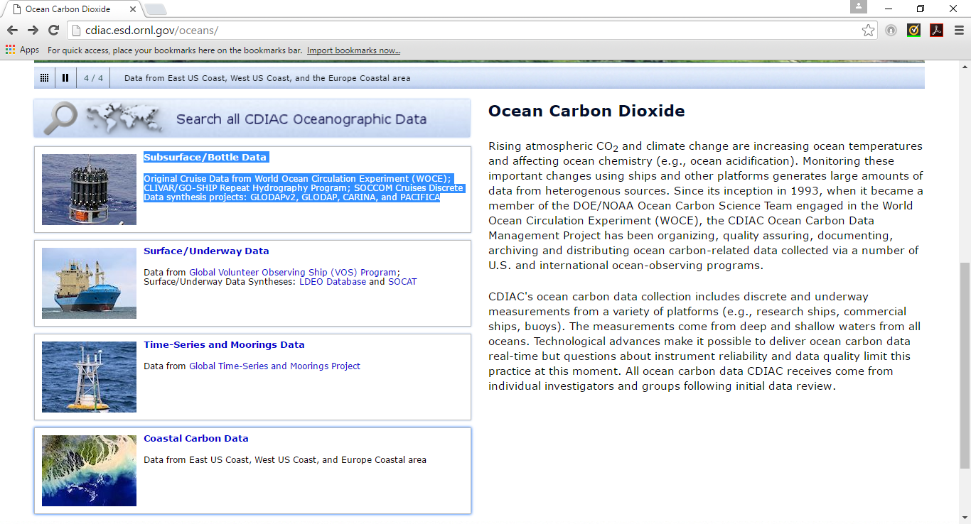

Step 3
Click on GLODAP v2 database under Data Synthesis Products ( left column -2nd heading)
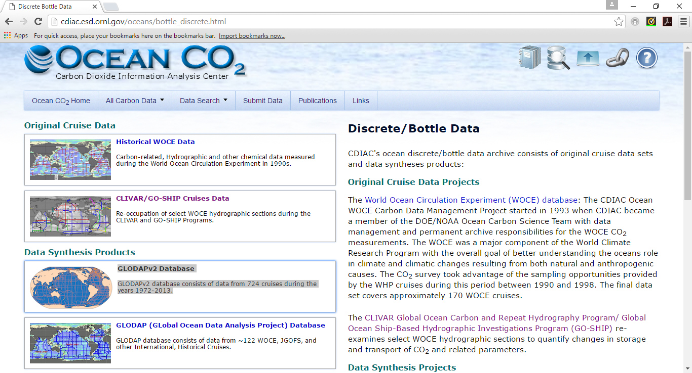

Step 4
Click on W.A.V.E.S.: GLODAPv2 Database Search which will take you to Web Asseccible Visulization and Extraction System

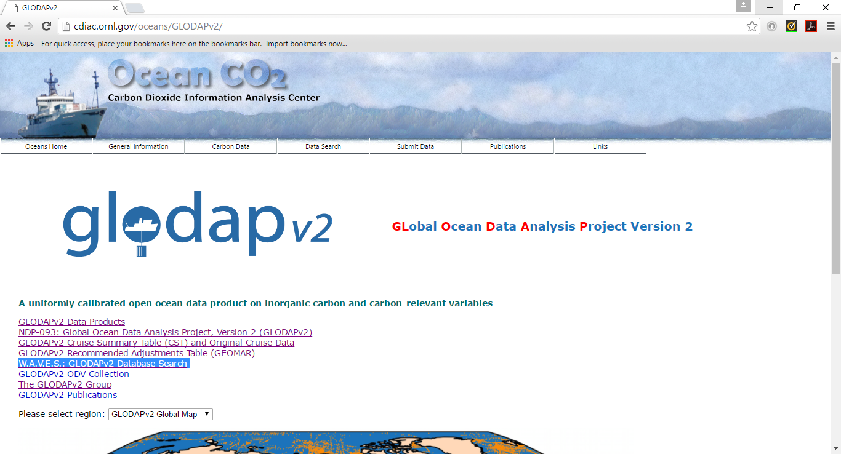

Step 5
Extract data form given Geogarphical Location, given Time limits, given ranges of Depth, Temperature, Salinity and/or Pressure

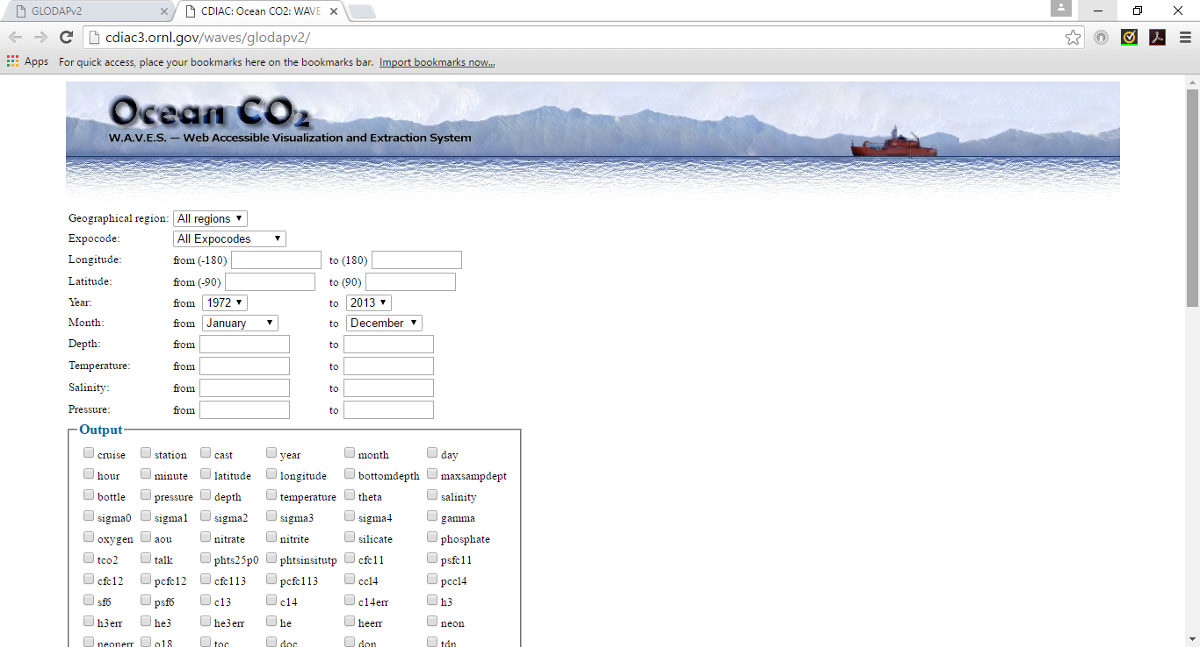

Step 6
You can also zoom on to a specific location on the map ( map on the right of the screen) and select cruise data by selecting clicking on specific expocodes from the Metadata box below the map
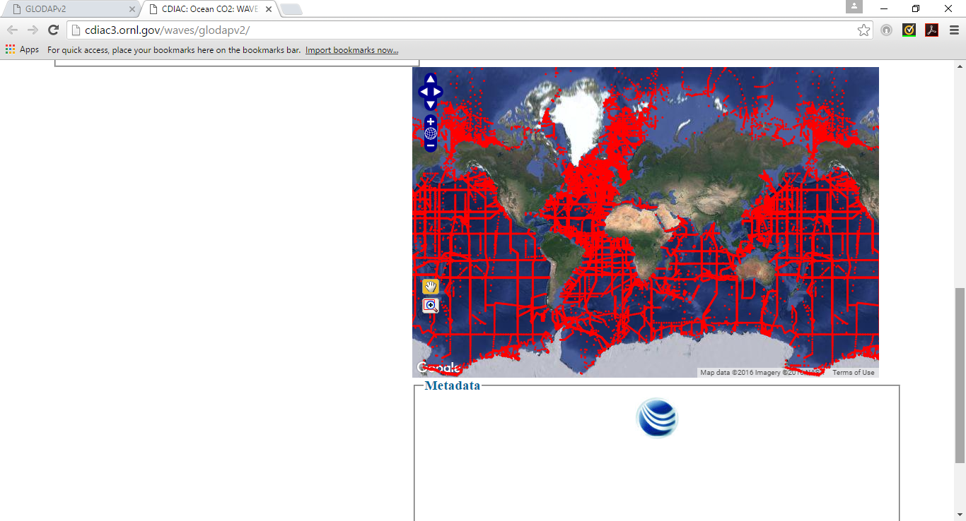
Step 7
Select parameters from the the output box and you can view data onscreen (good idea to preview and select data before downloading), download file (cvs form recommended) or onscreen plot( program compares only 2 variables at a time)
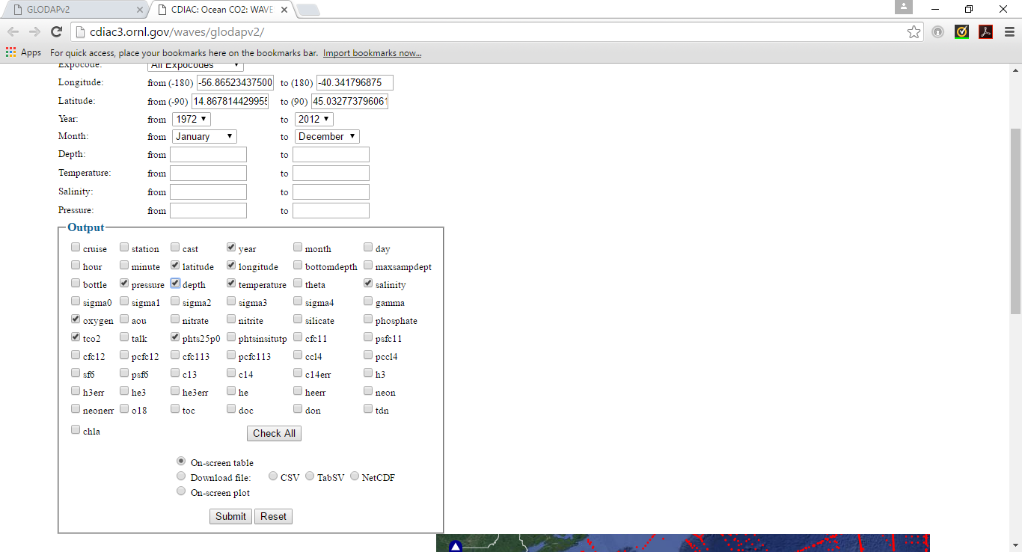
Step 8
Preview the data and accordingly narrow it down to specific output parameters, location and time to make up manageable data to compare two data sets from two different years to compare

