Salinity and Temperature profiles of Argo float WMO= 1900693
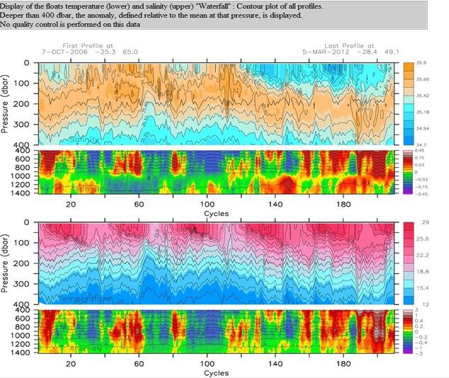

Salinity and Temperature profiles of Argo float WMO= 5901282
