Diatom Morphology Matching Cards
Centric  - Valve is organized around a point (radial symmetry)  - Lack significant motility (ability to move around)  - Oogamous sexual reproduction (the female gamete is large & non-motile and the male gamete is small & motile.) | 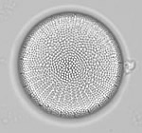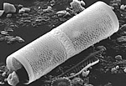
Araphid  - Valve is organized around a line (bilateral symmetry)  - Lack a raphe (movement) system, and therefore lack motility  - Rimoportulae (labiate process or opening) may be present | 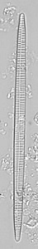
Eunotioid  - Valve is organized around a line (bilateral symmetry)  - Valves often asymmetrical to the apical axis  - Raphe (movement) system is weak, with raphe located on valve mantle and face  - Only raphid group with 2 or more rimoportulae (labiate processes or openings) | 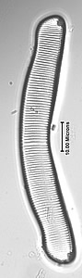
Naviculoid  - Valve is organized around a line (bilateral symmetry)  - Valves symmetrical to both apical and transapical axis  - Raphid (movement) system well developed, raphe on each valve makes cells highly motile  - This group has the greatest diversity among the freshwater diatoms | 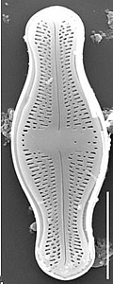
Cymbelloid  - Valve is organized around a line (bilateral symmetry)  - Valves symmetrical to transapical axis, asymmetrical to apical axis  - Raphid (movement) system well developed  - Valves with apical porefields that secrete mucilaginous (thick, gluey substance) stalks or tubes | 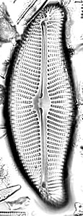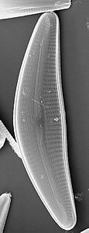
Epithemioid  - Valve is organized around a line (bilateral symmetry)  - Valves symmetrical to transapical axis, asymmetrical to apical axis  - Raphid (movement) system well developed, and enclosed within a canal | 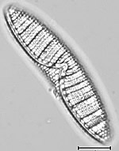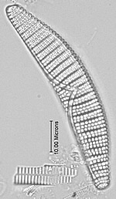
Amphoroid  - Valve is organized around a line (bilateral symmetry)  - Valves symmetrical to transapical axis, asymmetrical to apical axis  - Raphid (movement) system positioned eccentrically (irregularly), near the valve margin  - Primarily a marine genus, with a few freshwater representatives | 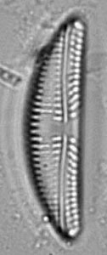
Nitzschioid  - Valve is organized around a line (bilateral symmetry)  - Valves usually symmetrical to both apical and transapical axes  - Raphid (movement) system well developed, and positioned near the valve margin  - Raphe is enclosed within a canal and raised onto a keel | 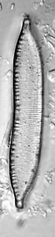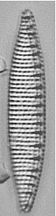
Surirelloid  - Valve is organized around a line (bilateral symmetry)  - Raphid (movement) system extremely well developed, and positioned around the entire valve margin  - Raphe is enclosed within a canal and raised onto a keel | 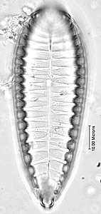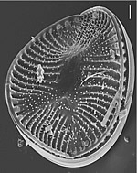
Monoraphid  - Valve is organized around a line (bilateral symmetry)  - Raphe (movement) system present on one valve  - Heterovalvar: one valve with a raphe (movement) system and one without | 