Overview of selected data from WARM buoy #3.
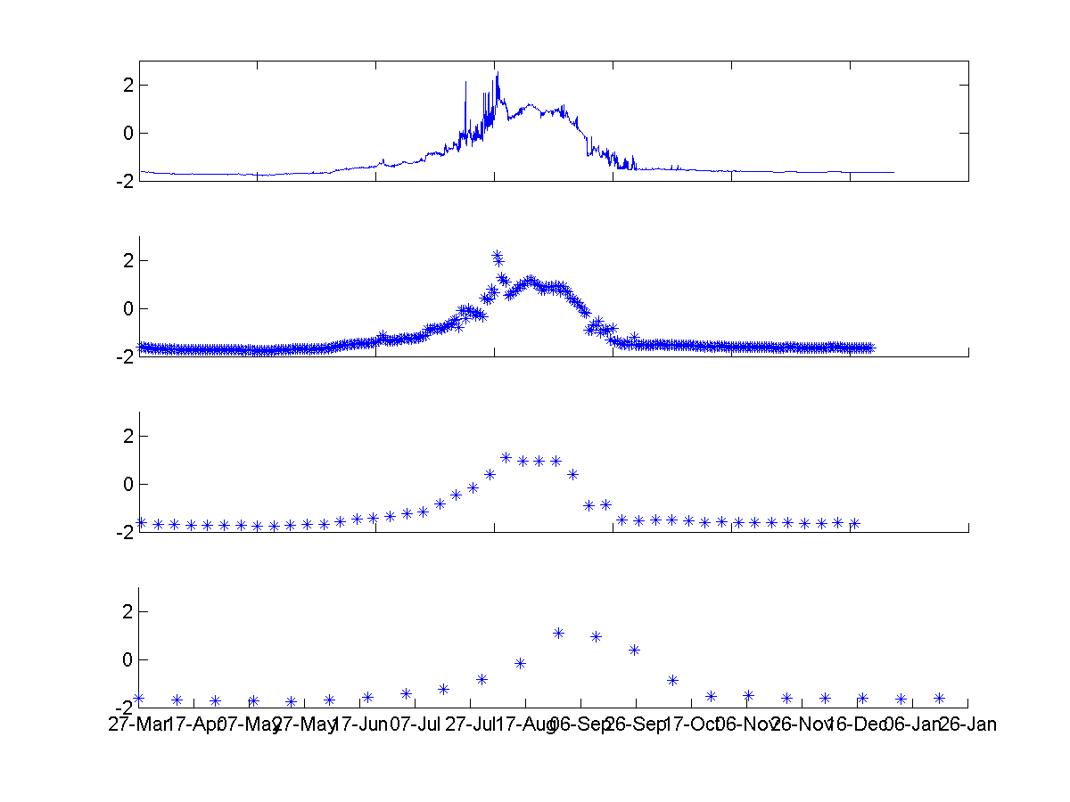
The data represented here is the temperature and light intensity data from 5 m depth sensor. The data is plotted as hourly, daily, weekly and bi-weekly data points to show you how the plots will change depending on how you decide to plot the data.
Temperature (ºC)
A
B
D
C

Figure 1. Temperature data from 5 m on the tether. Due to the thickness of the ice this is approximately 3 meters under the ice. A) The hourly datapoints, B) Datapoints from noon each day (brightest part of the day), C) Data collected at noon every 7 days, D) Data collected at noon,
every 14 days.
The temperature data shows the gradual warming occurring under the ice, water starts to warm in June and continues through the summer with cooling starting in September. Noise observed in the hourly data represents daily warming and cooling patterns. By plotting daily and weekly data the plots still follow the general pattern seen in the hourly data but without the diurnal patterns. If you only plot data every two weeks, then you will miss the warming in July. Therefore I recommend showing students the plots of all the data if they are going to only manually plot the biweekly data.
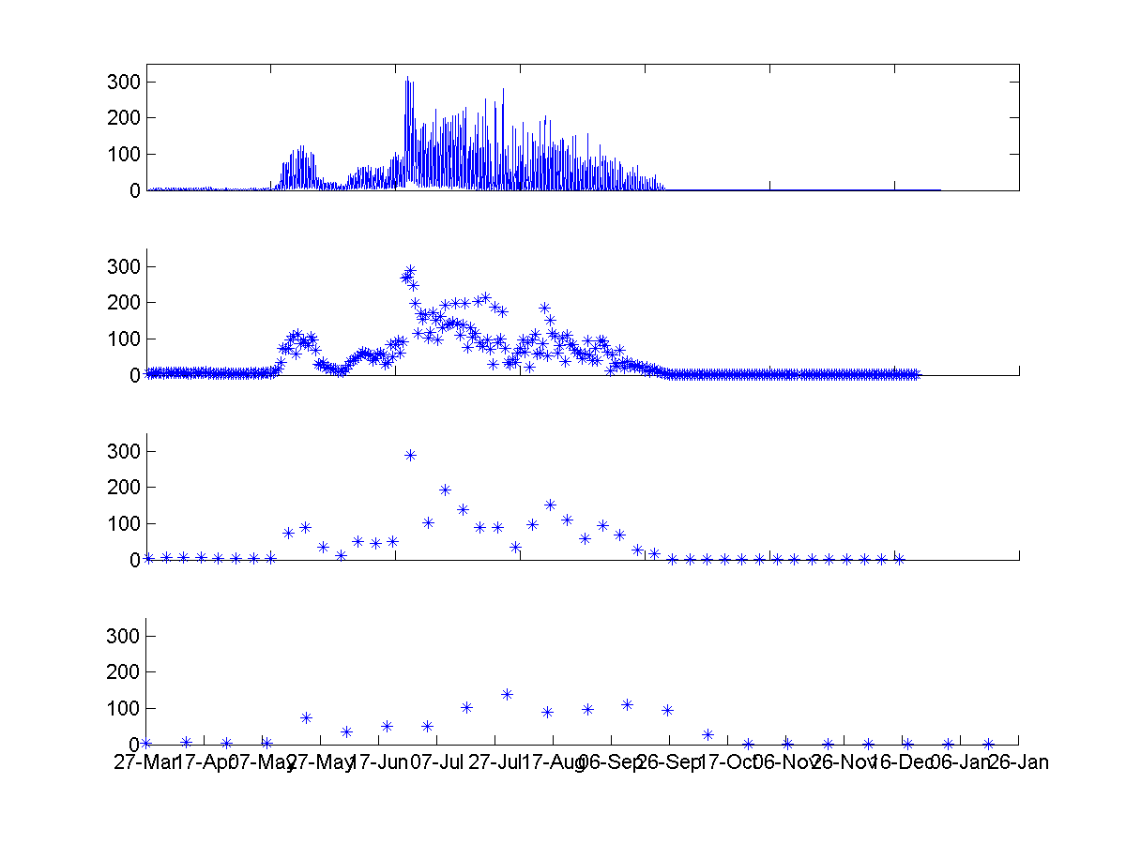
Light intensity (umol/cm-2/s-1)
A
B
D
C

Figure 2 Light intensity data from 5 m on the tether. Due to the thickness of the ice this is approximately 3 meters under the ice. A) The hourly datapoints, B) Datapoints from noon each day (brightest part of the day), C) Data collected at noon every 7 days, D) Data collected at noon, every 14 days.
The light intensity was very low until the end of May, there was a peak in light at this point that then decreased until the end of June. This peak in light was most likely the result of a melt pond on the surface of the ice that increased light transmission. The melt pond can be seen the photos from this time. Increases in light at the end of June are linked with rapid warming at this time. A steady decrease in light occurs through September and the fall and this occurs at the same time as temperature decreases.

