Name: Date: Period:

Alien Species Invading Antarctica By Charles Q. Choi, for National Geographic News

Questions:
Before you read:
- Look at the map
  - Identify the Antarctic.
  - Indicate from where alien species may be coming from.

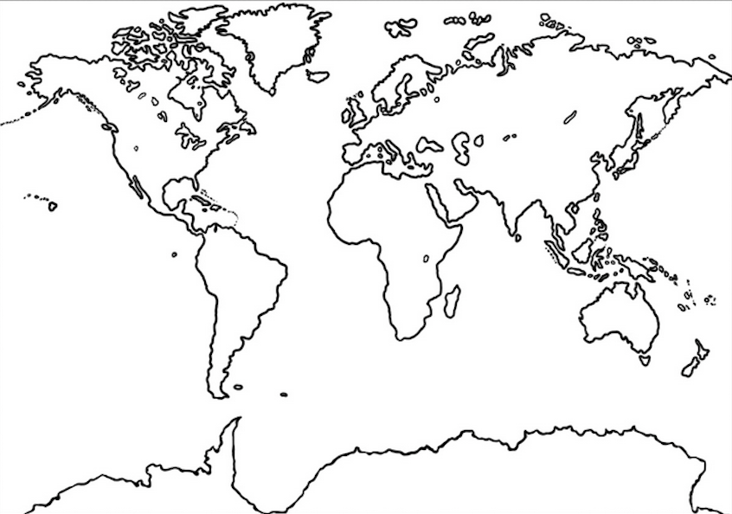

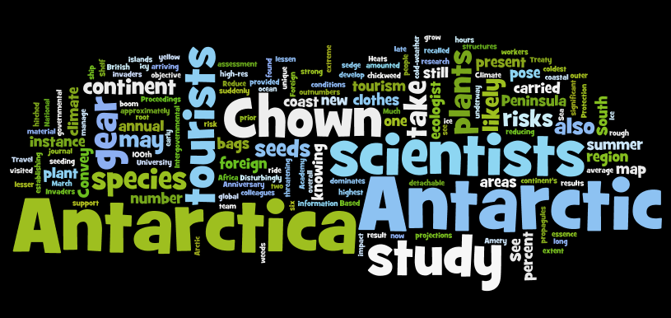
- Use the word cloud as a word bank to describe
  - Ways alien species may be invading Antarctica

  - What types of organisms may be invading Antarctica

As you read:
- Describe the Antarctic, including the conditions that make it a unique and vulnerable environment?

- What are the “hitchhikers” heading to the Antarctic and why are they concerning?

- What adaptations of the hitchhikers allow them to get to the Antarctic and be successful there?

- What is the relationship between climate change, the hitchhikers and the Antarctic ecosystem?

- What are some solutions mentioned in the article to reduce hitchhikers? What is at least one solution NOT mentioned in the article?

After you read:
- Add to the map you used in the “before you read section” use pictures, arrows etc to indicate things like where alien species are coming from, who is brining them and what types of alien species pose a threat.

- Create an illustration and caption to summarize the main ideas and key points of the article. Use the worlde as a word bank.

Caption:

