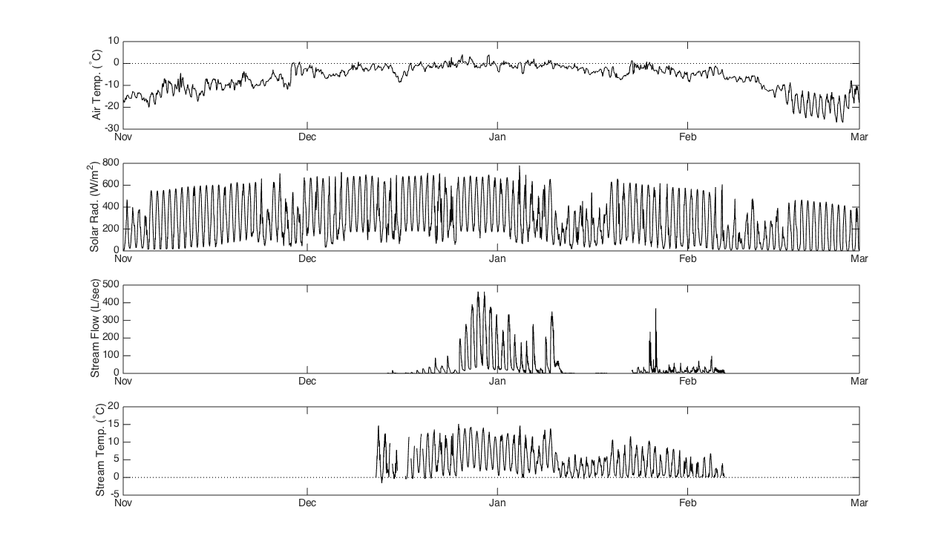
VonGuerard Stream Data – Dry Valleys Antarctica

