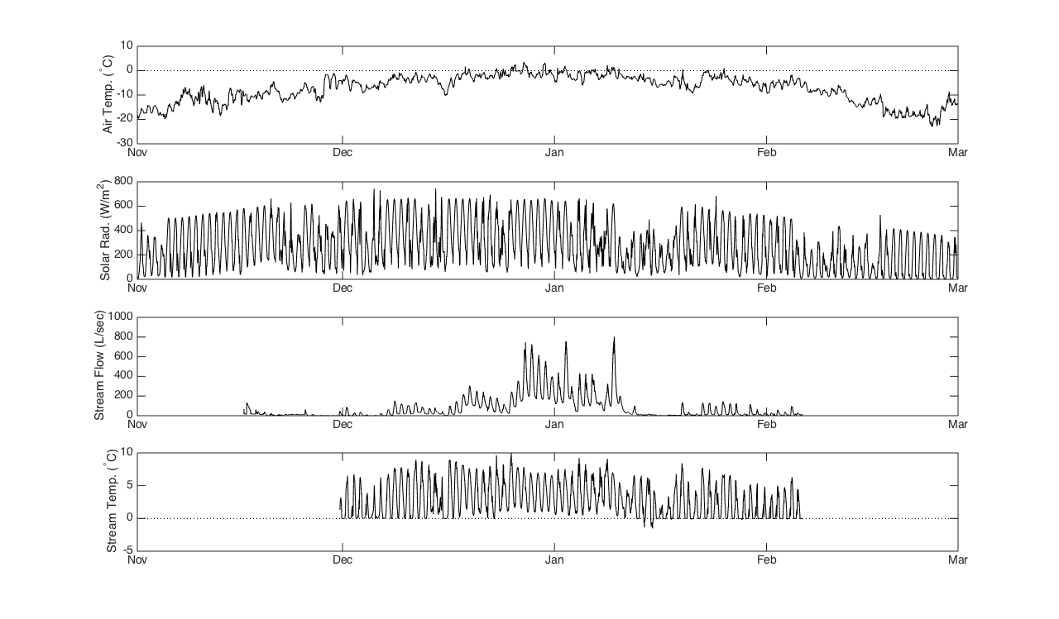
Canada Stream Data – The Dry Valleys of Antarctica

