A Whale of a Tale:
Using BLAST to Identify the Source of Mitochondrial DNA from Whales

Your teacher has made available to you a digital document containing mitochondrial DNA sequences from four unknown samples. You will be using BLAST to identify the source of these sequences. BLAST is an online tool that allows you to compare biological sequences (DNA, RNA or protein) to an online database of sequences from a wide variety of organisms. All you have to do is cut and paste the unknown sequences into the website and the BLAST tool does the search work for you. The information generated will allow you to solve the problem outlined in your scenario.

Procedure:
- Read through your scenario.
- Open up your unknown mitochondrial DNA in a separate window or document.
- Go to the NCBI homepage http://www.ncbi.nlm.nih.gov/
- Under Popular resources, click on BLAST.
- Click on Nucleotide BLAST.
- In the Enter Query section, copy and paste the first mtDNA sequence given to you on the unknown nucleotide sheet. Make sure to copy and paste one sequence at a time.

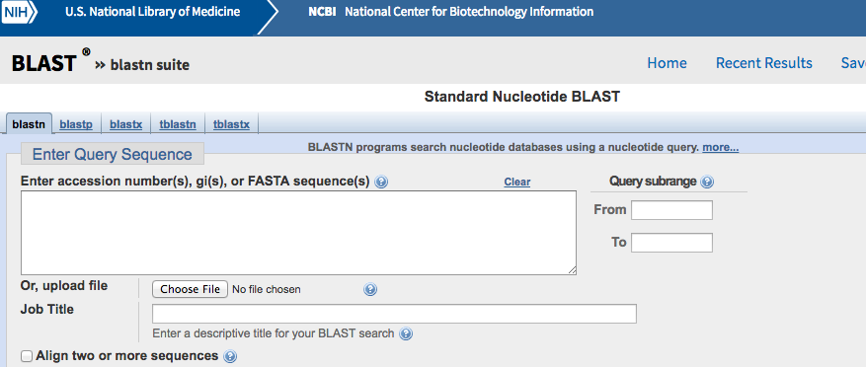

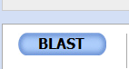

- At the bottom of the page, click on the BLAST button

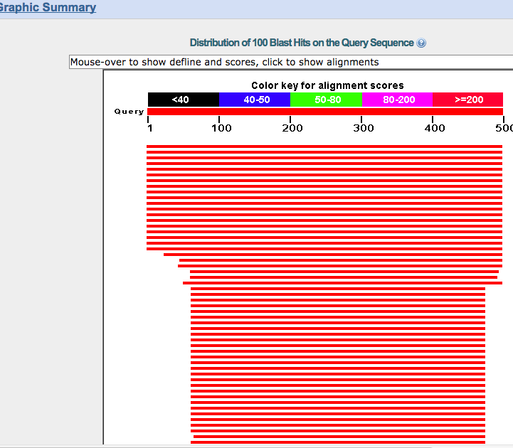
- After a few seconds, a diagram similar to this will appear.

- Scroll down to the Description Section; look for as close to 100% match that you can find.
- The first two words are the genus and species of the organism. Write this in your data table for the appropriate specimen.
- Follow steps 4-9 for the remaining unknown nucleotide sequences.
- When finished with BLASTing your sequences, do an internet search to find the common names of the species that you have identified and enter them into the table.

Data:
Complete the following table using the information you complied using the BLAST tool.

Sources of the Unknown mtDNA Samples

Specimen # | Species Name | Common name
1
2
3
4

Conclusion:
Write a paragraph explaining the significance of your findings in relation to your scenario.

____________________________________________________________________________________________________________________________________________________________________________________________________________________________________
____________________________________________________________________________________________________________________________________________________________________________________________________________________________________
____________________________________________________________________________________________________________________________________________________________________________________________________________________________________
____________________________________________________________________________________________________________________________________________________________________________________________________________________________________
______________________________________________________________________________________________________________________________________________________________________________________________________________________________________________________________________________________________________________________________________________________
____________________________________________________________________________________________________________________________________________________________________________________________________________________________________
____________________________________________________________________________________________________________________________________________________________________________________________________________________________________
__________________________________________________________________________________________________________________

