Accessing Palmer LTER Data (Instructions for Datazoo)

- Datazoo is the name of the data catalog (online data portal) for all of the available online Palmer LTER data. You can access it via: http://pal.lternet.edu/data (click on “Go to Catalog”) OR http://oceaninformatics.ucsd.edu/datazoo/data/pallter/datasets
  - To download data you will need to log in by selecting the “Log In” button in the top right corner of the webpage.
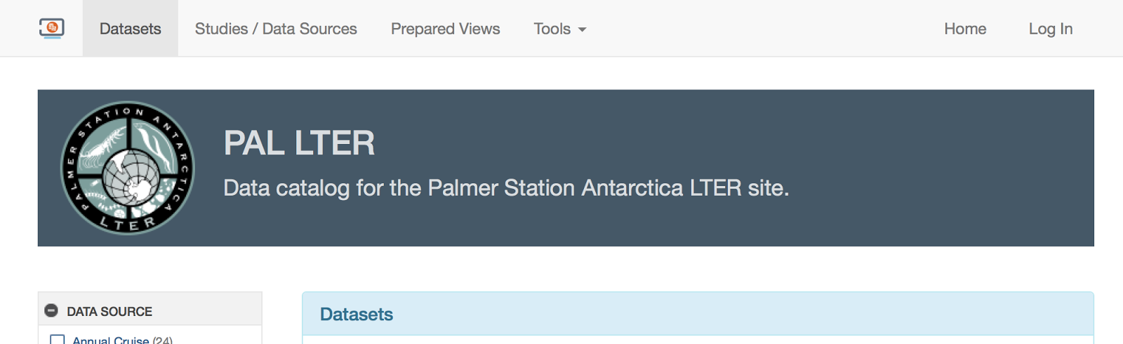
  - Register as a public user, by putting in your name, email, and Education (K-12)
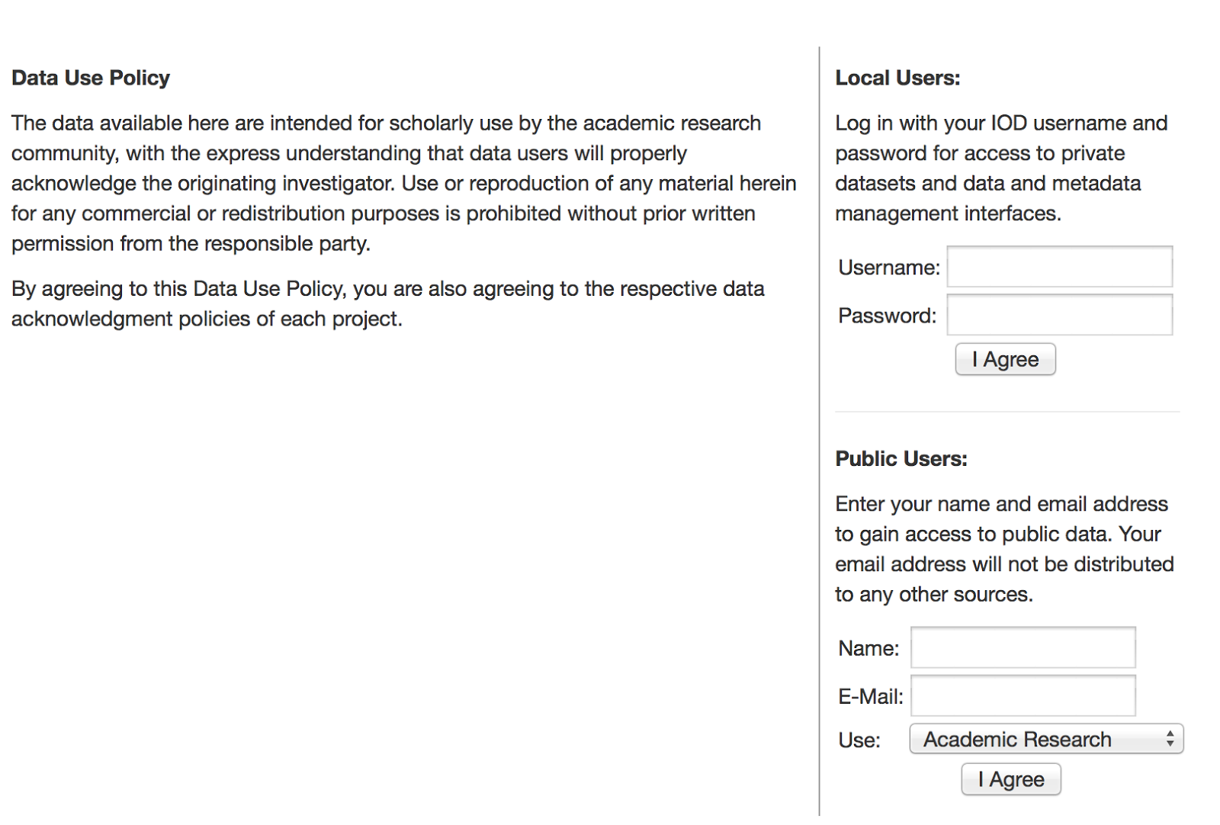
  - Once registered, click “Return to Previous Page” at the bottom of the Public Users section to begin to search for data.
- There are multiple ways to search through the available data sources.
  - If you know a specific data source you are interested in finding (e.g., Adelie, diet, chlorophyll) then you can type the term(s) into the Search field in the center of the page and click “Submit”
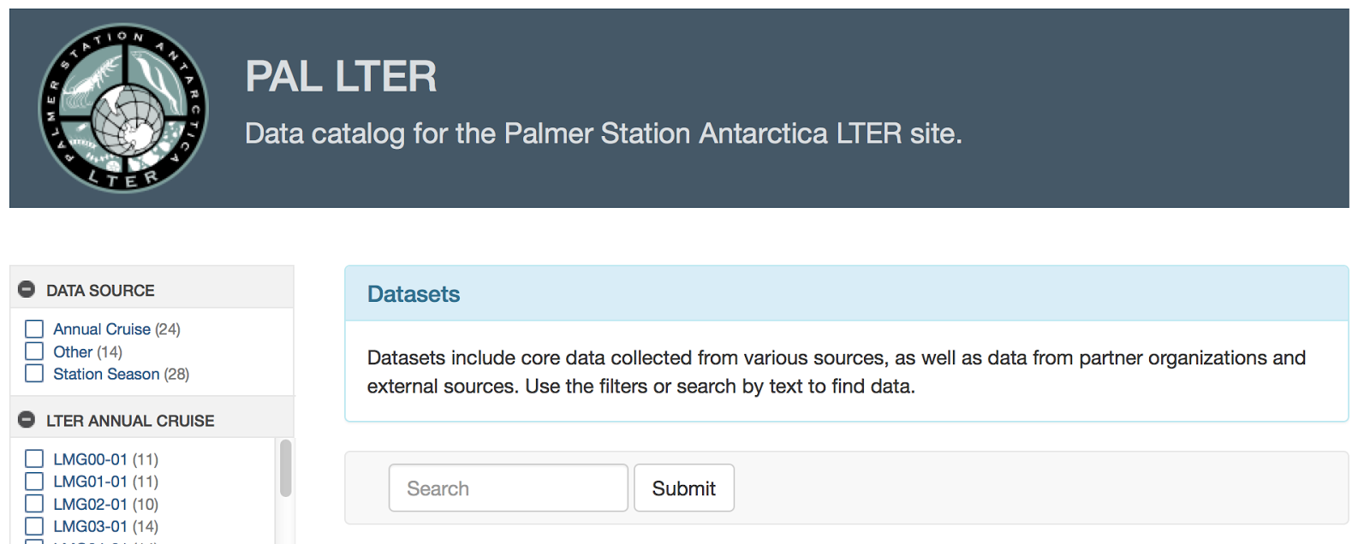
  - If you are not certain of a specific data source you are interested in finding, you can look through the various categories along the left-hand side of the page to select from the options. Click on an option to select it and then click Submit in the Search feature section at the top of the page.
    - Data Source - this is how/where the data were collected (remember the Palmer LTER project has scientists both on a research cruise out in the Palmer Research Station)
    - LTER Annual Cruise - you can select a particular year of the research cruise to access data which were collected aboard the vessel from the selected year(s)
    - Station Season - you can select a particular field season of the data collected by the researchers based at the U.S. Palmer Research Station from the selected field season(s) [note - the field season is during the austral summer, so field season spans the calendar year, hence PAL0001 is the Palmer field season from 2000 to 2001]
    - Contributor - you can select data collected by a specific researcher participating in the Palmer LTER project
    - LTER Core Area - you can select the data relevant to each of the 6 core areas of the Palmer LTER project (disturbance patterns, inorganic matter, organic matter, population studies, primary production, signature)
    - Keyword - you can select data relevant to 68 different pre-selected keywords that may be of interest to you (e.g., biomass, climate, ecosystem, nutrients)
  - All of these options will automatically populate a list of relevant/selected data sources in the Results section under the Search feature in the center of the page.
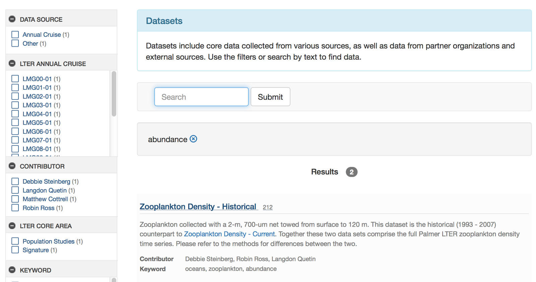
- Select a data source by clicking in the data source’s blue title.
  - You will be directed to a page with information about that specific data source. “Documentation” will be highlighted as the default and that includes [note - not all datasets have information for every field]:
    - Overview - title, abstract, projects, creators, contact, keywords
    - Methods/Protocols - title, description
    - Supplemental Documents
    - Associated Publications
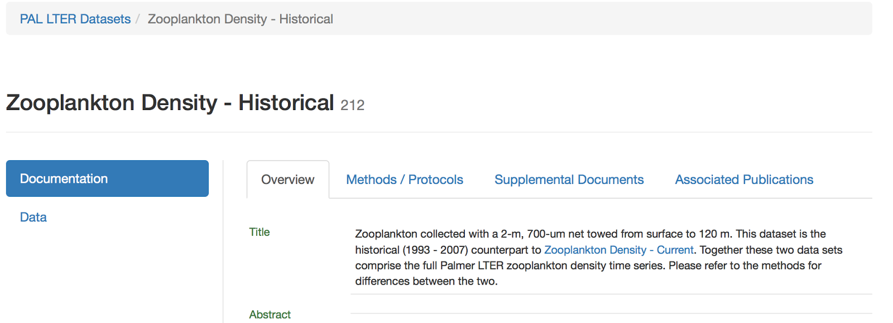
  - To access the data, click on the “Data” button on the left-hand side of the page
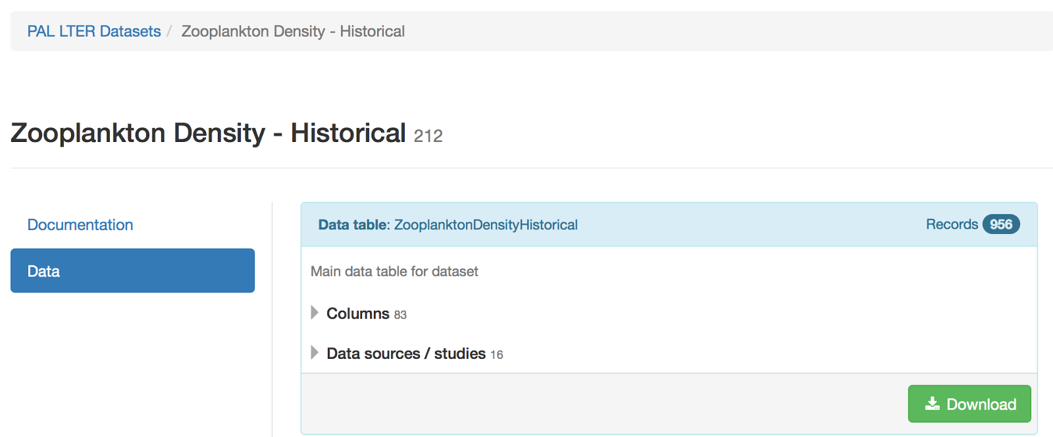
    - The name of the data table is listed at the top in blue “Data table:”
    - By selecting the down arrow next to the “Columns” you can see what variables are included in the data table.
    - By selecting the down arrow next to the “Data sources/studies” you can see which data sources/studies from which the information within the data table came.
    - To see the data click the green “Download” button
- You will be taken to a page dedicated to the main table for the data you are requesting.
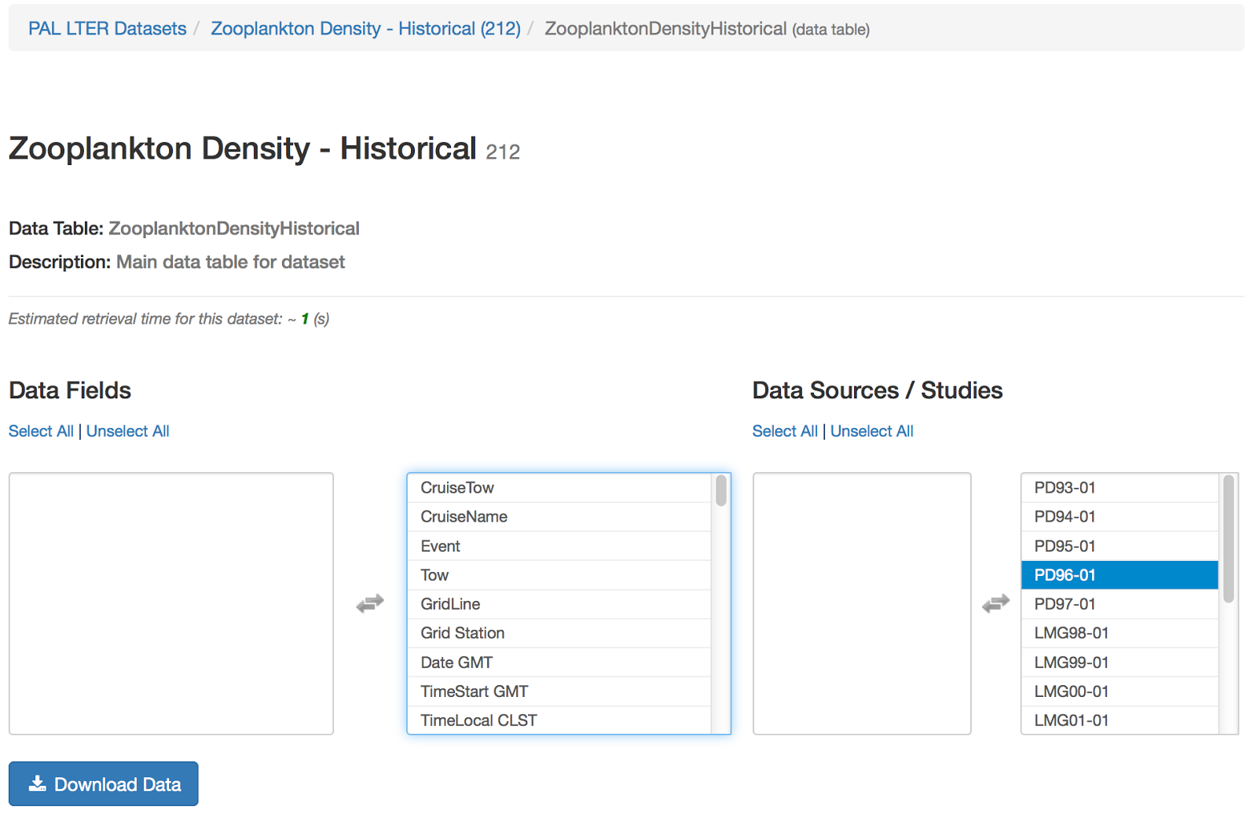
  - By default, all of the variables from all of the data sources/studies are selected to be exported (appear in the middle and far right columns).
  - If you do NOT want all of the variables and/or all of the data sources/studies, then you can click on the variable or data source/study to remove it from the right hand column of data to be downloaded into the left hand column of data not included in the download.
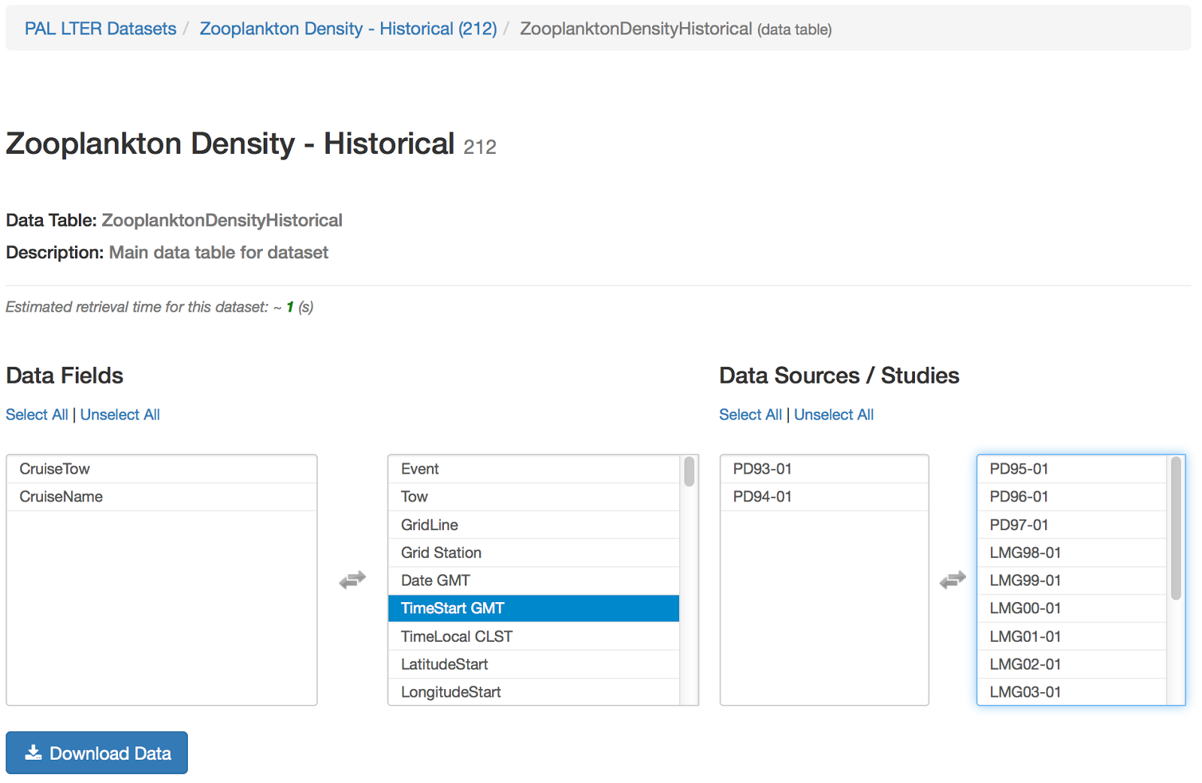
  - When you have finalized your selection of what data to download, click the blue “Download Data” button.
- If the request for data is successful, a green bar with “Data Query Successful” will appear below the blue “Download Data” button.
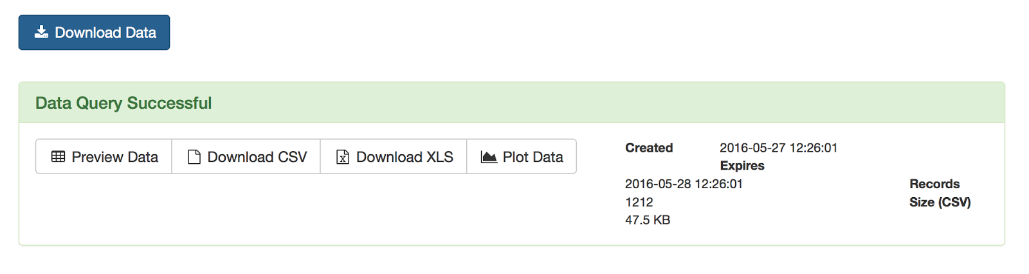
  - Preview Data - enables you to look at the data table in a new tab webpage
  - Download CSV - enables you to download the data table as a .csv file (a table structured format of the data that you can open in a variety of software programs)
    - If clicked, the file will download onto your computer and you will be prompted to save or open the file.
    - Once you have saved or opened the file you can access the data in whatever software program that accepts .csv files.
  - Download XLS - enables you to download the data table as a .xls file to open in Microsoft Excel
    - If clicked, wait for the green “XLS Ready” button to appear and then click the button to be prompted to save or open the file.
    - Once you have saved or opened the file you can access the data in Microsoft Excel (or other software programs that accept .xls files).
  - Plot Data - pulls up a widget on the page that enables you to select which aspects of the data you want to plot within the webpage [note - this should be treated as a way to do a quick look at the data, it should NOT be used as a way to visualize the data for analysis]
    - The data can be viewed in the following different data visualization formats (if the data are appropriate for that form of data visualization): time series, scatter, box plot, contour, map contour

