Adding a Sighting to JellyWatch APP

Category is a dropdown menu

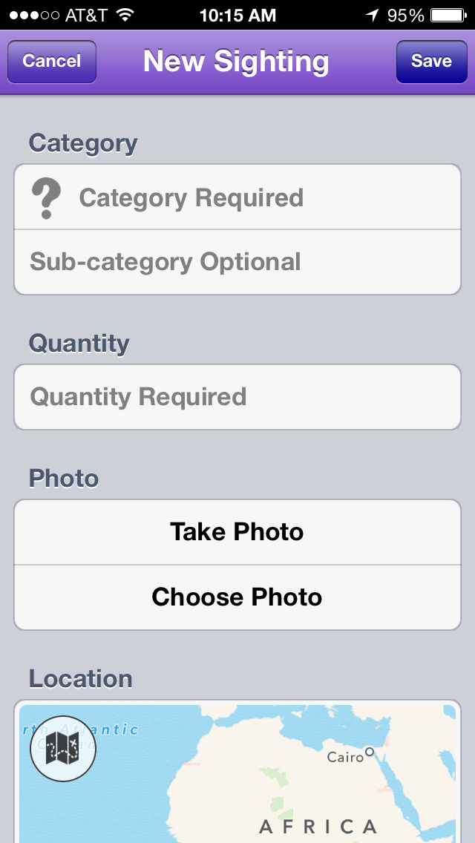
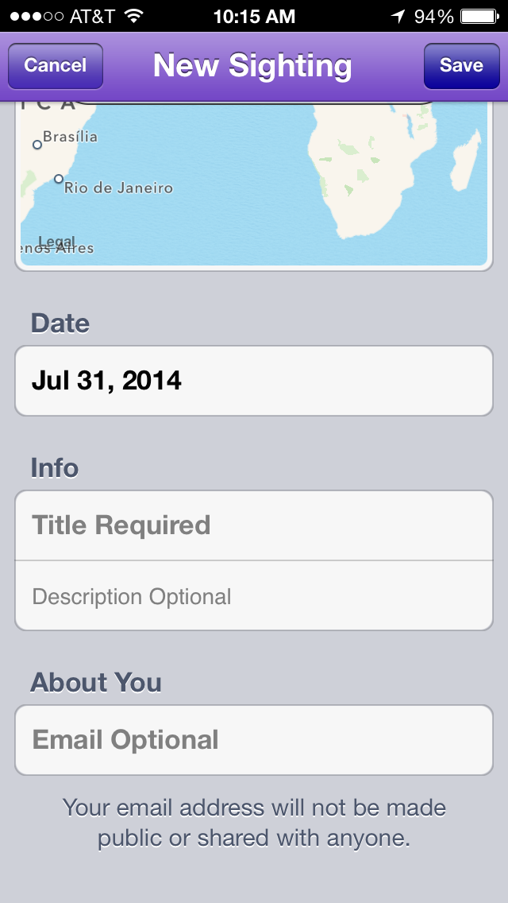
Scientific Genus; common name
(if not known, leave blank)

Quantity is a dropdown menu

Can add on your own, or click for coordinates to automatically upload
Date of sighting
Is this part of a class observation, an annual event, etc.?

