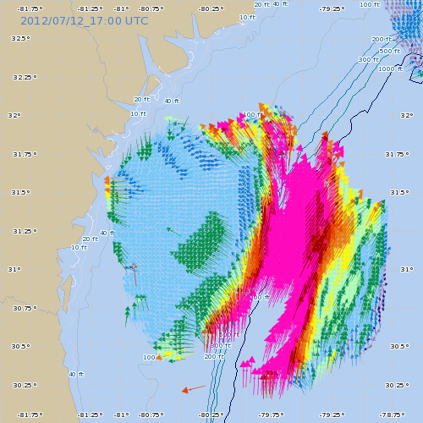  [image: http://secoora.org/ ] | 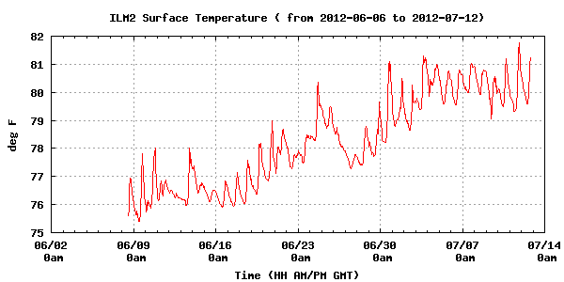  [image: http://www.cormp.org]
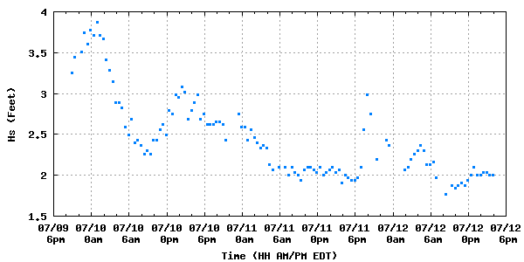  [image: http://www.cormp.org] | 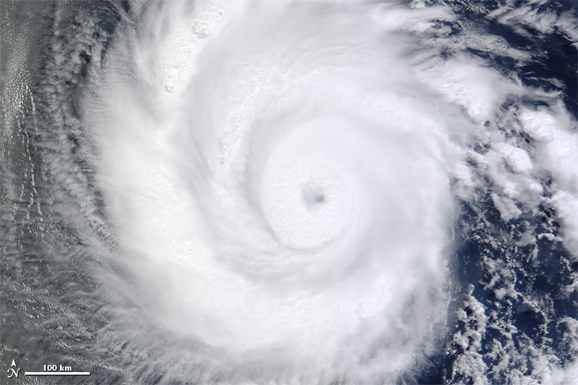  [image: http://earthobservatory.nasa.gov/NaturalHazards/view.php?id=78495]
  [image: http://www.mbari.org/mars/science/eits.html] | [table from: http://www.ncdc.noaa.gov/sotc/national/2012/6/supplemental/page-1/]
  Year-to-Date average temperatures for selected locations
  Location | 2012 Jan-Jun  Temp. | 1981-2010  Average | 2012  Depar-ture | 2012 Rank
  Aberdeen, SD | 44.3 °F | 37.7 °F | +6.6 °F | 3rd Warmest of 118 yrs
  Abilene, TX | 65.5 °F | 61.2 °F | +4.3 °F | Warmest of 65 yrs
  Akron, OH | 50.5 °F | 44.8 °F | +5.6 °F | Warmest of 64 yrs
  Alamosa, TX | 41.2 °F | 37.6 °F | +3.6 °F | Warmest of 65 yrs
  Albany, NY | 47.6 °F | 42.8 °F | +4.8 °F | Warmest of 74 yrs
  Albuquerque, NM | 57.0 °F | 53.8 °F | +3.2 °F | Warmest of 81 yrs
  Allentown, PA | 51.1 °F | 46.1 °F | +5.0 °F | Warmest of 65 yrs
  Amarillo, TX | 58.4 °F | 53.6 °F | +4.8 °F | Warmest of 65 yrs
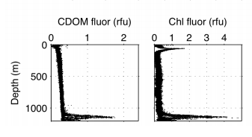  [image: http://www.noaa.gov/sciencemissions/PDFs/MBARI_AUV_DataReport_GU-10-02.pdf] | 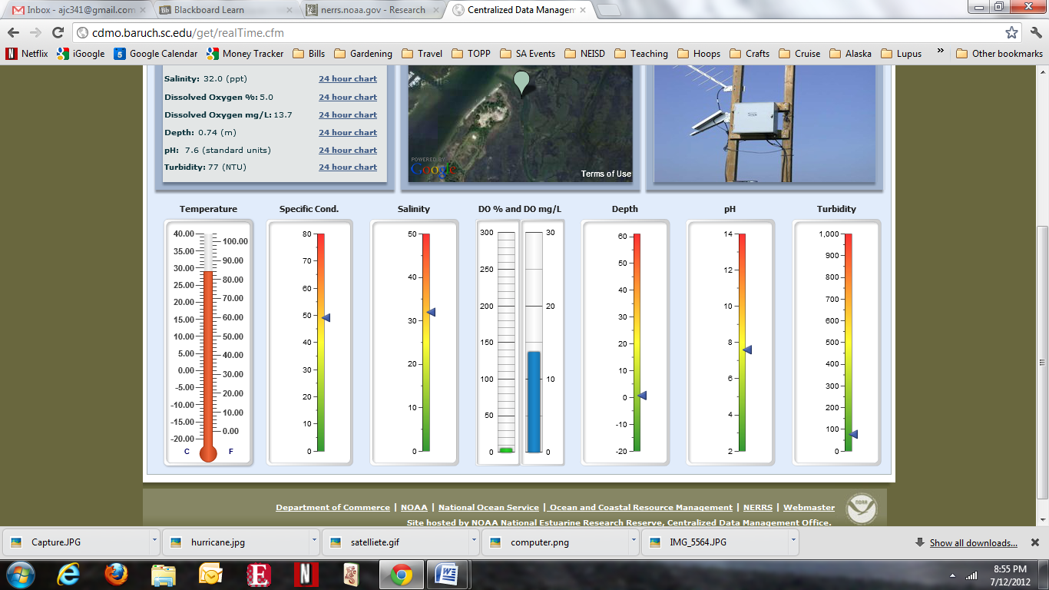  [image: http://cdmo.baruch.sc.edu/get/realTime.cfm]

